Privacy Regulation and Online Advertising

Advertisers use online customer data to target their marketing appeals. This has heightened consumers’ privacy concerns, leading governments to pass laws designed to protect consumer privacy by restricting the use of data and by restricting online tracking techniques used by websites. We use the responses of 3.3 million survey takers who had been randomly exposed to 9,596 online display (banner) advertising campaigns to explore how privacy regulation in the European Union (EU) has influenced advertising effectiveness. This privacy regulation restricted advertisers’ ability to collect data on Web users in order to target ad campaigns. We find that, on average, display advertising became far less effective at changing stated purchase intent after the EU laws were enacted, relative to display advertising in other countries. The loss in effectiveness was more pronounced for websites that had general content (such as news sites), where non-data-driven targeting is particularly hard to do. The loss of effectiveness was also more pronounced for ads with a smaller presence on the webpage and for ads that did not have additional interactive, video, or audio features.
Key words: privacy; online advertising; targeting

- Introduction
Automated collection of the vast stream of electronic data from consumers’ use of the Internet represents an opportunity for marketing modelers to improve targeting in their marketing campaigns. For example, a product campaign can now use data on website browsing behavior to identify the subset of consumers who are likely to respond to an ad. This large-scale collection of data has also heightened consumers’ concerns about their privacy. As a result, governments around the world are considering new privacy regulations designed to restrict the collection and use of customer data by firms. In the United States, the Federal Trade Commission (FTC) is considering moving to regulate the use of customer data for online ad targeting, rather than relying on industry selfregulation. However, this government regulation is largely being passed in an empirical vacuum. So far, there has been no systematic study that evaluates the effect of such measures on advertisers and media (Lenard and Rubin 2009).
To fill this empirical vacuum, this paper measures the effects of the enactment of data privacy laws
on how well advertising performs. We find that in Europe, where privacy laws have been implemented,
banner ads have experienced, on average, a reduction in effectiveness of 65% in terms of changing a stated purchase intent. We saw no similar change in ad effectiveness in non-European countries during a similar time frame. Ads on general interest websites (such as news sites) and plain banner ads experienced a particularly large reduction in effectiveness. Ads on specialized websites (such as baby and travel websites), and also larger and more intrusive ads, experienced far less of a decline. In describing proposed U.S. regulation, Congressman Rick Boucher, chair of the subcommittee on “Communications, Technology and the Internet,” said that “We do not want to disrupt targeted advertising” (Corbin 2010). However, the empirical findings of this paper suggest that even
moderate privacy regulation does reduce the effectiveness of online advertising, that these costs are
not borne equally by all websites, and that the costs should be weighed against the benefits to consumers. To measure how well online advertising performs in different privacy regimes, we use data from a large-scale database of field studies that randomized advertising exposure. The database contains 3.3 million survey responses for 9,596 different online display advertising campaigns conducted on different websites over the course of eight years. The surveys
were conducted by a marketing research company
on behalf of advertisers to measure the effectiveness of each campaign in a way that could be compared consistently over time and across campaigns and that could also help advertisers allocate advertising budgets. For each campaign, on average, 347 Web users were surveyed. These users were in the target
group to receive the ads. Prior to being surveyed, the research firm set it up so that half of the respondents randomly saw the ad campaign while the other half did not. Each respondent was then asked whether they were likely to purchase the product advertised. The relative increase in purchase intent among the group that was exposed to the ad (the treatment group) compared to those who did not see the ad (the control group) measures the effectiveness of the campaign.
We then evaluate how the enactment of the European Union (EU) “Privacy and Electronic Communications Directive” (2002/58/EC) (the “Privacy Directive”) affected the performance of ad campaigns in the European countries that enacted it, relative to other countries that had no such laws and relative to the performance of ad campaigns in Europe prior to the enactment of the law. Several provisions in the Privacy Directive limited the ability of advertisers to use and collect data about customers to target advertising. These limitations are widely seen as stricter than those in the United States and elsewhere (Baumer et al. 2004). In particular, these provisions made it more difficult for the advertisers in our data to target their ads to customers who exhibited behavior relevant to the product advertised. For example, a car manufacturer may want to show ads only to people who they know are interested in buying a car. An attractive way of identifying the target pool for the ad is to use information that a customer appeared to be trying to find information about new cars elsewhere.
However, the Privacy Directive limited websites’ ability to use data on consumers’ past browsing behavior in this way. This could theoretically limit advertisers’ ability to show ads to consumers who were likely to be influenced by the advertising message. We therefore measure how such changes in the ability to target influenced the average response to online advertising. Combining the differences across countries and the differences over time with the differences between the treatment and control groups yields a difference-indifference-in-difference econometric specification.
Our analysis suggests that after the Privacy Directive was passed, advertising effectiveness decreased
on average by around 65% in Europe relative to the rest of the world. We present some rough bounds
analysis to suggest that such a change could have a striking impact on the $8 billion spent each year on
digital advertising. To check that it is the regulation that is associated with the reduction in effectiveness
rather than unobserved changes in European responsiveness toward online advertising, we exploit the fact that sometimes people browse websites outside their country. We found that when Europeans browsed websites outside of Europe (mostly in the United States) that were not affected by these laws, there was no reduction in ad effectiveness. Conversely, when non-Europeans browsed EU websites that were covered by the laws, there was a reduction in ad effectiveness. This suggests that the change in effectiveness we observe is not linked to time-varying changes in consumer attitudes in Europe relative to the United States.
Websites that had general content unrelated to specific product categories (such as news and media
services) experienced larger decreases in ad effectiveness after the laws passed than websites that had
more specific content (such as travel or parenting websites). Customers at travel and parenting websites
have already identified themselves as being in a particular target market, so it is less important for those
websites to use data on previous browsing behavior to target their ads. The Privacy Directive also disproportionately affected ads that did not have additional visual or interactive features. One interpretation is that plain banner ads’ effectiveness depend on their ability to be appropriate and interesting to their audience. Therefore, the laws curtailing the use of past browsing behavior to identify a target audience for the ads would affect plain banner ads disproportionately. We also find that the Privacy Directive affected ads that had a small footprint on a webpage more than those with a large footprint. Our findings build on a small empirical literature that has documented costs associated with privacy regulations (Romanosky et al. 2008, Miller and Tucker 2009).1 It also builds on previous work that has documented that privacy concerns can influence the effectiveness of different online advertising techniques (Goldfarb and Tucker 2011, Tucker 2010). Overall, our results suggest that, although there may be many reasons to enact privacy regulation, such regulation may reduce ad effectiveness, particularly for plain banner ads and for general interest websites. Speculatively,
this may change the number and types of businesses sustained by the advertising-supported Internet.
2. Data and Institutional Background
2.1. Laws
We study the effects of the implementation of the Privacy Directive by five EU countries. The Privacy Directive clarified how the “Data Protection Directive” 95/46/EC (which guaranteed rights to individuals when it came to the processing of their personal data) pertained to the electronic communications sector. One of the primary purposes of the Privacy Directive was to regulate the use of telephones, faxes, and e-mail, but there were also implications for websites that wished to store and use data about their users for marketing purposes.
The Privacy Directive was implemented on different dates in different member countries. This variation adds to our experimental variation for identification purposes, and we exploit it in our robustness checks. Table 1 describes the differences in implementation date for each of the European countries for which we have ad campaign data before and after the change in regulation.
Our empirical specifications treat the enactment of these laws as a discontinuous event, but in reality, in
the time since they have been enacted, most EU countries have tightened enforcement of these provisions and have clarified them in the context of national laws. For example, the 2004 German Telecommunications Act’s provisions on privacy were replaced by the “German Telemedia Act” of 2007. We do not model these clarifications and amendments, so our estimates should be interpreted as the effect of the change in privacy regime that facilitated this legal clarification process, rather than purely the effect of these precise laws as they were initially passed.
2.2. Effect of Laws on Advertisers
The Privacy Directive strengthened European law. Baumer et al. (2004, p. 410) emphasize that the privacy laws that resulted from the Privacy Directive are far stricter than in the United States and that “maintaining full compliance with restrictive privacy laws can be costly, particularly since that adherence can result in a loss of valuable marketing data.” The Privacy Directive affected online ad targeting in three main ways: Web bugs, cookies, and collection of clickstream data.2

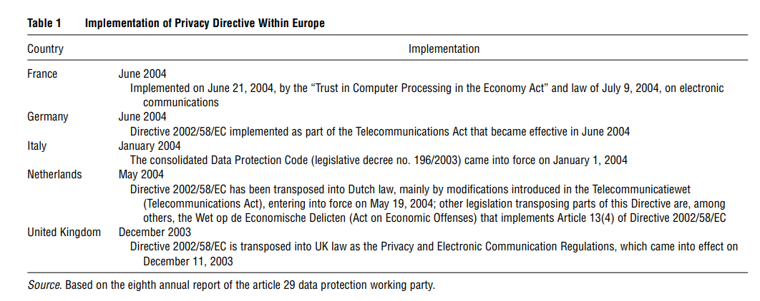
2.2.1. Web Bugs.
“Web bugs” are 1 × 1 pixel pieces of code that allow advertisers to track customers remotely.3 Web bugs are different from cookies, because they are designed to be invisible to the user and are not stored on a user’s computer. This means that without inspecting a webpage’s underlying HTML code, a customer cannot know they are being tracked. Web bugs allow advertisers to track customers as they move from one webpage to another. They also allow advertisers to document how far a website visitor scrolls down a page. Combined, this means they are very helpful in determining website visitor interests. Web bugs are widely used on commercial websites. Murray and Cowart (2001) found that 96% of websites that mentioned a top 50 brand (as determined by the 2000 FT rankings) had a Web bug. Online privacy advocates such as the Electronic Frontier Foundation voiced early objections to marketers’ use of Web bugs because of this intentional invisibility (Smith 1999). Recital 24 of the Privacy Directive explicitly says,
So-called spyware, web bugs, hidden identifiers and other similar devices can enter the user’s terminal
without their knowledge in order to gain access to information, to store hidden information or to trace the
activities of the user and may seriously intrude upon the privacy of these users. The use of such devices
should be allowed only for legitimate purposes, with the knowledge of the users concerned.
This “knowledge” restriction matters because the need to ensure that users are informed about the use of Web bugs removes one of their major advantages, which is that they are otherwise invisible to the user. If regulation curtails advertisers’ use of Web bugs, advertisers become less able to use data on
current and past browsing behavior to target their advertising.
The law suggests the following:
(17) For the purposes of this Directive, consent of a user or subscriber, regardless of whether the latter is a
natural or a legal person, should have the same meaning as the data subject’s consent as defined and further
specified in Directive 95/46/EC. Consent may be given by any appropriate method enabling a freely given
specific and informed indication of the user’s wishes, including by ticking a box when visiting an Internet
website.
The costs involved in obtaining such such user consent are large. For example, in confidential discussions, executives at two large European companies suggested that explicitly obtaining user consent to
be tracked online costs around 15 euros per user in administrative costs and promotional incentives.
There is some ambiguity, however, about whether “knowledge” directly implies opt-in consent. Some
authors, like Gilbert (2008), suggest that the law implies that Web bugs should be treated like cookies,
meaning that opt-out consent is enough.
2.2.2. Cookies.
According to Recital 25 of the Privacy Directive, cookies can be a “legitimate and useful tool,” and their use should be allowed on the condition that users are provided with “clear and precise information in accordance with the Data Protection Directive about the purposes of cookies.”4 For U.S.-based websites, notice of the installation of cookies, if it takes place at all, takes place in website privacy policies. The EU law we study is therefore more restrictive on the placement of cookies than U.S. law and makes it easier for customers to become aware that cookies are being used and to reject them. As discussed by Debussere (2005), the wording of the directive does suggest that the requirements apply to any cookie, rather than cookies used to store personally identifiable information. In general, the tone taken in the Privacy Directive toward cookies is more favorable than that taken toward Web bugs, perhaps because cookies can be controlled and are visible to the user. However, cookies pose problems to marketers because of customer deletion,5 so Web bugs 4 On October 26, 2009, after the period we study, the EU voted
to require Internet users’ opt-in consent before cookies could be placed on their machines.
5 It was reported that 38.4% of surveyed Web users said they deleted cookies each month (Moran 2005).
(which a user cannot avoid) have been increasingly used in conjunction with, or even in place of, cookies
in targeting of advertising (Reiley and Lewis 2009). Web bugs also have greater reach in terms of tracking
ability than cookies because they can be used to track consumer scrolling within a webpage.
2.2.3. Clickstream Data.
“Clickstream data” describes data that record the webpages a user viewed at a website, how long the user spent on each webpage, the visitor’s path through the site (including her points of entry and exit), the visitor’s IP address, and the webpage the user viewed immediately before arriving at the website. As pointed out by Wong and Garrie (2006), the Privacy Directive never deals explicitly with restrictions on the use of clickstream data except to say that sites are permitted to retain traffic data that is necessary for websites to provide their service or user-requested “information society services.”
However, more recently, legal scholars and privacy experts have pointed out that the presumption that such clickstream data is never personally identifiable is not correct. First, there has been a growth of static IP addresses that can directly identify a user, especially if the network administrator uses identifiers connected with physical location or name. Static IP addresses are increasingly used in large firms, government, and educational institutions. In a recent court case in Germany described by Jakobs (2009), Google has been criticized for not obtaining their users’ consent prior to websites analyzing their behavior with Google Analytics. Second, it may be possible to inadvertently collect data that is considered private under the scope of the Data Protection Directive if it relates to religion, union member status, or medical issues (Clayton 2008). This distinction between whether clickstream data is personal or anonymous is crucial because of the different provisions regarding consent. Anonymous data can be collected if the user is informed and then given the ability to opt out, but personal data require a clear “opt-in” form of consent (Baumer et al. 2004). The lack of clarity in whether or how the Privacy Directive applies to clickstream data therefore adds another challenge to online ad targeting beyond Web bugs and cookies.
2.2.4. Ambiguities in Interpretation.
Given that there are multiple ambiguities in interpreting the laws, firm and advertiser response has been mixed. Some firms have been conservative in their interpretation, and have limited their collection and use of data for targeting if they have not received prior consent.
Some EU lawyers have even recommended that firms do not store IP addresses unless consent is obtained.6
Other firms have interpreted the regulations less strictly. For example, an attorney at a large provider
of information society services and advertising contacted the authors anonymously to argue that opt-in
consent was not required—
[W]here “consent” is required under the ePrivacy directive, this consent doesn’t have to be opt-in consent, unless this is specifically requested, e.g., as “explicit consent” or “prior consent.” [ ] [A]s long as they provide information [about how users’ data is used] and browsers provide an opt-out [for cookies], they comply with the law.
Given the controversies over how to interpret the EU Directives in the light of technological change,
we emphasize that our estimates show the effects of firms’ and advertisers’ interpretations of the EU
Directives, not the effects of the laws’ actual texts unmediated by interpretation.
2.3. Advertising Data
We use data on 9,596 different field studies of online ad campaigns worldwide from 2001–2008. We define
a “campaign” as a separate ad campaign created for a specific product on a specific website. This database
contains over three million survey responses collected by a media metrics agency to measure the effectiveness of these ad campaigns. Each of these field studies were conducted by a firm to assess the relative performance of an existing campaign. After the field study data were collected by the media metrics agency, firms could access the data through a “marketing dashboard” that allowed them to judge the performance of their portfolio of ads across different websites and different designs. This information was then used to help guide future banner ad design and placement. The focus on evaluation of existing campaigns means that our data contain fully fledged campaigns typically run on the Web
with attendant targeting ambitions. We cannot rule out selection effects entirely, but we present evidence
below that suggests that ad campaign characteristics do not change significantly in the EU relative to outside the EU after the regulation takes effect.
Each field study lasted a mean of 55 days (median 49 days). The campaigns that were evaluated in the
field studies advertised over 400 different kinds of products on 40 different categories of websites over
8 years. This means that our data should be thought of as a repeated cross-section. There are 10 different
countries in our data. Of these, we have 894 campaigns for Italy, France, Germany, The Netherlands
and the United Kingdom within the EU and 8,792 for the United States, Canada, Australia, Brazil, and
Mexico outside the EU. Because the measurement firm’s clientele grew over time, 81% of our data comes
from after the EU regulation came into effect.
These field studies are based on randomly displaying ads to a subset of the group of Web users who
are in the target group for the ad. The browsers in the target group who did not see the ad saw a placebo
ad, typically for a nonprofit. Both exposed and not exposed (control) respondents were recruited via an
online survey invitation that usually appeared in a pop-up window. They then completed the survey
online in this pop-up window immediately upon positively responding to the invitation.The survey usually took less than 10 minutes to complete. Each campaign had an average of 347 people in its subject pool, of whom half were exposed to the ad for the product. Because advertising was randomized conditional on being in the target group, both exposed and control groups should have had the same underlying purchase intent. The only difference between the two groups is whether they saw the ad, so differences in survey responses for the exposed group can be attributed to the content and selection of audience for the online campaign. This online questionnaire asked the extent to which a respondent was likely to purchase a variety of products (including the one studied) on a five-point scale. In the main specifications in this paper, we focus attention on whether the respondent reported they were “very likely” or “likely to make a purchase.” As reported in our summary statistics in Table 2, over one-third of respondents said they were likely or very
likely to purchase. We convert the scale in this manner to reflect the fact that on an ordinal scale the perceived distance between 1 and 2 may be different than the perceived distance between 3 and 4 (Malhotra 2007, Aaker et al. 2004).
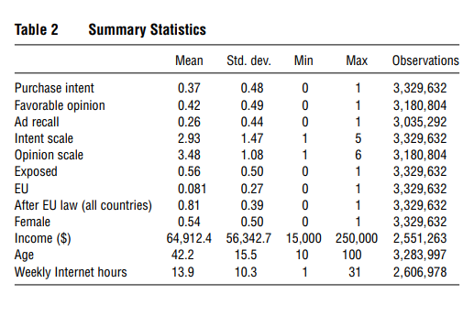
However, we recognize that there is no consensus about whether such scales should be used as discrete measures or used as a continuous measure (Fink 2009), so we replicate our main result using a linear regression with the full scale as a dependent measure. The use of stated purchase intent as a measure of ad effectiveness differs from the majority of the marketing literature such as Manchanda et al. (2006) and Chatterjee et al. (2003), which has focused on measuring the effect of ad exposure on click-through rates. There are arguments in favor of either measure: Clicking on an ad does represent a measurable action on the part of the consumer, but it may indicate mere curiosity. In contrast, purchase intent implies an intention to act on something of key interest to firms, but only an expressed intention. In other robustness checks, we use two additional dependent variables: The respondent’s favorability toward the product and whether the respondent recalled seeing the advertisement. Respondents rated on a five-point scale their favorability toward the product (as well as toward some decoy products). We use whether a respondent felt “favorable” or “very favorable” toward the product as our dependent measure. For recall, the surveys displayed the ad, alongside some decoy ads for other products, and the respondents were asked whether they recalled seeing any of these ads. Overall, we focus on the purchase intent measure because it is closest to the metric that advertisers care about: whether a customer will purchase. Ad recall and brand favorability (and also click-through rates) are further away from purchase in the hierarchy of persuasion discussed in the advertising literature (Ehrenberg 1974, Vakratsas and Ambler 1999). If they responded that they had seen the focal ad,
then we code this variable as one and as zero otherwise. As can be seen in Table 2, recall is relatively low
at 26%, much in line with the eye-tracker research of Dreze and Hussherr (2003), which suggests that Internet users avoid looking at banner ads during their online activities.
An important strength of this data set is that it allows comparison of campaigns across many countries over eight years in a variety of categories, including apparel, automotive, consumer packaged goods, energy, entertainment, financial services, home improvement, retail, technology, telecommunications, travel, and many others. These measures are, however, weaker measures of ad success than purchasing (as used by Reiley and Lewis 2009) because users may claim that they intend to purchase but never do so. However, the direction of our core results depends only on these measures being positively correlated with purchase outcomes, a correlation demonstrated by Bemmaor (1995), because we ultimately focus on comparative ad effectiveness. The very privacy laws that we study also mean it is problematic to track customers’ subsequent purchase decisions in a manner similar to Reiley and Lewis (2009), who combine Web
bugs and link online and offline data. The Privacy Directive would require the Yahoo! users that these
authors study to give their opt-in consent because the data become identifiable when combined with an
offline identity. The survey also asked about respondent income, age, and the number of hours spent on the Internet. We converted these to zero-mean standardized measures and used them as controls in our regressions. The nonstandardized values are reported in our summary statistics in Table 2. The number of observations for each demographic variable makes clear that there are some missing values. We normalize these to zero. We use two other types of data. First, we use campaign-specific information that described the
physical size of the ad and the multimedia features it had. Second, for the purpose of establishing the legal
regime, we identify the country from information on where the survey was based. This identifies the relevant legal regime because the presence of a server or other such physical presence generally establishes
country of jurisdiction when it comes to Internet law.7
2.4. Effect of Privacy Regulation on Campaign Ad Effectiveness
The Privacy Directive restricts the ability of the advertisers in our data to identify a group of consumers
for targeting. Because the marketing research company randomizes ad assignment conditional in being
in the targeted group, this means that the Privacy Directive alters the composition of the subject pool
(both in the treatment and control groups) and, by extension, how targeted the subject pool can be in
our field data. This occurs without affecting the randomization that is crucial to our identification of the
effect of online advertising. Although we do not know which targeting technologies were used in each campaign, we do know that these are large advertisers on the leading edge of technology and it is therefore
likely that they would use the best legal techniques available, including Web bugs and cookies.
Table 3 displays the raw difference-in-difference for ad campaigns in European countries before and
after their laws were enacted. It indicates two things:
First, after the law was enacted, purchase intent was slightly lower for both the exposed and control group.
This is to be expected if it is now harder for advertisers to identify an appropriate target group (and consequently an appropriate subject pool). Second, there was little difference between the exposed and the control groups after the law was enacted. This suggests that advertisers became less able to identify a subject pool where someone who was exposed to the ad would be influenced by the ad.
Table 4 replicates this result for the rest of the world using the median date of enactment among the countries in our survey as the date for the placebo privacy law. It does not appear that there was a comparable decrease in the effectiveness of ad exposure at changing purchase intent outside of Europe.
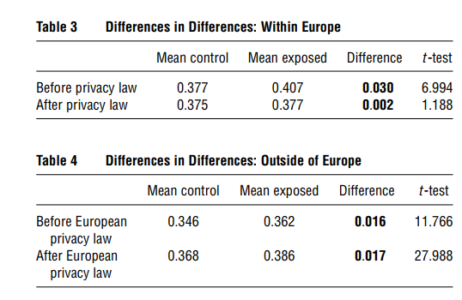
3. Estimation and Results
3.1. Main Specification
Next, we use econometric analysis to formalize the insights of Tables 3 and 4. First, we focus on European campaigns only. We use a straightforward specification that reflects both the variation in time to
implementation and the randomized nature of exposure to advertising in our data. As such, we start
with a difference-in-difference using only the EU data; below, we will add the third difference between the
European countries and the other countries. For person i who was exposed to advertising campaign j in country c in year t, we estimate the following specification:
Intent
ijct = Exposureij + Exposureij × Lawct
+ Xi + jct + ijct (1)
where measures the effect of being exposed to an advertisement; captures the core relationship in this
paper—the incremental change in advertising effectiveness when a privacy law is in place; Xi is a vector of demographic controls including gender, age, income, and hours online; jct is a fixed effect that captures differences in baseline purchase intent for each campaign in each website in each country (and because each campaign runs for a short period, therefore controls for the main effect of PrivacyLawct); and ijct is the error term.
Our estimation procedure is straightforward because of the randomized nature of the data collection. We have an experiment-like setting, with a treatment group that was exposed to the ads and a control group that was not. We compare these groups’ purchase intent and explore whether the difference between the exposed and control groups is related to the implementation of the Privacy Directive into various European countries. Identification is based on the assumption that coinciding with the enactment of privacy laws, there was
no systematic change in advertising effectiveness independent of the law (an assumption we explore below). Heteroskedasticity-robust standard errors are clustered at the website-campaign level, to adjust for
intrawebsite and intracampaign correlation across respondents.
We report our main results using a linear probability model, although we also show robustness to a logit formulation. This robustness is in line with the findings of Angrist and Pischke (2009) that there is typically little qualitative difference between the logit and linear probability specifications. We focus on the linear probability model because it enables us to estimate a model with 9,596 campaign fixed effects using
the full data set of 3.3 million observations (the linear functional form means that we can partial out
these fixed effects through mean-centering), whereas computational limitations prevent us from estimating a logit model with this full set of fixed effects.
Likely because our covariates are mostly binary and the mass point of the dependent variable is far from
zero or one, the predicted probabilities all lie between zero and one. This means that the potential bias of the
linear probability model if predicted values lie outside of the range of zero and one (Horrace and Oaxaca
2006) is not an issue in our estimation.
Table 5 shows our main results, building up to the full specification for Equation (1) in column (4).
Columns (1) and (2) show general trends in the data without campaign fixed effects. Column (1) confirms
that there is a positive relationship between ad exposure and purchase intent. Column (2) replicates the
results in Table 3 using the regression format, showing that purchase intent is lower in places with privacy laws and that advertising exposure has little relation to intent in places with privacy laws. Column (3) adds demographic controls that capture differences in the demographic composition of those exposed and not exposed to ads—little changes, as expected given the randomization of ads.
Column (4) adds campaign-level fixed effects (that is, a fixed effect for every product-website combination). These fixed effects, combined with the random assignment of the ads, control for four distinct influences on purchase intent: first, heterogeneity across people who browse websites; second, heterogeneity in people who are targeted for ads for different products; third, heterogeneity across countries, because each campaign is launched in only one country; fourth, heterogeneity across time, because these campaigns run on average for seven weeks. These fixed effects are collinear with the privacy law variable.8 The privacy variable consequently drops out of the fixed-effect specifications. Column (4) reports the change in results for the EU when we add these fixed effects. The estimates suggest that the law is associated with a decrease in effectiveness of on average 65% of the initial exposure effect.9 The identifying assumption for Columns (1)–(4) is that there was no other change in ad effectiveness after 2004 that was not related to the privacy law.
However, it could be that generally (perhaps because of customer fatigue or growing inertia) online ads
were simply becoming less effective. To rule out this explanation, we compare the change in Europe to the
rest of the world as follows:
Intent
ijct = Exposureij + 1Exposureij
× AfterEULawct × EUc + 2Exposureij
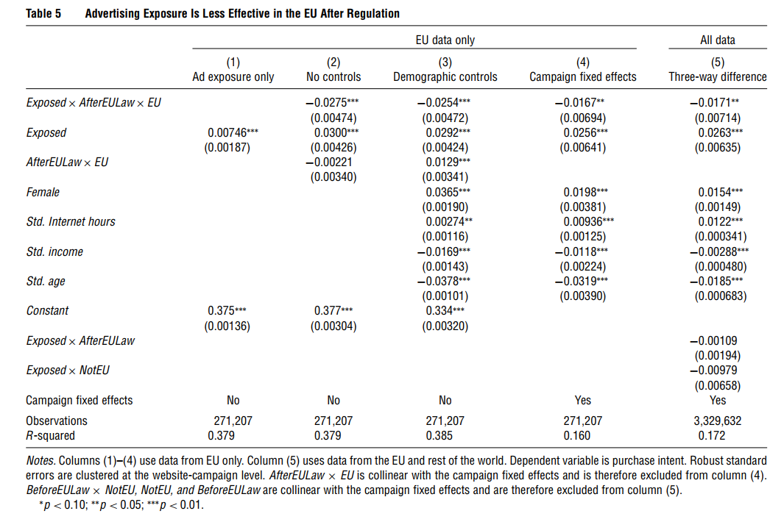
× BeforeEULawct + 3Exposureij
× NotEU
c + Xij + jct + ijct (2)
This equation combines the insights of Tables 3 and 4 into a single specification, using a “differences-indifferences-in-differences” approach. We use ad effectiveness in the other countries in our data to control
for changes over time (prelaw and postlaw) in the effects of ad exposure with the coefficient 2. We also
allow for differences in the baseline effect of ad exposure between Europe and the rest of the world with
the coefficient 3. We again use the median effective date of the EU law as the date of the law for countries
where there was no law. Subsequently, we check for robustness to alternative definitions.10 Column (5) of Table 5 reports the results for this three-way differencing approach that uses the nonEU countries in the data to control for a general time trend in the effectiveness of online advertising exposure. The key coefficient of interest, Exposureij × AfterEULawct × EUc, is negative and significant and similar in magnitude to before. It suggests that after the policy change ads in the EU lost nearly twothirds of their effectiveness in terms of purchase intent. The coefficients for Exposureij ×BeforeLawinEUct are insignificant, suggesting that in this time period there has been no systematic change in ad effectiveness over time outside of Europe. The coefficient in Exposureij × NotinEUc is also not significant, suggesting that there was not much initial difference between the EU and the non-EU countries.
One thing to note is that across all specifications the measured main effects of exposure are relatively
small, in the 2.5 percentage point range. This makes sense given the low relative price of each banner ad
impression of 0.02 cents (Adify 2009). Generally, banner advertising should be viewed as an advertising
mechanism where advertising effectiveness is relatively low, but where, as a result, equilibrium prices
are relatively low too.
3.2. Robustness
We check the robustness of these results in two ways. First, we perform a wide range of tests aimed at
reducing concerns related to functional form and specification. In §3.3 we discuss lingering selection concerns related to our fundamental identifying assumption that the European campaigns and the European respondents do not systematically change over time for reasons other than the regulations. Table 6 checks the robustness to alternative specifications. Column (1) shows the robustness of the specification in column (5) of Table 5 to a logit regression. Because of computational limitations, we are not able to estimate the full set of 9,596 fixed effects, but instead include the full set of lower-order interactions. In a logit specification the interpretation of interactions is not straightforward, because they are a crossderivative of the expected value of the dependent variable. The sign of this marginal effect is not necessarily the same as the sign of the coefficient of an interaction term. Therefore, we also verified that the marginal effects and logit coefficients are similar in sign and significance, using the method suggested by Ai and Norton (2003). The results are consistent with the main specification. The main interaction term capturing the effect of the law is negative and significant.
Columns (2)–(4) of Table 6 show robustness to different potential measures of ad effectiveness. Column (2) replicates column (5) of Table 5, where the dependent variable is the full intent scale, and we again use a linear regression with fixed effects. The qualitative results do not change. Column (3) shows a similar negative interaction effect between the law and exposure for favorable opinion. Column (4) shows a smaller negative effect relative to the main effect for ad recall. Contrasting the effect of the regulation on ad recall to the effect of the regulation on stated purchase intent suggests that the laws made it harder to identify customers who could be persuaded to change their purchase intent, more than it made it harder to identify customers who could recall the ads.
One issue with the survey methodology is that once someone was exposed to the ad, they could be reexposed to it if they refreshed the page or returned to it later. Column (5) shows that our results are robust
if we focus our attention only on people who saw the ad once.
Column (6) of Table 6 shows that our results are robust if we put in a variety of controls for the interactions with exposure for the timing of each country’s law (as can be seen in Table 1) rather than merely capturing the before and after period with a single interaction. These controls are largely insignificant or, where they are marginally significant, the signs do not show a consistent pattern. Column (7) checks that our results are robust to the exclusion of the lower per-capita income countries Mexico and Brazil where change may have been more fast paced. Column (8) shows robustness to fixed effects for each respondent’s country in order to control for respondent origin as distinct from website origin.
One concern with any study of regulation is that the dates of enactment might not give a precise measurement of the law’s effect because advertisers anticipate the laws. In further specifications, which are available at http://cetucker.scripts.mit.edu, we show the robustness of our main results in column (5) of Table 5 to using slightly different timing assumptions about when the law started influencing the behavior of the advertiser. Our results remain robust whether or not we used the date the regulation was first scheduled,
the implementation deadline, or the date the law was passed, all of which are alternative dates that advertisers may use as the date they changed their targeting practices.
3.3. Unobservables
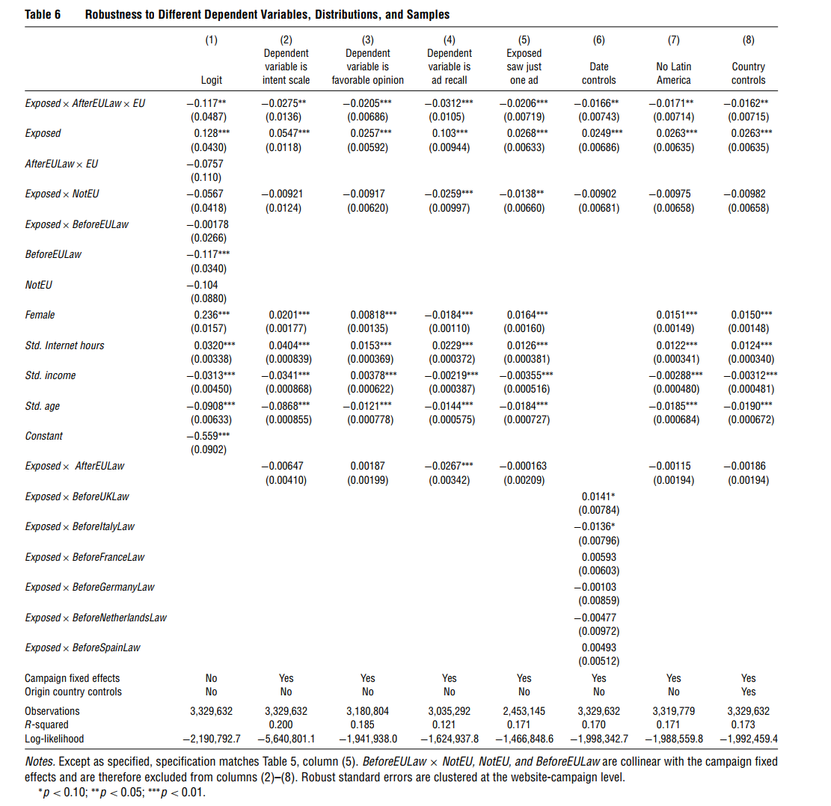
Table 6 documented robustness to several alternative data and modeling decisions. In this section,
we examine the likelihood that there is an unobserved change in measured advertising effectiveness in Europe relative to the rest of the world that is not related to the Privacy Directive. Specifically, we examine three such issues: (1) the campaigns we may observe are nonrandom, (2) the respondents might not represent the general Internet population, and (3) there may have been a change in European consumer attitudes and responsiveness to online advertising separate from the Privacy Directive. To address the first issue, we checked to see whether the observable nature of campaigns changed in Europe relative to the United States as a result of the change in the regulation. In particular, whereas the respondents were randomly assigned to treatment or control groups, the campaigns in the data were not randomly chosen. It might be troubling if there were evidence that European ad agencies invested less in their ad creatives relative to the United States (though this is only a concern for our interpretation of the results if this underinvestment was not due to the regulations). In further robustness tests, which are available at http://cetucker.scripts.mit.edu, we show that there is no significant difference in the proportion of ads using different “ad improvements,” like interactive features such as “floating over the webpage,”
video, or a large ad footprint, in the EU and the rest of the world before and after the laws. This does
not completely overcome concerns about selection, but it suggests that there was little difference before
and after in the United States and EU in terms of the expense of creative formats used. Nevertheless, although it is comforting that there is little change in observable characteristics and that this is the main
data source in the industry, there is still the possibility that the ads changed in some characteristic that
we do not observe.
The second issue relates to the possibility that respondents might not represent the general Internet
population. The company does not make data available about response rates to the survey, but response
rates are likely to be low. However, given the experimental nature of our data and that the surveys are
explicitly opt-in (and therefore the response rate is unaffected by the implementation of the law), the
response rates should not affect our qualitative measures of advertising effectiveness, although it is possible that they might affect the magnitude. For example, these are people who (by design) responded to an ad
and therefore might be more ad sensitive overall. To address this concern, we note that the demographic profile of the respondents appears to be representative of the general population of Internet users
in terms of average income, age, and time spent online (DiMaggio and Bonikowski 2008), although
with a slightly larger proportion of women. The costeffectiveness calculations also look right in the sense
that in Goldfarb and Tucker (2011) with similar data we show that the small effects of the ads are consistent with the low prices for such ads. In addition, it is these very survey data that advertisers use when evaluating where to allocate advertising dollars. Therefore, if we are interested in the potential effects of the laws on advertising purchase decisions, then these data are likely to be the best guide to actual advertising decisions. Still, we acknowledge that selection issues may still bias the magnitude of the effects we observe and that it is not clear which direction the bias would take. The third concern about unobservables is whether
there are alternative explanations for the measured changes in the attitudes of survey participants toward
online advertising that were separate but contemporaneous with the change in European privacy laws.
For example, our results could also be explained if Europeans became more cynical about online advertising relative to the rest of the world after the Privacy Directive became effective.
To check for such unobserved heterogeneity, we perform a falsification test. We look at the behavior of Europeans on non-European websites that are not covered by the European Privacy Directive to see if
we observe a similar shift in behavior. If the alternate explanation we just described is true, Europeans
should also be less influenced by ads on U.S. websites.
However, if it is the law that is causing the shift in ad effectiveness at the website level, we should see no such effect for these websites not covered by European law.11
Table 7 reports the results of this specification. It shows that Europeans on the non-European websites have similar ad-effectiveness patterns to nonEuropeans in Table 4, as opposed to the pattern they displayed on European websites in Table 3, because ads appear to be getting more effective rather than less effective over time. This suggests that the changes in behavior are connected with the websites covered by the law, rather than with the people taking the survey. We verified that there was no significant difference in the age, gender, or income of the Europeans who were visiting non-European sites compared to the Europeans who were visiting European sites before and after the implementation of the directive. 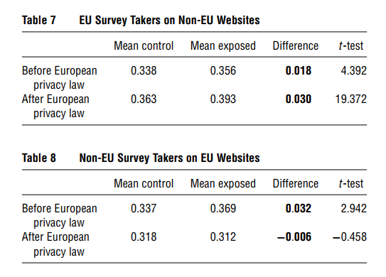
We also conducted the mirror image of the falsification test by looking at residents of non-EU countries
who visited EU websites. Again, if it is unobserved heterogeneity attached to EU residents that explains our results, we would expect that these external visitors to EU websites would not display diminished
susceptibility to ads.
If, however, the privacy law and the reduced ability to target ads to a specific group of consumers explain the result, then we would expect a reduction in ad effectiveness with respect to these users. Table 8 displays the results and shows that ads shown to nonEU users of EU websites did have a similar reduction in ad effectiveness to those shown to EU residents.
This suggests again that the change in behavior associated with EU privacy law occurred at the website level, rather than potentially being explained by unobserved heterogeneity for European residents.
Nevertheless, we cannot completely rule out the possibility that there is an unobserved factor affecting
campaign and website characteristics in the EU relative to the rest of the world. Although we believe the
that above analysis points to a causal relationship, it is possible that our measures of campaign effectiveness on European websites were systematically falling over time for reasons other than the regulation.
3.4. Economic Implications
Section 3.2 establishes that our results are statistically robust to many different specifications and also provides evidence supporting our interpretation of the effect as causal. However, we have yet not established that the impact of laws is economically meaningful. The point estimates in column (5) of Table 5 suggest that the laws reduced the effectiveness of advertising by over 65%, but it is 65% of a relatively small number. In this section, we provide some rough “back-ofthe-envelope” calculations to estimate the regulations’ impact on advertisers’ bottom line. The main purpose of this analysis is to provide suggestive evidence on the importance of our results. We want to emphasize that the numbers in this section are not due to equilibrium analysis, which would require different data (e.g., prices of the online ads and substitutable offline ads). Therefore, the values should be taken as suggestive of the importance of the phenomenon rather than as exact measures of costs.
Column (5) of Table 5 suggests that seeing one plain banner ad increases purchase intent by 2.63 percentage points. The introduction of privacy laws in the EU was associated with a decrease in this effectiveness of
1.71 percentage points, or around 65%. Therefore, for an advertiser to achieve the same lift in likely intent
as they did prior to the law, they would have to buy 2.85 times as much advertising. Currently in the United States, $8 billion is spent per year on the type of display-related advertising that we study (Interactive Advertising Bureau (IAB) 2010). If prices and demand of advertising did not change, that would mean that advertisers would have to spend $14.8 billion more than they are currently doing to achieve the same increase in purchase intent after the introduction of privacy regulation. Of course, another possibility is that advertisers might reduce expenditure in line with this decrease in effectiveness. The nature of our data emphasizes that this could happen, because we are studying “adeffectiveness” measures that are specifically designed and used by advertisers to determine relative allocation of ad budgets across different types of advertising media. If this occurs, then our estimates suggest that at the extreme, revenue for online display advertising could fall from $8 billion to $2.8 billion. Furthermore, if the effects documented here apply more broadly to the advertising-supported Internet, this could potentially have implications for the wider
economy. Deighton et al. (2009) suggest that the advertising-supported Internet represents 2.1% of the
total U.S. gross domestic product (GDP) and directly employs more than 1.2 million Americans.
These possibilities are nonequilibrium proxies of potential outcomes from privacy regulation suggested
by the estimates in this study. As discussed in Athey and Gans (2010) and Bergemann and Bonatti (2010),
the extent to which advertisers end up paying more or websites receive less advertising revenue will be
mediated by the extent to which advertisers view other media as substitutes for the privacy-restricted
banner ad. Therefore, these large numbers should be considered to be “worst-case” scenarios. If there
are general equilibrium shifts in both advertiser and media behavior, the results are likely to be less
pronounced. A final point of caution about these estimates is that they are predicated on the idea that our data on surveyed purchase intent corresponds to measures of banner ad effectiveness that drive advertisers’ purchase decisions. For the advertisers we study, this was their major way of evaluating the relative effectiveness of their display advertising campaigns and consequently allocating advertising budgets. However, there may well be other methodologies that advertisers use (such as click-through rates).
3.5. Asymmetric Effects of Regulation
In this section, we explore whether the regulations had asymmetric effects across websites and across
ads. This matters because privacy regulation may shape the future development of the Internet if the
regulation affects some websites and ads more than others.
One potential asymmetry is across the breadth of content provided by a website. For example, the use of Web bugs and cookies is more important for websites that aim for a general or mainstream audience that is not connected with a specific type of product. Someone visiting www.cruise.com is more likely to be interested in purchasing cruises and can be targeted accordingly, but a portal or a news website cannot be sure whether someone visiting its main page is in the market for cruises unless they track whether that consumer is also reading news features on cruises. This means that general or less product-specific websites could find consumer tracking technologies relatively more useful for targeting ads than product-specific websites. This reliance on tracking technologies for targeting advertising by general content websites is supported by external empirical evidence. For example, the E-Soft annual survey (Reinke 2007) documents that the 100 websites that use the most Web bugs have consistently been general interest websites like Information.com, photobucket.com, flickr.com, and YouTube, as well as various ad networks.
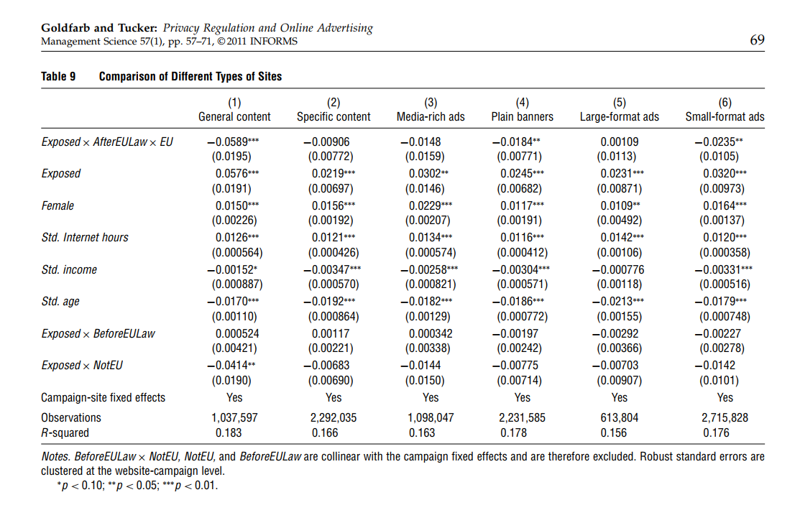
Table 9 stratifies our data by website type and ad type. Column (1) compares the most general content (news, political news, business news, education magazines, regional news, Web services, streaming music,
and games and contests) with all other websites (auto, parenting, men, women, entertainment, shopping, health, cookery, special-interest groups, house and garden, fashion, and style, apparel, beauty and
makeup, and travel) in column (2). These general content websites have a larger negative effect from the
law being enacted on ad effectiveness. This supports Evans (2009), who suggests that two-sided media
platforms that rely on content to bring together disparate groups of advertisers and users have a greater
need to use customer data for targeting. Another potential way that the law could have asymmetric effects is across ad type. As discussed by Goldfarb and Tucker (2011), there is a negative relationship between contextual targeting (or matching a website’s content with a product) and the optimal level of ad obtrusiveness. Columns (3)–(6) of Table 9 compare the effects of the laws on different ad types.
We distinguish between ads that had visual, interactive, or audio features and ads that had no multimedia capacity. Columns (3) and (4) compare the results.
The negative effect associated with enactment of laws is significant only for ads that did not have multimedia features. We should note, though, that the difference is not significant because of the lack of precision of the estimate in column (3). In columns (5) and (6) we check to see whether the effect of regulation varied by ad size. We compared ads that on one dimension were larger than a half-page format. The results suggest that these large ads experienced a lower negative effect from the introduction of the laws than ads that were smaller. The apparent difference in magnitude between larger, more obtrusive ads and other ads may be because obtrusive ads can still be effective without targeting, as they grab viewers’ attention. However, without such attention-grabbing features, plain banner ads’ effectiveness depends on their ability to be appropriate and interesting to the audience. Therefore, the laws’ curtailment of the use of browsing and scrolling behavior to identify a target audience for the ads affected plain banner ads disproportionately.
4. Conclusions and Implications
We investigate how privacy regulation influences online advertising effectiveness. We use data from a
large database of field studies that randomly exposed website users to banner ads. We find that in Europe,
where privacy laws have been implemented, banner ads have experienced a reduction in effectiveness of
65% on average in terms of changing stated purchase intent. We observe no similar change in ad effectiveness in non-European countries over the same time frame. This provides empirical evidence that privacy regulation can reduce the effectiveness of advertising.
Furthermore, we show that the loss in effectiveness has been particularly pronounced for websites
with more general content that could not be easily linked with a specific product, such as news and
Web services sites. These websites have content that is already not easily monetizable. The privacy regulation makes monetizing it even more challenging.
This suggests that stronger regulations may make it harder for ads running on general content websites to be effective, relative to ads running on websites that are linked to specific product categories. In addition, we found that privacy regulation is related to reduced effectiveness of ads that did not have interactive, audio, or visual features. Again speculatively, we suggest that as the use of customer data by marketers online becomes increasingly regulated, ads may become more obtrusive. This matters in both the United States and Europe. Specifically, the FTC is considering moving to directly regulating online targeting in the United States rather than relying on self-regulation, whereas new EU regulations requiring opt-in consent for cookies are likely to pass into individual countries’ laws by 2011. Measurement of the effect of privacy regulation is important because, as highlighted in a recent complaint to the FTC,12 whether or not regulation is desirable depends on weighing the potential harm privacy regulation would cause to advertisers against
the potential for an increase in privacy protections for customers. In describing proposed U.S. regulation, Congressman Rick Boucher, chair of the subcommittee on “Communications, Technology and the
Internet,” said that “Our goal is not to hinder online advertising [ ] This will make people more likely
to trust electronic commerce and the Internet” (Kang 2009). However, our results do suggest that regulation
does hinder the effectiveness of online advertising. Broadly, our results therefore suggest that privacy
regulation may affect the direction of innovation on the advertising-supported Internet. To the extent
that the regulation makes ads less effective, it will limit the scope of the advertising-supported Internet. To the extent that general interest sites are particularly effective, regulation will make these sites either less prevalent or they will switch to alternative business models. And to the extent that unobtrusive ads are less effective, regulation implies larger, more obtrusive ads. These costs must be weighed against the potential benefits to consumers of privacy regulation such as a fundamental right to privacy (Rubenfeld 1989), an aversion to sharing personal details with strangers (Hui and Png 2006), and the potential for efficiency-reducing information externalities (Hermalin and Katz 2006). Therefore, regulation is a trade-off between the benefits of consumer privacy and the benefits to consumers of a potentially broader, less obtrusive advertising-supported Internet.
There are limitations to this research. First, the campaigns in our sample are not random and therefore
may not be representative of all online display advertising. Second, the sample consists of people who
responded to a survey, and they may be different from other Internet users. Third, our estimates reflect how
firms interpreted the law rather than the effect of the actual text of the law. There was substantial ambiguity
about how much the laws curtailed different tracking activities, so we may be picking up in our estimates
a conservative legal interpretation of the law in addition to the actual effects of the law themselves. Fourth,
we do not have data that allow us to analyze whether these changes in ad effectiveness led to a change in
revenues for the websites or changes in the prices charged for different kinds of ads. Fifth, although we
provide considerable suggestive evidence in favor of a causal relationship from the regulations to a reduction in ad effectiveness, as in every empirical study based on historical data we cannot completely reject the possibility that some omitted variable is driving our results. Sixth, it is not clear whether our results generalize to websites, such as Facebook, that explicitly offer users control over their privacy settings. It is possible that such proprietary opt-in advertising networks may even benefit from regulation of this kind, if it means they are relatively more efficient. Nevertheless, our results do suggest that online
advertising in Europe became less effective after the introduction of the Privacy Directive and that not all
websites and all types of advertising were affected equally. Consequently, any new privacy regulations
will likely play a significant role in shaping economic activity on the Internet.

