An Introduction to Privacy in Economics and Politics

Stigler, George J

The enormous increase in interest in privacy in our society is evident in the public press and in the statute books. In some respects this interest in privacy is paradoxical, for the average citizen has more privacy -- more areas of his life in which his behavior is not known by his fellows -- than ever before. He lives in a large city, where no one is his keeper; in the small towns of former times privacy was won only by the cleverest people. He works in large organizations, and indeed he (or more likely, some self-appointed spokesman) laments his alienation. He can shake off most of his past simply by moving -- to the South, the West -- and no earlier generation except the immigrant waves before World War I was as mobile.
If then the privacy issue is a real issue, and not one of those contrived issues that march across the headlines for a time, it probably exists because of the vast growth of government. Governments (at all levels) are now collecting information of a quantity and a personal detail unknown in history. Consider: it would have been quite impossible for a public official to learn anything of the income of a citizen chosen at random without leaving Washington, D.C. in 1860. Today the files of Social Security, the IRS, the S.E.C., the microfilms of banking transactions, and other sources are potentially available to answer the question, to say nothing of the fact that perhaps one family in three or four receives payments directly or indirectly from the federal government. In addition the govern-ment has become the major instrument by which the information-collect-ing and information-using practices of private citizens are controlled. Technology has enormously changed the mechanics of gathering and dis-seminating information, but it is politics and economics that direct the uses of the machinery. Three topics in this large subject are explored here: the nature of privacy in economic behavior; the eco-nomic effects of contemporary privacy policies; and the reasons for . the appearance of privacy legislation.
- What is Privacy?
Privacy as a subject of public policy refers to the possession and acquisition of knowledge about people and implicitly or explicitly also knowledge about associations. A highly miscellaneous variety of laws, which are still increasing in number, restrict possession or dissemination of information about individuals, or conversely compel its dissemination. Three major examples of such legislation will illustrate the variety of public policies in the privacy area:
The Privacy Act of 1974 controls the collection and access to information about individuals by the Federal Government. Extensive rights are given to the concerned individual to examine and challenge the accuracy of such records.'
The Fair Credit Reporting Act (1970) gives the individual the right to examine and correct the credit rating given to him by a credit rating agency. Old information (more than 7 years in general; 14 years for bankruptcy) must be destroyed. A number of fair employment practices laws prohibit the collection or use in employment of information on past arrests (and often convictions) as well as sex, race, or physical handicaps. These are comparatively recent pieces of legislation and they may convey the quite misleading impression that public concern with information about individuals is a new concern. The history of taxation, and above all of income taxation, is replete with laws and regulations compelling personal disclosure (anti-privacy?) and often prohibiting public disclosure. The regulatory arms of government have been given steadily increasing powers, -- a modern example is the Bank Secrecy Act (1970) which compels reporting by banks to the Federal Government of various financial transactions. The S.E.C. has greatly enlarged the disclosure obligations of corporate officials and even of market advisory services. The Bureau of the Census and its predecessor bodies have been collecting information on individuals and businesses for almost two centuries, maintaining a relatively austere posture toward other governmental agencies with respect to access to information about individuals and enterprises. Much of the information the Census collects about individuals, however, is of no immediate or direct relevance to government operations: the individual is compelled to reveal information useful to the research community. "Privacy" connotes the restriction of the collection or use of information about a person or corporation: the information in question "belongs" to the individual. The primary peculiarity of information as a property right is commonly held to be its public goods character: if A gives (sells) information to B, there is usually no efficient way to insure that B does not disseminate the information to C (while still retaining possession of the information). The view popular among economists that the production of information is costly but its dissemination is almost free is supported by no known empirical study. The storage and retrieval of information, and its accurate dissemination, are often extremely expensive, and in a vast number of situations it is much cheaper to produce the information anew rather than to seek it out. (For some elaboration, see Appendix A.) There may be special difficulties 'in contriving or enforcing contracts for the ownership of knowledge, but at present they are assumed rather than ascertained. Information about persons is also frequently alleged to be inac-curate or misused: 1. Information about individuals is often mistaken, and there is inadequate care in verifying and up-dating it. 2. Information derogatory to a person may be used excessively (vindictively?), as when a stale criminal record is erroneously treated as informative. 3. Information of improper sorts (e.g., race or sex) may be taken into account in decisions in which the legislature does not wish it to enter.
The first alleged problem -- insufficient accuracy of information -- presumably represents a market failure: it may be worth more to me (or to a merchant) to correct an error in (e.g.) my credit history than it would cost the credit-rating agency to make the correction. The second misuse (use of obsolete information) asserts that people are systematically mistaken in their calculation of the informative value of old information. The third misuse (use of "bad" information) presents a conflict between social (majority) and individual preferences or knowledge, often with the implication that it is empirically inefficient as well as legally wrong to take the designated characteristic into account. The efficient use of a resource is normally achieved by assigning ownership of it to some particular person or enterprise, so that the maximizing of the returns from that resource (= optimum use) is the in-centive to its proper allocation. The production of information might seem not to lend itself to this rule of ownership. An individual's credit record, for example, is the outcome of transactions with other people, and they may have invested as much or more resources than the individual in question in learning about him. Yet if all credit history information, for example, were "owned" by the debtor, and there were not a special difficulty in enforcing thi6 ownership because of the public good character of information, this inherent partnership in producing information would create no special problems. I would have an established credit record with the merchant with whom I customarily dealt, and be charged for credit according to the cost of dealing with me (including the cost of learning my payment habits).
Another merchant, to whom I denied access to my regular merchant's in-formation, would charge for credit appropriately to his ignorance of my creditworthiness, so in general it would pay me to ask the regular merchant to supply the credit record to others. This would be true even if I were a poor credit risk: the new merchant would extend credit only at high charges to those who refused to reveal their previous records. In the long run -- in a sequence of many repetitive transactions, -- even a poor credit risk can do no better than to deal with informed creditors. (This is similar to the fact that poor students must sign waivers of their right to see letters of recommendation, under the Buckley law, in order not to label themselves as even more different from good students.) The economy of the multiple use of the same information should be accommodated nc matter how the ownership of the information is assigned. The failure of contracts to emerge which specify that the creditor may not sell the consumer credit information is in the interest of debtors, for whom credit would otherwise be more expensive.1
The possibility of large error in a person's record (whether as debtor, employee, or whatever) always plays a prominent role in the hearings on privacy legislation -- instances are given of a clerical error which has led to demands for multiple payment of a debt or which plagued a person's search for employment. Error is of course unavoidable (also in the direction of failing to report recent transgressions) but there are substantial incentives of information agencies to keep the error in reasonable bounds: the rejection of a sound debtor or acceptance of a deadbeat are clearly costly to a merchant. If many of us had in our records errors whose removal was worth $X to each of us, and these errors were not removed by an information agency even though the cost of the removal would be less than $X, the market would again be failing to allow a mutually profitable transaction to take place. One may surmise that the number of such transactions would be too small to allow the review procedure to appear. Again, when it is said that creditors or employers will retain and be influenced by episodes in a person's past so remote as to be un-informative, non-maximizing behavior is alleged: the creditor or em-ployer does not know how to use information correctly. There is no known evidence on the matter; we will offer a different explanation for why the age of information has been controlled by recent statutes. The utilization of "improper" information (e.g. race) is parallel, and will also be discussed below. Finally, let us return to the "rightful" ownership of knowledge about a person. If knowledge did not arise out of, and normally get used in, transactions, there would be little interest in the subject: indeed the common state of man is that others are not interested in listening to what he wishes to recount of himself. Only an idle curiosity could exist concerning information about a person that has no implications for his behavior in dealing with others. Of course most people would like their public reputations to be high, and the conduct of people under observation is usually of a somewhat different style than their private conduct. This may be viewed as the useful effect of social norms of proper behavior, and, to repeat, the public conduct of a person is more important to others than his private conduct. Private conduct is indeed of interest primarily be-cause it has predictive value with respect to public conduct. This subject is elaborated in an appendix note (B) on reputation and privacy. It is argued there, what will be unnecessary to argue to economists, that in voluntary transactions there is no reason to interfere to pro-tect one party provided the usual conditions of competition prevail: the efficient amount of information will be provided in transactions, given the tastes of the parties for knowledge and privacy. We have been discussing real or alleged peculiarities of the ownership and use of information in the context of voluntary transactions between individuals. Much of the modern interest in pri-vacy has arisen in a different context: the state demands large amounts of information about its members, amounts that grow with the rapid growth of public expenditures, regulations, and data-collecting programs. This information is usually provided under compulsion, and information supplied under one public program often provides important aid in the administration of other programs. When the state enters into a voluntary relationship with an individual, the role of information will not differ from that in private transactions. Thus if the state makes highly intrusive investigations of its employees, it will pay for this burden through higher wage rates or lower quality employees, But if coercion enters the relationship, how do we proceed?
The discussion of coercive disclosure soon takes one of two turns. First, a doctrine of fairness or justice may be invoked. Thus it is said to be unfair to maintain in later life the criminal records of a teen-ager, or unfair to have an anti-nepotism rule in employment, or to have (or not to have) an affirmative action program in employment. Economists are, even in their own opinion, not shy to enter into the discussion of subjects that do not appear to be part of their professional knowledge, but they will generally admit that they have no comparative advantage in striking the balance of justice. Or second, the private possession of knowledge about one-self is postulated to be a fundamental value, and each incursion by the state must meet a test of essentiality for the performance of governmental functions. Since the legislature and the executive must determine both state functions and the behavior of the public information gatherers, the effective implication of this view is that any in-formation the state collects should be collected. This need not be so. It would usually be a perfectly operative rule to ask that the benefit of an information demand of the state be shown to be worth as much as it cost to be fulfilled. In principle this criterion is now imposed by the federal data-collecting agencies and by the OMB but one is entitled to hold reservations about its success, and for two reasons: i. Usually a very small part of the cost of information gathering is borne by the collecting agency, and the remainder is borne by the individuals or enterprises being canvassed. Their costs are often and prob-ably usually given less weight. ii. When the information is held to be essential for governmental action (e.g., taxation or reg-ulation), there is virtually no control over what is called for. If the ICC asks a trucker for any information about his operations, there will be no review of the cost-benefit ratio of the information. But there is something strange and singularly uninformative about talking of the state's demands for information for itself or of its interventions in the dealings among private parties with respect to disclosure. If it is fatuous to identify the state with "the people", it is equally obfuscatory to treat the state as an alien and inscrutable entity. The state enters into the information business for the same reason that it enters any other activity: because some group important to the government wishes it. It may well be that each of the immensely varied and numerous groups possessing governmental influence will be limited by general rules on information if these rules can be given specific content and wide political support: this is perhaps the most important social question about privacy. We shall seek to uncover some of the political forces behind the present legislation in section 3.
2. Economic Effects of Privacy Policies
The common element of all privacy statutes is that the amount of information about a person that is available to other persons is reduced. If information about a person is forbidden to others, substitute (and inferior) information sources will be utilized by parties dealing with that person. Procedures which ostensibly serve only to increase the accuracy or completeness of information will in general have the same effect: unless they employ previously unavailable tech-nologies, the mandated procedures compel use of methods previously spurned as unnecessary (= more costly). How much information should economic actors have about the goods in which they deal? Exhaustive information costs more than it is worth; complete ignorance would make rational conduct impossible. Hence in all economic and social life we resort to classification: it is enough to know to which class a good belongs. The determinants of the optimal degree of classification of productive services has apparently received little attention from econo-mists. In classifying a laborer or a machine, we are governed by the precision of the task to be performed -- obviously requiring more spe-cialized (precisely defined) factors for more specialized tasks -- and the precision of the tasks (and products) in turn depend upon avail-ability of specialized inputs (of materials as well as labor and capital). A superb statistician with ample technological assistance could carry the definition of even simple-appearing goods (say, corn flakes) to levels that we would find astonishing before encountering the limits of accuracy of his instruments of measurement. Even if we cannot go much beyond the statement of the usual marginal conditions for the optimal classification of factors, however, we can be confident that this information plays an important role in the efficient conduct of economic life. Privacy legislation in general increases the cost of achiev-ing a given level of classification (by which we mean the number of classes and the accuracy with which they are filled). When distinguish-ing marks that would serve to divide a group of people into more homo-geneous classes are suppressed, there are several consequences to be observed. Whatever the distinguishing mark that is suppressed, some other methods of distinguishing members will exist. If the employment his-tory of a worker is not known, his work can be more closely watched during a trial period. If the criminal tendencies of a worker are not known, the very frequency of previous job changes is a clue. If a debtor is wont to elude repayment of debt, a new debtor can be held to a period of low credit limits. But these methods of distinguishing individuals are less efficient (= more costly) than the method that has been suppressed, or they would have been relied upon before the suppression. Hence the classification will be less accurate: the classes will be wider (and hence the membership of the class more heterogeneous) and the errors of classification larger.1
Resources will be used less efficiently when they are less finely and accurately classified. In extreme cases this would be obtrusively apparent: if the pilot of an airplane were chosen at random from passengers and crew, at least the first flight would be perilous. (Because people are able to learn, the second flight would have only crew: the passengers would have found a new designation, perhaps as baggage.) It is often said of a distinguishing character-istic that is to be suppressed that it is irrelevant to the proper use of resources, a direct or indirect expression of prejudice. (Thus continuity of employment is required, perhaps, to exclude women who alternate between household and market.) The validity of this argument has not been assessed in convincing fashion. One interesting test would be to see whether the distinguishing characteristic in question survives when the employer (or creditor, etc.) employs the characteristic when prejudice, if it exists at all, runs the other way. Do banks that are run by women ignore marital status of women in making loans? In principle a direct test of the relevance of any disputed information would be feasible: compare performance with the screening characteristic and measure its predictive value. (I predict that if the study supported the use of the characteristic in hiring or extending credit, the test would be widely impugned.)1 There is a redistribution of income within a class when classes are made less homogeneous. When it becomes more difficult to measure differences among individuals, their treatment becomes more uniform. Lower and higher risk credit are treated as average risk credit, and similarly with the traits of workers, students, and others. It has become a little easier to default on consumer credit, to embezzle funds, and to shirk duties. A redistribution of income takes place within the enlarged class. Customers of the industry with less well classified inputs are affected through the increase in cost of the service or product. Let us look at this latter, allocational effects, more closely, using a simple example in which two types of laborer are employed by a firm. When workers are classified as superior (S) and inferior (I), they will be assigned to appropriate tasks and equipment, with marginal products D' and DI (see Figure 2.1). If the workers are mixed in one class, the marginal product curve will not become D' (the ap-propriate average of Ds and DM) but some lower curve DM, because the gains of better matching of workers and tasks is lost. The loss of product (2xSRJT) will be larger, the greater the differences between
the two classes of workers and the more equal they are in numbers.'
The reduced knowledge of the qualities of units of a factor of
production thus reduces the productivity of that factor. Almost neces-sarily the total income to that factor will be reduced: if, as seems reasonable, capital and entrepreneurial abilities are highly versatile in use, the supply of cooperating factors will be elastic to the oc-cupations in which privacy legislation is influential.
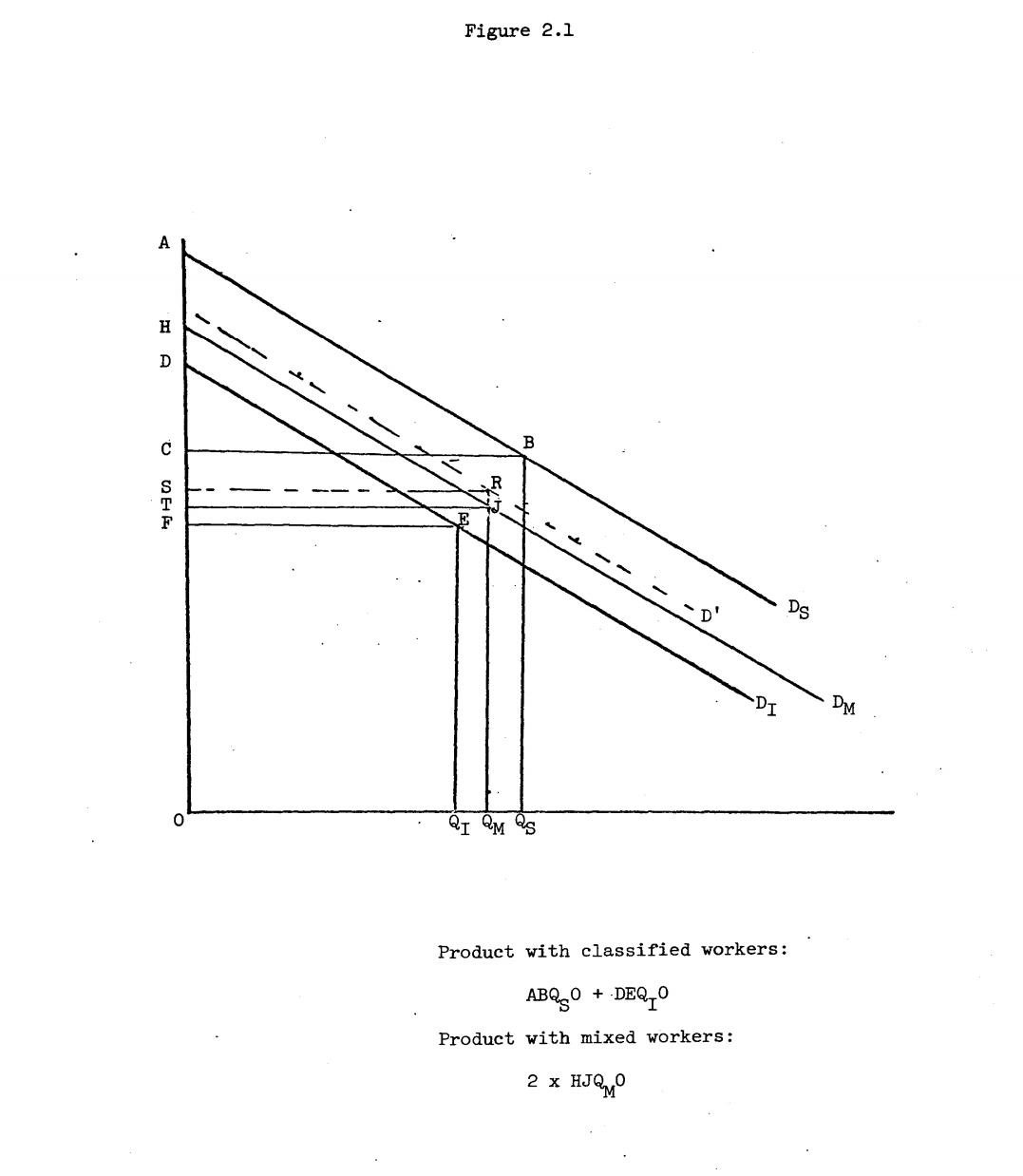
The reduction in the knowledge of and rewards for superior productivity will lead the owners of resources to invest less in improving their quality. Ignorance of ability by buyers is a tax upon the production of increases in that ability, and this traditional argument is applicable equally to human capacities and to capital goods. In the long run the ability as well as the incentive to invest in improving resources is reduced if the measurement of their quality becomes less accurate: in a school where all students get "pass" it becomes difficult for a student to measure his own knowledge. The compulsion of disclosure by individuals has this familiar effect upon output: it leads to underinvestment in information. The SEC rules that compel the free disclosure by market analysts of private information accumulated on enterprises in effect separate the private and social marginal products of more accurate information, -- a con-trived externality is created. Unusually high and low marginal rates of return are less quickly discovered because they are less profitable to discover and the signals to new capital investment given by high and low security prices are retarded and reduced. Thus the compulsory dis-closure of valuable information has the same effect as a rule which renders it unattainable. The decrease in information that results from privacy or dis-closure laws has probably been of small quantitative importance to date, -- at least that is the testimony of employers and creditors with whom I have discussed recent policies. That is not the same thing, however, as saying that the information problem is an easy (cheap) one to solve. Indeed perhaps no theme in current price theory has been more pervasive than the variety and complexity and importance of the influence on economic life of the information collecting and distributing systems in our economy. If the public control of information flows expands substantially, we shall expect to see responses in economic organization calculated to offset this control. The following are a few tentative hypotheses on these responses: (1) Formal information systems are essential to large scale organizations, whether public or private, and these organizations are especial-ly susceptible to the enforcement of information regulatory policies, so such policies will reduce the comparative advantage of large scale organizations in dealings with outsiders. (2) But conversely, regulation of the information flows within an enterprise is difficult because of the very intangibility of many forms of information flows.' This serves as a force, although probably a lesser one, working in the opposite direction.
(3) Information control can take place at any level, but its potential scope is largest in dealing with unskilled labor, small borrowers, and the like.1 Even if the grades of law school graduates have been suppressed, it is worth a considerable expenditure by a prospective employer to learn about the gradu- ates, and obviously the same argument holds for large borrowers. (Apprenticeship systems are an obvious method of learning -- in both directions.) If the information policies have this differential effect, they will act as a differential tax on less skilled labor and small scale borrowers. (4) The more costly the acquisition of knowledge, the more expensive it becomes to enter into transactions with new parties. We should expect less mobility of laborers, creditors, etc., and some increase in the dispersion of prices. The extent to which developments such as these actually occur will depend upon how far, and in what directions, the privacy and disclosure movements extend. We make an exploratory study of that difficult question in the next section.
3. The Origins of Privacy Legislation
Before we begin the search for an explanation for the surge of privacy laws in the last ten or twelve years, we should notice that the legislative concern with privacy has been international. Thus the Swedish Data Act of 1973 requires registration and approval of every non-governmental computer-based file of information on individuals, and most governmental files are partially covered. Strict controls are put on even company files, dating bureaus, and exportation of data. The Data Inspection Board which administers this act also licenses operations under the Credit Information Act and the Debt Recovery Act. Similar though less far-reaching laws have been passed in Norway, Germany, Canada, France and Denmark and one is pending in the U.K. These laws differ from ours primarily in showing an extreme sensitivity to, and in the case of the Data Act only to, the information about individuals that is stored in computers. This international concern with privacy instructs us that we should not expect to explain this class of legislation by conditions peculiar to the United States. Students of economic legislation have long been familiar with the legislation favorable to politically powerful groups in the com-munity. The statute books are full of favors to veterans of the armed forces, homeowners, agricultural blocs, and, at various times, to majority or minority races and to men or to women. We explain such policies as responsive to the pressures from groups that are large in number or cohesive in action or otherwise able to make their influence effective in the legislature.
It is possible, of course, that the various laws reducing the availability of information originate in the endeavors of effective political groups to use political means to improve their market posi-tions. We can test this hypothesis fairly directly for one law, which could be viewed as designed for the benefit of black and Spanish-speaking people -- namely the law that discourages financial institu-tions from making location an explicit basis for lending or insuring decisions (the anti-redlining law) by requiring reports on loans by lo-cation. On the self-interest view, the law could reflect the direct political power of a strong minority, rather than a general social de-sire that the merits of individuals be judged independently of race, sex, location, and other such characteristics. To test this alternative hypothesis we have regressed the votes of individual congressmen on this bill against several economic and social characteristics of their constituents:
Vote = Constant + .0273 (Per Capita Income) (t = 5.9) + .231 (Percent Black or. Spanish speaking) (t = 1.2) - •189 (Percent high school graduates) (t = .49)
and, replacing income by urbanization,
Vote = Constant + 1.051 (Percent Urban) (t = 7.8) - .500 (Percent Black or Spanish speaking) (t = 2.3) - .264 (Percent high school graduates) (t = .8)
On neither version do we find that congressmen from districts containing relatively many blacks and Spanish-speaking people voted systematically for the anti-redlining law, and the relationship is negative when income is replaced by urbanization. There is no support here for the special-interest theory for this law.1 Indeed we could interpret the negative relationship in the second equation as evidence that the ethnic groups themselves realize that on balance these laws are costly to them, and thus that our test of self-interest has weak support! The alternative explanation we examine is that the policies in this area represent social altruism. For a variety of possible rea-sons, such as rising wealth or education, the members of a society wish to reduce the hardships borne by various individuals in the society. The number of people improperly denied credit, or misleadingly labelled with a former transgression, or erroneously convicted of an offense, or burdened by catastrophes beyond their control, are in each instance presumably relatively small, and they invite compassionate assistance. This assistance will never be free (indeed free assistance could hardly be deemed benevolent, for it would only be non-sadistic): if fewer honorable debtors are misclassified as deadbeats, fewer dead-beats will also be correctly classified, and this same argument holds in essence for all ameliorative schemes. The explanation for altruistic behavior has only recently attracted the attention of theoretical economists. Income is well established as a determinant of altruistic contributions (with a prediction the income elasticities will exceed unity), and price (e.g., tax deductibility) plays its invariable role.2 The brevity of this list of confidently known determinants of altruism is not reassuring. Our difficulties are increased by the need to explain why political (that is, coercive) measures are used to deal with privacy, or for that matter with such issues as aid to handicapped workers Or foreign disaster assistance (to be discussed below).1 Some partial explanation for the political treatment may be in the desire to force everyone, to act non-discriminatingly or pro-discriminatingly toward citizens in depressed areas (anti-redlining) or handicapped persons. It is difficult to translate such explanations into testable hypotheses. For example, would we expect a resort to politically administered altruism if the income per family of a community differed little across families -- with the purpose of making families which are similarly situated contribute equally to the cost of a program -- or if family income differed greatly — with the purpose of putting a larger proportion of the costs on the rich. 2
Even when altruism ie dominant, we expect special support or opposition from groups that are especially affected by a policy. The workers with unblemished records will bear a large share of the cost of suppressing information.3 Until the precise beneficiaries and losers under any altruistic program are determined -- and no analysis of this sort has ever been undertaken -- we are poorly equipped to sift out the self-interest elements of its support and opposition. Nevertheless, we shall investigate the similarity in the support for various public policies, some of which are directed to privacy and others of which are more evidently altruistic in motive, in order to make at least a preliminary test of this explanation for privacy laws. We must omit a variety of laws (the Privacy Act of 1974, the Truth in Lending Act) because they were passed by essentially unanimous votes. Consider the following policies, which we may label "privacy" since they are intended to control the possession or relevance of information: 1. A privacy proposal (the Erlenborn amendment to the Privacy Act of 1974) which would have exempted governmental agencies from disclosing sources of certain types of information in personnel files. 2. Laws against "red-lining" in insurance or mort-gage industries assert the inequity of treating all the residents of an area as if they were homogeneous. If the practice was sensible, and a large majority of the residents of such areas are similar with respect to the attribute being regulated, then the effect of public policy, if successful, is to protect a small fraction of a group from improper treatment. The 1975 federal law we analyse requires banks in metropolitan areas to disclose their loans by area. We shall assume that these "economic" lays and privacy lava are responsive to the same general forces which have led to a variety of benevolent or altruistic social legislation, including -- as a quite varied sample -- the following policy actions undertaken in the same period. 3. The Parole Reorganization Act (1975) changes parole procedures to increase the protection of persona on or eligible for parole. 4. The Speedy Trials Act (197k) specifies time limits on the delays in bringing to trial people charged with criminal acts. 5. Physically handicapped persons are now provided special and costly facilities and various anti-discrimination protections. The affected number is unknown but even if it is on the order of five percent of the population, one would think that it is a widely dispersed, uncohesive class (the benefits to one, say the blind, bear little relationship to those of another class, say the dis-abled). The vote we analyze was on the Landgrebe amendment to the Vocational Rehabilitation Act of 1973, restricting funds to assist disabled persons. 6. Foreign disaster aid (PL 93-333), granting aid to victims of disasters in Pakistan, Nicaragua, Ethiopia, and the Sahelian nations of Africa (1974). 7. Prevention of child abuse (P1. 93-247), making appropriations for several programs for prevention and treatment of child abuse (1974). 8. Animal welfare (PL 94-279), controlling treatment of animals in interstate commerce (1976). 9. Public safety officers' benefits (PL 94-430), where-by widows of policemen are given $50,000 if their husbands are killed in line of duty (1976). Our measure of the similarity of support for these various policies is the correlation of the respective votes for these acts by the members of the House of Representatives. We report, as a measure of concordance in Table 3-1, Kendall's Tau B. The general concordance of the voting practices of identical representatives is obvious in Table 3.1: every Kendall-Tau coefficient except one (handicapped workers v. animal welfare) is significant at conventional levels, and we have denoted by the letter "b" the six coefficients which could have arisen by chance with a probability greater than .001. Nevertheless there are ambiguities in these similarities that are not easily resolved. Our selection of legislative acts is not random: in fact we have been forced to omit numerous statutes (Privacy, Freedom of Information) where the "aye" votes approached 100 percent.
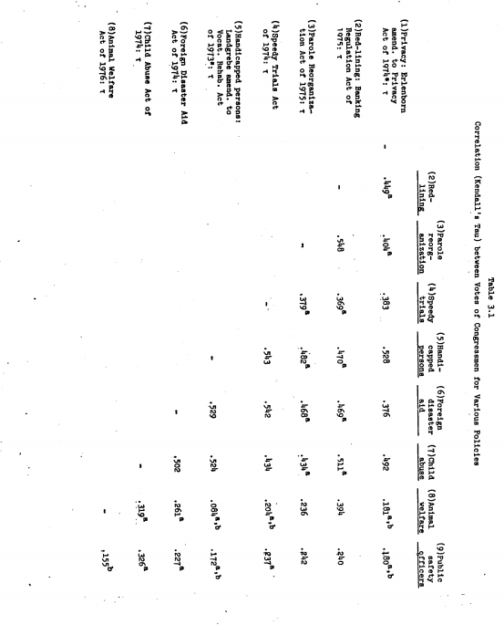

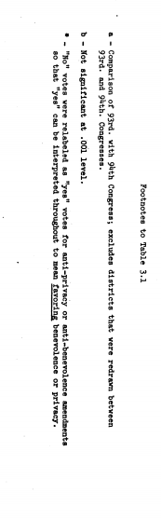

Again, no one has sought to determine the precise class or constit-uency benefits of each of these actions to determine the extent to which altruism was a disguise for self-interest. (Thus, even the pensions for widows of policemen may have been concentrated in a few cities.) gbreover, the Kendall-Tau coefficient is sensitive to the difference in the margins with which different measure are approved, although this has only a moderate effect upon our results.1
Finally, and most crucially, the test of similarity of sup-port should not be compared with Tau-values of zero: perhaps two bills drawn at random have similar degrees of association. To test this latter we have compared the privacy votes with the votes on
"key votes" in the same Congress chosen by Congressional Quarterly.2
The results may be summarized:
Privacy (Brienborn amend., 93rd. Congress)
Average Tau Value, Votes in same Congress (disregarding sign) Benevolent Legislation Key Votes
.445 .439
Anti-redlining (94th. Congress) .394 .541
These results on their face say that the association of the support for privacy laws with that for benevolent legislation is no better than the association of the former with legislation in general! That is too harsh a verdict: key votes will involve unusual party loyalty, and our practice of ignoring signs in averaging the key votes is mildly biased against our hypothesis. Still the hypothesis of an altruistic motive for privacy legislation must be labelled "unproved". Finally, we report in Table 3.2 the votes of congressmen on the class Of benevolent legislation in relation to the income, education, and urbanization of their constituents: (1) The support for these laws is always positively correlated with income, but it is almost without exception vastly better correlated with urbanization.1
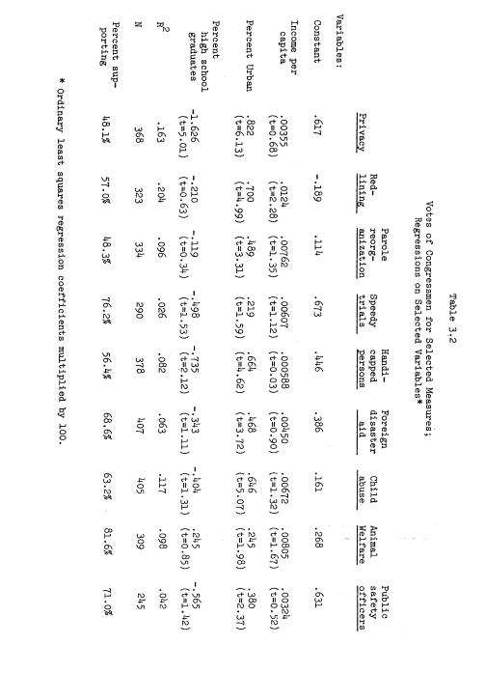
Urbanization clearly dominates income in the equations in Table 3-2. (The correlation between per capita income and urbanization across congressional districts is .669.) (2) The educational level of the population consistently is negatively related to the support for these laws, although the relationship is seldom significant. If we accept this last finding despite its uncertain statistical base, we could interpret it as showing that the better educated constituencies realize that many of these laws are inefficient or conceivably perverse in achieving their announced goals. The support for the privacy lave remains opaque: neither simple (minded?) self-interest nor altruism finds ready support. We have shown that some things are not true, a conclusion which would be more gratifying if most things were true.

