Information Privacy Research: An Interdisciplinary Review

Abstract
To date , many important threads of information privacy research have developed, but these threads have not been woven together into a cohesive fabric. This paper provides an interdisciplinary review of privacy-related research in order to enable a more cohesive treatment. With a sample of 320 privacy articles and 128 books and book sections, we classify previous literature in two ways: (1) using an ethics-based nomenclature of normative, purely descriptive, and empirically descriptive, and (2) based on their level of analysis : individual, group, organizational, and societal.
Based upon our analyses via these two classification approaches, we identify three major areas in which previous research contributions reside : the conceptualization of information privacy, the relationship between information privacy and other constructs, and the contextual nature of these relationships.
As we consider these major areas, we draw three overarching conclusions. First, there are many theoretical developments in the body of normative and purely descriptive studies that have not been addressed in empirical research on privacy. Rigorous studies that either trace processes associated with, or test implied assertions from, these value-laden arguments could add great value. Second, some of the levels of analysis have received less attention in certain contexts than have others in the research to date. Future empirical studies - both positivist and interpretive - could profitably be targeted to these under-researched levels of analysis. Third, positivist empirical studies will add the greatest value if they focus on antecedents to privacy concerns and on actual outcomes. In that light, we recommend that researchers be alert to an overarching macro model that we term APCO (Antecedents Privacy Concerns -> Outcomes).

Keywords: Information privacy, multi-theory, regulation, society, interdisciplinary

Introduction:

Information privacy is of growing concern to multiple stakeholders including business leaders, privacy activists, scholars, government regulators, and individual consumers. Public opinion polls report that privacy is one of the largest concerns for consumers. For instance, a Consumer Reports poll revealed that "72 percent are concerned that their online behaviors were being tracked and profiled by companies" (Consumers-Union 2008).

To a great degree, these consumer worries are grounded in the growing "art of the possible" in the technological realm. The spread of ubiquitous computing and the seemingly unbounded options for collecting, processing, distributing, and using personal information trigger consumer worries. In a recent study analyzing the organizational privacy practices of the top 50 most visited websites, Gomez et al. (2009) found that most of these websites use personal information for customized advertising, and a large number of reputable firms like Google, Y ahoo, Microsoft, and Facebook share their collected customer data with hundreds of their affiliated companies. Along with this use and sharing of data comes an associated risk: in the Ponemon Institute's 2007 survey with a sample of 786 American consumers, it was found that 62 percent of respondents had been notified that their confidential data was lost or stolen and that 84 percent of these consumers expressed increased concern or anxiety due to the data loss.
Against this backdrop, the number of privacy-related research contributions has grown significantly in recent decades. However, Information Systems (IS) researchers who wish to examine topics related to information privacy may well find themselves frustrated with the research domain. Numerous studies - a number of them based on compelling theoretical frameworks and undergirded by sound, rigorous, methodology - have been published over the past few decades. However, the findings and the theories that emerged have often relied on overlapping constructs nestled within loosely bounded nomological networks. This has resulted in a suboptimal cumulative contribution to knowledge. In historical terms, it is now widely recognized that the recent evolution of the concept of privacy in general - and information privacy in particular - follows the evolution of information technology itself, as can be seen in Table 1.
While it is impossible for any discipline to claim ownership of the research concept of privacy in general, we believe that IS scholars' contributions to information privacy have been, and will continue to be, very important in shaping modernized information privacy conceptualization during the "third era”.

In an attempt to assist the IS research community in providing a more cohesive treatment of information privacy issues, we first examine the privacy-related research that has been published to date. We consider the strengths and weaknesses of this research stream, and we then provide guidance regarding future directions for research. We rely on the following assumptions:

- The ultimate target of our review is information (rather than physical) privacy.

- Our target audience consists of IS scholars interested in empirical information privacy research.

- These scholars will be best enlightened by guidelines that are grounded in an interdisciplinary review of prior work.

- It is not our goal to build and propose a comprehensive. broad model of information privacy.

While we will provide some guidelines and outline the difficulties accompanying such an effort. it is well beyond the scope of our research endeavor to create such a meta-theory.

Literature Review

This literature review deals directly with information privacy as opposed to physical privacy. The latter concerns physical access to an individual and/or the individual's surroundings and private space; the former concerns access to individually identifiable personal information. Historically, the concept of physical privacy was explicated first. Later, as it became apparent that information about individuals and groups (especially families and organizational teams) was gathering saliency, information privacy was subsumed under the larger umbrella of general privacy.
In the initial period of this transition, physical privacy con-cepts and definitions were directly and seamlessly applied to information privacy, without reported contradictions. The continuity of the transition from physical privacy to informa-tion privacy allowed scholars to embrace the earlier adopted definitions and to carry them through specific contexts and cases associated with information privacy. More recently. however. nomological models associated with information privacy have been targeted directly to that construct. Thus, in a manner parallel to that of privacy research development, we will apply early privacy concepts to information privacy, and we will also analyze information privacy-specific concepts.

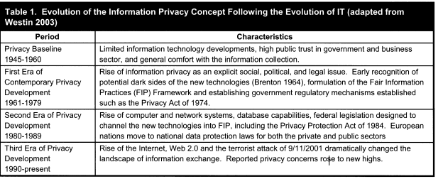

We note that the distinction between physical and information privacy is seldom clarified in public debate or, for that matter, in many areas of research. For example, comments about privacy violations in the public media seldom draw a clear distinction between the constructs of physical and information privacy. Most of the questionnaires embraced in the cited literature ask about privacy rather than information privacy , as do the general surveys of polling agencies. In a related vein, popular terms and names of organizations, such as privacy advocates , Privacy International , World Privacy Forum , etc., are unclear in the distinction. The situation is the same with the legal language and the laws in many countries.

In an attempt to provide as direct a treatment of the concepts as possible, we will follow the following principle throughout the remainder of this paper: we will use the term privacy as a reference to information privacy , which is our immediate focus. We will occasionally refer specifically to physical privacy or to general privacy (which includes both physical and information privacy), and we intend those references to be distinct from those to (information) privacy.

Although general privacy is broadly multidisciplinary in nature, each discipline offers a unique angle and perspective following its own accepted methodologies and discovery processes. Even so, across numerous disciplines, general privacy is often subsumed under the rubric of ethics. Indeed. in most encyclopedias, textbooks, and sociology readings (e.g., Bynum 2008; Pearlson and Saunders 2009), the topic of privacy is often found in the "ethical issues" chapter. As we will see below, general privacy beliefs are integrated in the moral value system of the society, and it is therefore natural that general privacy would be seen as an ethics topic. Con-sistent with this approach, we will classify general privacy studies using an ethics-based nomenclature of normative, purely descriptive, and empirically descriptive (Copp 2007; Singer 1991; Walshalin 1996; Werhane 1994). The word nonnative refers to guidelines or norms, so norma-tive assertions rest upon ethical commitments and behaviors to be prized, preferred, and valued; they arc often called ought statements. Examples of nonnative general ethical theories are Kantian ethics, virtue ethics, and utilitarian ethics. Examples of normative business ethics theories are stock-holder, stakeholder, and social contract (Pearlson and Saunders 2009). In an overarching sense, descriptive studies attempt to explain what is rather than what ought to be. Descriptive studies can be purely descriptive (simple state-ments of fact) or empirically descriptive (tests of theories/ frameworks utilizing positivist, scientific methods).

Published studies can thus be classified as normative , purely descriptive , or empirically descriptive. The normative publications provide an ought argument for how the world should be, according to society's or the author's value system. Many (but not all) normative publications involve some statement of the author's opinion regarding an issue; per Herson (1990), some of these normative opinions may be buttressed by descriptive or empirical statements, but the overall tone of the argument is normative in its nature.
The purely descriptive studies are characterized by descriptions of a state of affairs, with no rigorous attempt to infer causality or to provide a process mapping. Empirically descriptive studies often attempt to provide tests of relationships between constructs or to map processes. For example, a study that tested a nomological model that showed how various psychological constructs such as cynicism and paranoia were associated with privacy concerns would be empirically descriptive.4 Similarly, interpretive process tracing studies would also fall under the rubric of empirically descriptive studies.
In addition to their categorization as normative, purely descriptive, or empirically descriptive, general privacy studies can also be classified based on their level of analysis : individual, group, organizational, and societal (both crossnational and cross-cultural). In reviewing the literature by level of analysis, we follow the review methodologies embraced in previous scholarly work (Clark et al. 2007; Leidner and Kayworth 2006). Almost all empirical research associated with privacy has attempted to address one or more of these levels of analysis, but it will be seen that very little attention has been paid to group-level analysis.
Appendix A describes the methodology used to identify general privacy publications. Tables В 1 , B2, and B3 provide summaries of the purely descriptive works, normative works, and empirically descriptive studies, respectively. Our analysis reveals that the works addressed to privacy have almost all been associated, in one way or another, with attempts to answer one of three major questions.
(I) What is (and is nor) privacy? There is no single concept of privacy that crosses all disciplines and that is embraced by all observers. There are ongoing debates regarding the distinction, if any, between privacy and related constructs such as security.

(2) What is the relationship between privacy and other constructs? There are competing research assumptions and paradigms associated with empirical research into various nomological models that include privacy.

(3) To what extent does context matter in the relationships between privacy and other constructs? There is disagreement regarding the extent to which these rela-tionships can be generalized across contexts, such as types of information. different industries. and new tech-nological applications.
In the following sections. we discuss each of these major questions and provide a summary of the attempts to grapple with them. At the end of each section, we reflect on the work associated with that question. We summarize our reflections in our "Future Research and Conclusion" section.

Question #1: What Is (and Is Not) Privacy?

General privacy as a philosophical, psychological, socio-logical, and legal concept has been researched for more than 100 years in almost all spheres of the social sciences. And yet, it is widely recognized that, as a concept, privacy "is in disarray [and *body can articulate what it means" (Solove 2006, p. 477). Numerous attempts have been made by social and legal scholars to bring together the different perspectives found in different fields. However, the picture that emerges is fragmented with concepts, definitions, and relationships that are inconsistent and neither fully developed nor empi-rically validated.
Figure I and Table B4 summarize the approaches to defining general privacy that can be found in various disciplines (cor-responding to numbers of articles found in each discipline). The definitional approaches can be broadly classified as either value-based or cognate-based. The value-based definition views general privacy as a human right integral to society's moral value system. Historically, this was the first definition of general privacy. Subsequent works defined the boundaries between public and private. The evolution of IT complicated the debate about the boundaries - a process seen by some scholars as pervasive dissolution of the boundary (Marx 200 1 ; Rosen 2000) and by others as lack of rigor in defining these boundaries in the first place (Nissenbaum 1998).

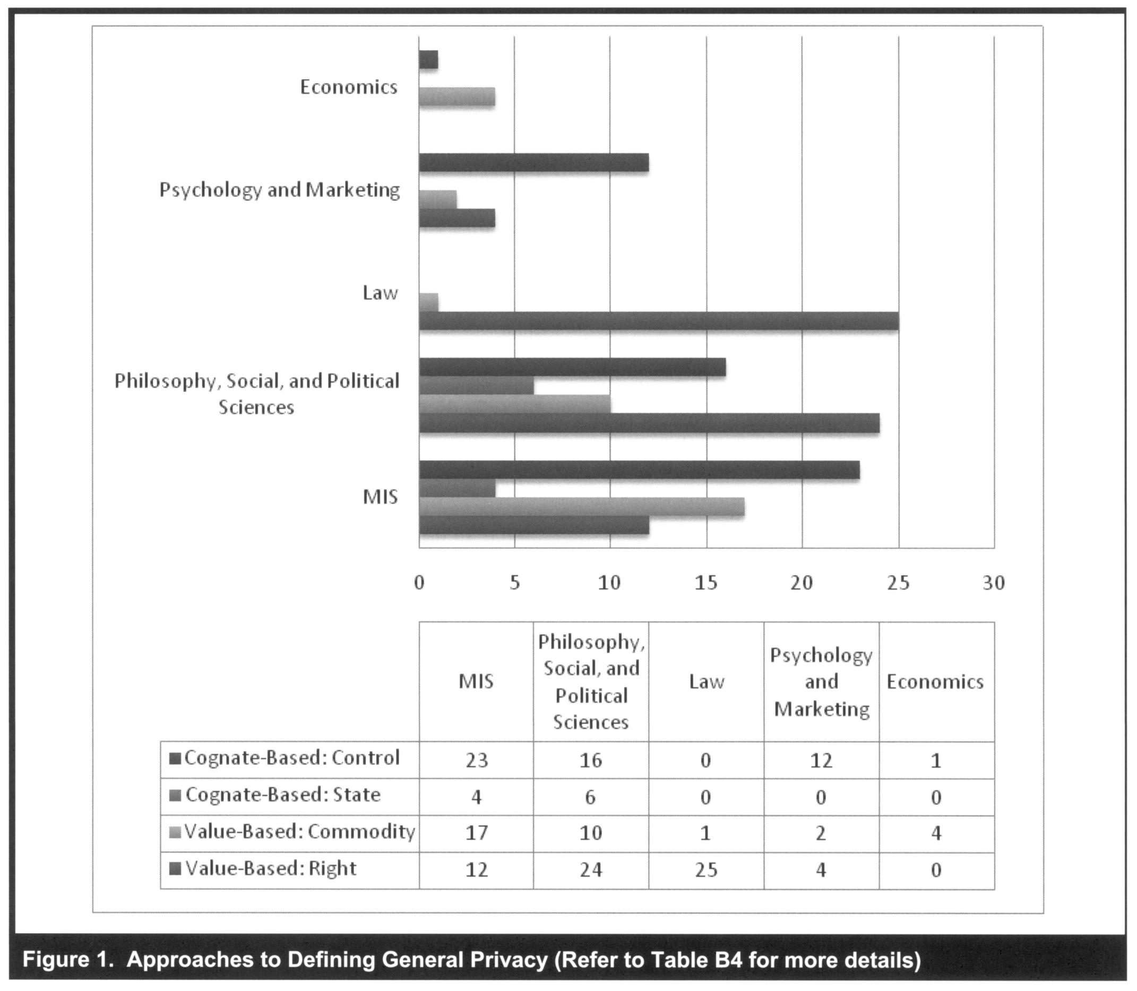
Furthermore, when the general privacy as right concept was applied to consumer behavior, a privacy paradox was noted: despite reported high privacy concerns, consumers still readily submit their personal information in a number of circumstances. Thus, the notion of privacy as a commodity was conceptualized (Bennett 1995). Under the commodity view, privacy is still an individual and societal value, but it is not absolute, as it can be assigned an economic value and be considered in a cost-benefit calculation at both individual and societal levels.
In his attempt to supply a more rigorous definition that can be used in empirical research, Westin (1967) introduced the notion of' state in the general privacy concept: -voluntary and temporary withdrawal of a person from the general society" (p. 7). Psychologists and cognitive scientists then became interested in producing a cognate-based conceptualization of general privacy-related to the individual's mind, perceptions, and cognition rather than to an absolute moral value or norm. Since the state of withdrawal rests within the physical or information space, scholars argued that general privacy was about control of physical space and information. We now discuss the major definitional streams from each category in more detail.

Value-Based Definitions
General Privacy as a Right

There is a substantive debate regarding general privacy's status as a human right: If such a right exists, how did it emerge? How is it justified philosophically (Schoeman 1984)? Who is responsible for protecting it (Milberg et al (2000)? This view of general privacy is fundamentally normative, and some scholars (e.g., Posner 1984) claim that it may be at odds with the legal and societal frameworks of various cultures and thus cannot be treated absolutely. The evolution of this debate is obvious when one considers the roots of general privacy as a right in legal and political theories. For example, in the United States, common law did not recognize any right to general privacy, general privacy is not spelled out in the U.S. Constitution, and the courts did not consider general privacy as a protected right until the 20thCentury. Although divergent from the traditional British perspective (Richards and Solove 2007), general privacy has generally been viewed as a developing right in U.S. law, with the U.S. derivation usually traced to Warren and Brandéis' s ( 1890) article in Harvard Law Review, in which they defined general privacy as "the right to be left alone."
This "general privacy as a right" perspective has since influenced numerous opinions and has been given constitutional sanction by the U.S. Supreme Court (Breckenridge 1970). Common themes of relevant court cases include general privacy and law enforcement (searches and seizures); general privacy and self (abortions and embryos); privacy and the press (private facts exposure, celebrity culture, intrusion); privacy and the voyeur (sex tapes, peephole); and privacy in the workplace (psychological testing, lifestyle monitoring) (Alderman and Kennedy 1997)

Two major issues arose with these court cases: I) the 'teed to define general privacy more specifically than the "right to be left alone" and (2) the state as the protector of general privacy. These two issues made the general privacy debate among legal and political scholars necessarily and unavoidably ideological. Regarding the first issue, courts have stopped seeking a definition of general privacy following the Younger Committee Report (1972), which concluded that general privacy could not be satisfactorily defined.

"Regarding the second issue, two major camps of scholars argue about the role of the state in protecting individual general privacy and thus argue for or against the need for regulation of general privacy. The rallying point in the “for” argument among political theorists is the role of the state as the guarantor of individual general privacy (Rosen 2000). Ironically, the same principles of liberalism that undergird this argument also serve as the rallying point of the "against" libertarian Camp of privacy protection. The against camp points to the market-based economic perspective of privacy. According to this view (to which we now turn), privacy is inherently an economic commodity and should be treated as such.

Privacy as a Commodity

Some libertarian political scientists argue that a call for greater privacy is, fundamentally antagonistic to the political economy of the information market (Bennett 1995; Cohen 2001). In their view, privacy is not an absolute right but is subject to the economic principles of cost-benefit analysis and trade-off. From this observation, a stream of treatment from the privacy as commodity perspective has arisen (Campbell and Carlson 2002; Davies 1997).
To explain the phenomenon of voluntarily providing information online (so called self-surveillance) social scientists recognize the economic component of privacy: individuals cooperate in the Online gathering of data about themselves as economic subjects. This participation in surveillance is possible because of recent reconceptualization of privacy in the consumer's mind from a right or civil liberty to a commodity that can be exchanged for perceived benefits (Campbell and Carlson 2002; Davies 1997; Garfinkel 2000).

Since libertarians have always treated privacy as a commodity, the salient question revolves around the extent to which the above observed commodification of privacy is a measurable result of a real individual shift and not a paradigm of scholarly shift. For example, Laudon (1996) has argued that the current crisis in the privacy of personal information is a result of market failure and calls for market correction through information technologies with privacy-enhancing mechanisms.

The distinction between privacy as a right and a commodity, although obviously undergirded by normative, value-laden assumptions, becomes important in empirical research. As will be seen in a later section in which we discuss the relationship between privacy and other constructs, many researchers unconsciously embrace one definition or the other without noting the value-laden assumptions.

Cognate-Based Definitions

General Privacy as a State

The general privacy as a state concept was introduced by Westin (1967), who defined privacy through four distinct substates: anonymity, solitude, reserve, and intimacy. Later, Schoeman (1984, p. 3) defined general privacy as "a state of limited access to a person." Weinstein ( 1971 , p. 626) defined general privacy as a state of "being apart from others." He drew a parallel between general privacy and alienation, loneliness, ostracism, and isolation and noted that, among those, only general privacy is sought after whereas the others are avoided by individuals and are regarded by society as punitive. Further, Laufer and Wolfe (1977) conceptualized general privacy as a situational concept (state) tied to concrete situations with three dimensions: self-ego, environmental, and interpersonal. Information systems, economics, and marketing scholars narrowed these definitions of general privacy so that they addressed information-based issues (see Table B4). The state of limited access was translated to state of limited access to information.

When privacy is viewed as a state, it is natural for researchers to consider it in terms of its role as a sought-after goal (i.e., an individual's desire to exist in a state of privacy). The implication is that there must be a continuum of states of privacy, from absolute to minimal.

General Privacy as Control

The concept of general privacy as control originated in Westin's (1967) and Altman's (1975) theories of general privacy. Altman's definition of general privacy is "the selective control of access to the self' (p. 24). Margulis (1977a, 1977b) unified and elaborated on Westin's and Altman's perspectives and proposed a control-centered general privacy definition: "Privacy, as a whole or in part, represents the control of transactions between person(s) and other(s), the ultimate aim of which is to enhance autonomy and/or to minimize vulnerability" (1977a, p. 10). The control-based definition has since entered the mainstream of privacy research - likely because it lends itself more readily to the attributes of information privacy - and has been further developed in the fields of information systems and marketing (Altman 1975; Culnan 1993; Kelvin 1973; Margulis 1977a; Smith et al. 1996; Westin 1967). It is worth noting that the original definition equates privacy with control, per se, while most evolving definitions equate privacy with ability to control.

More frequently than not, the element of control is embedded in most conceptual arguments and definitions of privacy and has been used to operationalize privacy in numerous measurement instruments (Altman 1975; Culnan 1993; Kelvin 1973; Margulis 1977a; Smith et al. 1996; Westin 1967).
Scholars have linked the concept of general privacy with control by either defining general privacy as control, per se, or by positioning control as a key factor shaping privacy. Johnson (1974), for instance, defined general privacy as "secondary control in the service of need-satisfying outcome effectance" (p. 91).

However, many researchers from several disciplines, including information systems, reason that control is actually one of the factors that shape general privacy and that general privacy is not control per se (Laufer and Wolfe 1977; Margulis 2003a, 2003b). For instance, Laufer and Wolfe (1977) conceptualized control as a mediating variable in the general privacy system by arguing that "a situation is not necessarily a [general] privacy situation simply because the individual perceives, experiences, or exercises control" (p. 26). Conversely, the individual may not perceive (s)he has control, yet the environmental and interpersonal elements may create perceptions of general privacy (Laufer and Wolfe 1977). As Margulis (2003a, 2003b) pointed out, there have been very few theoretical attempts to clarify the nature of control and to explicate this control: privacy contention in the privacy literature (exceptions are Dinev and Hart 2004; Johnson 1974; Xu 2007).

What Privacy Is Not

Privacy has been described as multidimensional, elastic, and dynamic in the sense that it varies with life experience (Altman 1977; Laufer and Wolfe 1977). Overlapping concepts such as confidentiality, secrecy, anonymity, security, and ethics have added to the confusion (Margulis 2003a, 2003b). Therefore, Question #1 also asks what privacy is not.
Although there is confusion regarding the boundaries around the construct, much of the murkiness can be stripped away by a careful consideration of the distinctions.

Anonymity : Anonymity is the ability to conceal a person's identity (Camp 1999; Marx 1999; Qian and Scott 2007; Rensel et al. 2006; Zwick and Dholakia 2004), which is central for the information collected for statistical purposes. In the IT context, anonymity is often shaped by the features of privacy-enhancing technologies. For example, anonymizers allow an individual to browse Web sites with a high degree of anonymity, as cookies cannot be placed on the user's browser and the IP addresses cannot be tracked (Waldo et al. 2007). Anonymity is not dichotomous, in that it varies in degrees (Kobsa and Schreck 2003 ; Nissenbaum 1 999; Qian and Scott 2007): individuals can choose to be totally anonymous, pseudonymous, or identifiable.
There has been much discussion as to what role anonymity plays in privacy. Although these two concepts interrelate, anonymity is not privacy (Camp 1999). Anonymity exists when someone is acting in a way that limits the availability of
identifiers to others. Since the information cannot be correlated back to the individual, this may enable privacy control. However, many other avenues to such control also exist.

Secrecy : Secrecy has been defined as intentional concealment of information (Bok 1989; Tefft 1980), and it usually expresses a disposition toward the sharing of potentially inaccurate information (Zwick and Dholakia 2004). Secretive withholding of personal information is then regarded as an attempt to block any digital representation from emerging in the network. Although secrecy is easily distinguishable from privacy (Hirshleifer 1980), they are often mistaken and confused with each other (McLean 1995). "Privacy need not hide; and secrecy hides far more than what is private" (Bok 1989, p. 11). Warren and Laslett (1977) also reflect on the conceptual comparison between privacy and secrecy. According to them, secrecy implies the concealment of something that is negatively valued by the excluded audience; privacy, by contrast, protects behavior which is either morally neutral or valued by society. Secrecy enables individuals to manipulate and control environments by denying outsiders vital information about themselves (Tefft 1980).

Confidentiality : Richards and Solove (2007) suggest that while the American derivation of general privacy is grounded in one's inviolate personality (focus on individualism), British law instead embraces a conception of privacy as confidentiality. With the advent of extensive information exchange, confidentiality concerns the externalization of restricted but accurate information to a specific entity (Zwick and Dholakia 2004). The distinction between privacy and confidentiality is well discussed in the literature (Camp 1999; Rindfleisch 1997). Privacy corresponds to the desire of a person to control the disclosure of personal information; confidentiality corresponds to the controlled release of personal information to an information custodian under an agreement that limits the extent and conditions under which that information may be used or released further.
Building on Zwick and Dholakia' s (2004) conceptualization of identity management, we can differentiate anonymity, secrecy, and confidentiality based on the externalization of personal information. Figure 2 illustrates how the various constructs are related based on the digital representation of an individual, which is determined by the amount and accuracy of the personal information collected. Of course, none of the constructs in Figure 2 is equivalent to privacy itself.

Security : The perceptions or concerns of security by users of electronic systems has been addressed in IS research (Benson
1983; Goodhue and Straub 1991; White and Christy 1987) but, as has been pointed out by Belanger et al. (2002), there is a lack of understanding of how privacy and security issues are related. Security corresponds to the concerns about the protection of personal information with three specific goals (Belanger et al. 2002; Camp 1999; Chellappa2008): integrity that assures information is not altered during transit and storage; authentication that addresses the verification of a user's identity and eligibility to data access; and confidentiality that requires data use is confined to authorized purposes by authorized people. As Culnan and Williams (2009) argue, organizations can successfully secure the stored personal information but still make bad decisions about the subsequent use of personal information, resulting in information privacy problems. Therefore, as Ackerman (2004) suggested, "security is necessary for privacy, but security is not sufficient to safeguard against subsequent use, to minimize the risk of. . .disclosure, or to reassure users" (p. 432).

Ethics : As mentioned above, general privacy has consistently been viewed as an ethical issue across various disciplines. While there are ethical dimensions associated with general privacy (Ashworth and Free 2006; Caudill and Murphy 2000; Culnan and Williams 2009; Foxman and Kilcoyne 1993), general privacy is not equivalent to ethics. General privacy has been examined in the literature from a number of ethical theoretical perspectives including social contract theory, duty-based theory, stakeholder theory, virtue ethics theory, and the power-responsibility equilibrium model (for a review, see Caudill and Murphy 2000). Even though philosophical argumentation may imply some normative ethical obligations to protect or to acknowledge privacy, it is incorrect to equate privacy with ethics. In fact, one can easily engage in empirical privacy-related research without ever considering ethical aspects of the construct.
In that light, having now considered what privacy is (and is not), we turn to a consideration of its empirical treatment across various disciplines.

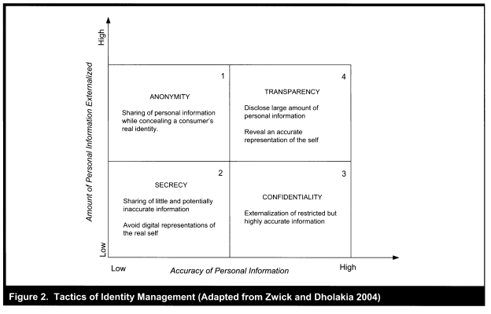

Question #2: What Is the Relationship Between Privacy and Other Constructs?
The relationship between privacy and other constructs has been examined by a number of empirically descriptive (and primarily positivist) studies that cut across several disciplines such as marketing, IS, and organizational behavior (see Figure 3).

We first examine the central construct in this figure ("Privacy Concerns"); we then consider the antecedents (on the left). and we then focus on the outcomes and associated relationships (on the right). We refer to this macro model as "Antecedents => Privacy Concerns => Outcomes" (APCO).

Privacy Concerns as a Measurable Proxy for Privacy

Because of the near impossibility of measuring privacy itself, and also because the salient relationships depend more on cognitions and perceptions than on rational assessments, almost all empirical privacy research in the social sciences relies on measurement of a privacy-related proxy of some sort. Although the proxies sometimes travel with monikers such as beliefs, attitudes, and perceptions, over time, espe-cially within IS research, there has been a movement toward the measurement of privacy concerns as the central construct. Several studies have operationalized privacy concerns in detail: The concern for information privacy (CFIP) scale was developed by Smith et al. (1996), who identified four data-related dimensions of privacy concerns (collection. errors, secondary use, and unauthorized access to information). These dimensions were later revalidated by Stewart and Segars (2002). These dimensions have since served as some of the most reliable scales for measuring individuals' con-cerns toward organizational privacy practices. More recently, Malhotra et al. (2004) operationalized a multidimensional scale of Internet users' information privacy concerns (IUIPC)„ which adapted the CFIP into the Internet context.
It should be noted that these privacy concerns are almost always measured at an individual level of analysis, so most of the research on the left side of Figure 3 has an individual unit as its dependent variable (DV). However, not all of the independent variables (IVs) are measured at the individual level, as some (e.g., culture/climate) are at the organizational or national level.

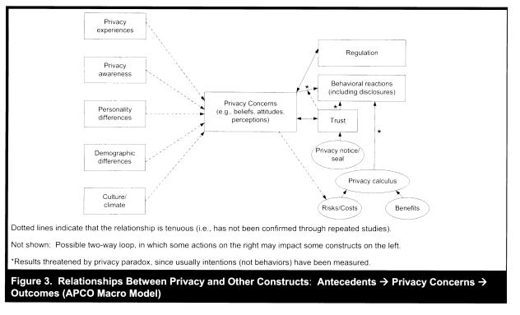

Privacy Concerns as Dependent Variable (DV)

Although relationships between a number of antecedents and privacy concerns have been investigated, these studies have usually been conducted in a somewhat disjointed manner and with only minimal replication. A smaller body of research has systematically emerged on the left-hand side of Figure 3. Drawing on information boundary theory, Xu et al. (2008) developed an integrative model suggesting that privacy concerns form because of an individual's personal characteristics or situational cues that enable one person to assess the consequences of information disclosure.
With respect to privacy experiences, Smith et al. (1996) found that individuals who have been exposed to or been the victim of personal information abuses should have stronger concerns regarding information privacy. Privacy awareness reflects the extent to which an individual is informed about organizational privacy practices (Malhotra et al. 2004; Phelps et al. 2000). Research suggests that consumers' privacy concerns arc triggered when consumers become aware that organizations have collected and/or used their personal information without their permission (Cespedes and Smith 1993). Consumers who are unaware of name removal procedures tend to be less likely to be concerned about privacy than consumers who are aware of name removal procedures (Culnan 1995). It has been found that consumers tend to be less concerned about their privacy when firms seek permission to collect and use their information (Nowak and Phelps 1995).
Personality differences such as introversion versus extroversion (Lu et al. 2004), independent-self versus interdependent-self (Xu 2007), and "big-five" personality traits' (Bansal et al. 2010) have been found to affect individual privacy concerns. Dinev and Hart (2006) found that social awareness is a predictor of privacy concerns. Individuals with high social awareness are aware of privacy policies and follow privacy issue developments. Various studies have also investigated how demographic differences affect the degree of stated privacy concerns (C 2004; Culnan and Armstrong 1999; Sheehan 1999; Sheehan and Hoy 2000).
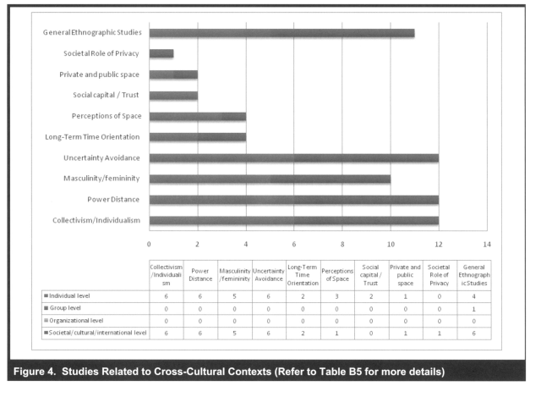

For example, woman have been found to be more concerned about the impact of information collection on their privacy (Sheehan 1999). Also, it was found that those consumers who were less likely to be concerned about privacy were more likely to be young, poor, less educated and African American (Culnan 1995).

Cross-cultural antecedents have also been considered as independent variables (see Figure 4 and Table B), most often at the individual and the societal levels. For example, Dinev et al (2006a, 2006b) showed that Italian society has a different concept of privacy that leads to lower privacy concerns but also to higher perceived risk. These differences inform weaker relationships between institutional trust and ecommerce use, privacy concerns and e-commerce use, and perceived risk and institutional trust, and a stronger relationship between perceived risk and privacy concerns.

Privacy Concerns as Independent Variable (IV)

In contrast to the limited empirical attention that has been focused on relationships between antecedents and privacy concerns, a larger body of research has emerged on the right-hand side of APCO model in Figure 3: that is, consideration of privacy concerns as an IV in which other outcomes arc viewed as the DVs.

Behavioral reactions. The most prominent DVs are those associated with behavioral reactions to privacy concerns, with the most visible reactions being individual? willingness to disclose information and/or to engage in commerce. Some researchers have viewed trust as a mediating variable between privacy concerns and disclosure itself (Metzger 2004; Xu et al. 2005), but in many other studies trust has been shown to be antecedent to privacy (e.g.. Belanger et al. 2002), outcome of privacy (e.g., Bansal et al. 2010; Chellappa 2008; Malhotra et al. 2004), or a moderator/mitigator (e.g., Bansal et al. 2008) of the influence of privacy concerns on individual behavioral reactions. In one study of 477 U.S. households, researchers found that privacy concerns had a significant impact on online purchase intent, with the greatest negative impact being through its relationship with trust (Eastlick et al. 2006). Firms that are positioned as "safer" or "trustworthy" on the privacy dimension will likely have a competitive advantage (Bowie and Jamal 2006). It has been found that consumers who trust the firm are less concerned about their privacy and more willing to provide personal information (Schoenbachler and Gordon 2002). In a study examining the efficacy of improving trust and reducing concern on managing consumer information, Milne and Boza (1999) showed that building trust is more effective than trying to reduce consumer concern.
Research has found that firms can build trust, and thus mitigate privacy fears, by exhibiting procedural justice through the implementation of fair information practices (Culnan and Armstrong 1999; Xu et al. 2010), explicit communication of a privacy policy (Andrade et al. 2002; Eastlick et al. 2006; Milne and Boza 1999), adoption of РЗР in their privacy policy development (Xu et al. 2005), and/or display of privacy notices and/or seals of approval (LaRose and Rifon 2006; Wang et al. 2004). The presence of privacy seals has been found to have a positive effect on the perception of trust in a website (Rifon et al. 2005) and resulted in more favorable perceptions toward the privacy statement (Miyazaki and Krishnamurthy 2002).

Privacy paradox. Recent surveys, anecdotal evidence, and experiments have highlighted the privacy paradox: individuals state privacy concerns but behave in ways that seemingly contradict their statements (Acquisti 2004; Acquisti and Grossklags 2005a; Jensen et al. 2005; Norberg et al. 2007). For example, Sheehan and Hoy (1999) found that stated privacy concern correlates negatively with the reported frequency of registering with websites in the past and positively with providing incomplete information during registration. Norberg et al. (2007) found that, for all information categories (personally identifying, financial, preferences demographic, etc.), the level of actual disclosure exceeded individuals' intentions to disclose information.
A plausible explanation provided by Acquisti' s work for such a privacy attitude/behavior dichotomy is that users' privacy decision processes are affected by bounded rationality (Acquisti 2004; Acquisti and Grossklags 2005b). The economics literature suggests that individuals have a tendency to discount "hyperbolically" future costs or benefits (O'Donoghue and Rabin 2001; Rabin and O'Donoghue 2000). Such hyperbolic discounting implies inconsistency of personal preference over time: future events may be discounted at different discount rates than near-term events
(Acquisti 2004); the benefits of disclosing personal information may be immediate (e.g., convenience of placing orders online), but the risk of such information disclosure may be invisible or spread over time (e.g., identity theft).

Although Figure 3 includes the construct "behavioral reactions" on its right-hand side, in reality it is quite common for researchers to measure stated intentions instead of actual behaviors, inferring through references to the Theory of Reasoned Action (TRA) (Fishbein and Ajzen 1975), that behaviors will match actual intentions. To the extent that the privacy paradox holds, however, this appeal to TRA may be misguided. In fact, associations between privacy concerns and stated intentions may not be reflective of actual behaviors. We have noted this exposure in Figure 3 with asterisks.

Regulation. In addition to behavioral reactions associated with disclosure and commerce, Milberg et al. (2000) suggest that if consumers do not perceive firms as adequately protecting their privacy, they will distrust self-regulation and prefer state intervention, which can eventually lead to a regulatory response. A limited stream of research (see, especially, Jentzsch 2001; Smith 2001) has investigated the dissonance between U.S. and European privacy laws, which is related to the conflict between viewing privacy as a right versus a commodity. Jentzsch (2001) has noted that Europe assigns more property rights to consumers than does the United States, and financial privacy is more strictly regulated in Europe than in the U.S., although the U.S. seems to be converging more on the European model.

At the societal level, several studies pointed out that human rights societies long approached privacy in an omnibus fashion by passing sweeping privacy bills that address all the instances of data collection, use, and sharing (Bennett and Raab 1997; Dholakia and Zwick 2001; Smith 2001). Some examples of countries in this category include Australia, Canada, New Zealand, and countries in the European Union (Smith 2004). Assigning fundamental rights to personal information would result largely in an opt-in market for information sharing, whereby firms would have access to the information only of those consumers who chose to make it available (Smith 2001). In contrast, in commodity societies, there are no omnibus laws governing collection, use, and sharing of personal information that transcend all types of data in all sectors of the economy (Smith 2001).
Some countries in this category have a patchwork of sector-specific privacy laws that apply to certain forms of data or specific industry sectors (Bennett and Raab 1 997; Dholakia and Zwick 2001; Smith 2001). For instance, in the United States, there are sector-specific laws for specific types of records such as credit reports and video rental records and for classes of sensitive information such as health information (Smith 2004). The commodity societies largely see opt-in as an undue burden.
The debate between the right and commodity views of privacy highlights another controversial issue in the privacy literature: the relative effectiveness of industry self-regulation versus government legislation in ensuring consumer privacy. Skepticism about the effectiveness of industry self-regulation in protecting consumer privacy (Edelman 201 1 ; Hui et al. 2007) has resulted in privacy advocates and consumers clamoring for strong and effective legislation to curtail rampant abuses of information by firms. At the societal level, Tang et al. (2008) indicate that although overarching government regulations can enhance consumer trust, regulation may not be socially optimal in all environments because of lower profit margins for firms and higher prices for consumers. Bellman et al. (2004) found that participants from countries with omnibus privacy regulation had greater desire for more regulation than participants from countries with sectoral regulation, while participants from countries with sectoral privacy regulation had less desire for more regulation than participants from countries with no privacy regulation.

Privacy Calculus

A subset of empirical studies - often somewhat disconnected from the other constructs within Figure 3 - addresses the
concept of privacy calculus by assuming that a consequentialist tradeoff of costs and benefits is salient in determining an individual's behavioral reactions. This perspective is found in various works (e.g., Klopfer and Rubenstein 1977; Laufer and Wolfe 1977; Posner 1981; Stone and Stone 1990) that view the concept of privacy as not absolute but, rather, subject to interpretation in "economic terms" (Klopfer and Rubenstein 1 977, p. 64). Such a calculus perspective of privacy suggests that, when requested to provide personal information to corporations, consumers would perform a risk-benefit analysis to assess the outcomes they would face in return for the information, and respond accordingly (Chellappa and Sin 2005; Culnan 1993; Dinev and Hart 2006; Hann et al. 2008; Hui et al. 2006; Milne and Gordon 1993; Milne and Rohm 2000; Xu et al. 2010). We consider these risks and benefits.
Privacy risk has been defined as the degree to which an individual believes that a high potential for loss is associated with the release of personal information to a firm (Featherman and Pavlou 2003; Malhotra et al. 2004). In the privacy literature, although privacy concerns have often been treated as a multidimensional construct (Malhotra et al. 2004; Smith et al. 1996), privacy risk has been treated as a single-dimensional construct that measures potential loss of control over personal information (e.g., Dinev and Hart 2006). Prior privacy literature has identified sources of organizational opportunistic behavior, including insider disclosure or unauthorized access and theft (Rindfleisch 1997), and selling personal data to, or sharing information with, third parties, financial institutions (Budnitz 1998), or government agencies (Preston 2004; Wald 2004). An individual's calculation of risk involves an assessment of the likelihood of negative consequences as well as the perceived severity of those consequences (Peter and Tarpey 1975). The negative perceptions related to risk may affect an individual emotionally, materially, and physically (Moon 2000). A number of e-commerce studies empirically verified the negative effect of perceived risk on intentions to conduct transactions (Budnitz 1998; Jarvenpaa and Leidner 1999; Jarvenpaa and Tiller 1 999; Jarvenpaa et al. 2000; Norberg and Home 2007; Norberg et al. 2007; Pavlou 2003; Pavlou and Gefen 2004). Additionally, previous studies generally supported the positive impacts of privacy risk on privacy concerns (Dinev et al. 2006b; Dinev and Hart 2004), and the negative impacts of privacy risk on intention to disclose personal information (Malhotra et al. 2004; Xu et al. 2005).

Privacy benefit. Following the notion of privacy calculus, "individuals are assumed to behave in ways that they believe will result in the most favorable net level of outcomes" (Stone and Stone 1990, p. 363). Scholars have identified three major components of benefits of information disclosure including financial rewards, personalization, and social adjustment benefits. Recent privacy studies provide empirical evidence that compensating consumers through financial rewards can foster their information disclosure (Caudill and Murphy 2000; Hann et al. 2008; Phelps et al. 2000; Xu et al. 2010). In terms of the value of personalization, Chellappa and Sin (2005) found that it can override privacy concerns: "the consumers' value for personalization is almost two times... more influential than the consumers' concerns for privacy in determining usage of personalization services" (p. 197). A study by White (2004) also confirmed that users are more likely to provide personal information when they receive personalization benefits. A study by Lu et al. (2004) demonstrated that social adjustment benefits (defined as the establishment of social identity by integrating into desired social groups) can also have an effect on intended disclosure behavior.

Looking Across the Empirical Research

In looking across the empirically descriptive (and primarily positivist) privacy research to date, it can be observed that the unit of analysis varies little within these studies; in particular, most studies from the privacy as a commodity perspective (including privacy calculus and privacy paradox) have considered only the individual unit of analysis (with Dinev et al. (2006b) an exception that addressed the societal level of analysis). No studies have considered the group level of analysis, and only a very few (represented in the sample by Walczuch and Steeghs 2001) have addressed the organizational unit of analysis in the context of these perspectives.

It will also be recalled, from our earlier discussion of Figure 3, that research attention to the overall antecedents privacy concerns outcomes (APCO) rubric has been distributed non-uniformly. In particular, almost all of the research focus has been associated with the linkage between privacy concerns and outcomes (usually at the organizational or societal level), with very little attention having been paid to the linkage between antecedents and privacy concerns (and what has been attempted has usually been at the individual level of analysis). Further, the theoretical and empirical connections between the APCO rubric and the privacy calculus stream are rather muted, which causes frustration for observers who wish to view all of the research findings in a cohesive framework.
It is rather clear, then, that the empirical research stream has to date been somewhat constrained. And, as will be seen as we consider Question #3, the picture is even further muddied when we consider the matter of context.

Question #3: To What Extent Does Context Matter in the Relationships between Privacy and Other Constructs?

Contextual Nature of Privacy

In our examination of Question #2, we proceeded as though privacy was a construct that could be considered as a singular entity. Yet, many legal and social scholars (Altman 1975, 1977; Hirshleifer 1980; Laufer and Wolfe 1977; Ledereretal. 2004; Malhotra et al. 2004; Margulis 1977a, 2003a; Solove 2004, 2006, 2008; Waldo et al. 2007; Westin 1967, 2001, 2003) believe that general privacy - its conceptual understanding, rigorous definition, and the intensity of the individual and cultural beliefs it informs - is so dependent on the specific context that it is impossible to develop a one-sizefits-all conceptualization of general privacy. Scholars have tended to conclude that it can mean different things to different individuals and, hence, the roots and consequences of its violation are also contextual (Bennett 1992).
Acquisti (2004) holds that privacy should be regarded more as a class of multifaceted interests than as a single, unambiguous concept, and its value may be discussed only once its context has also been specified. Recently, Bansal et al. (2008) provided a review of the general definitions and meaning of context. Context has been defined as "stimuli and phenomena that surround and, thus, exist in the environment external to the individual, most often at a different level of analysis" (Mowday and Sutton 1993, p. 198). Context could be related to the type or domain of the research construct (discipline), time (when), location (where), occupation (who), culture (with whom), and rationale (why) (Bansal et al. 2008). For example, the industry to which an organization belongs can be viewed as a contextual variable; longitudinal studies can be viewed as contextual studies with time as the
contextual variable (when); comparisons of behavior and beliefs across occupation, gender, race, income, culture, etc. can be viewed as contextual studies, demographic being the contextual variables (who); comparing privacy concerns across different types of information or web sites with different levels of information exchange renders the "type of information" or "information sensitivity" (Malhotra et al. 2004) as contextual variables (see also Bansal et al. 2008).

Individuals are continually engaging in an adjustment process in which desires for privacy are weighed against desires for disclosure and personal communication with others (Kimmel 1996; Sheehan 2002). The adjustment occurs in the context of various situational forces, such as pressures from others, societal and political norms and processes of surveillance used to enforce them (Kimmel 1 996). Privacy either depends on or derives from the nature of its threats (Regan 1995; Sheehan 2002). Indeed, context has been found to moderate (Bellman et al. 2004; Dinev et al. 2006a, 2006b; Milberg et al. 1995; Smith et al. 1996) or to directly influence (Malhotra et al. 2004) the nature and extent of privacy-related relationships (see also Pedersen 1997, 1999).

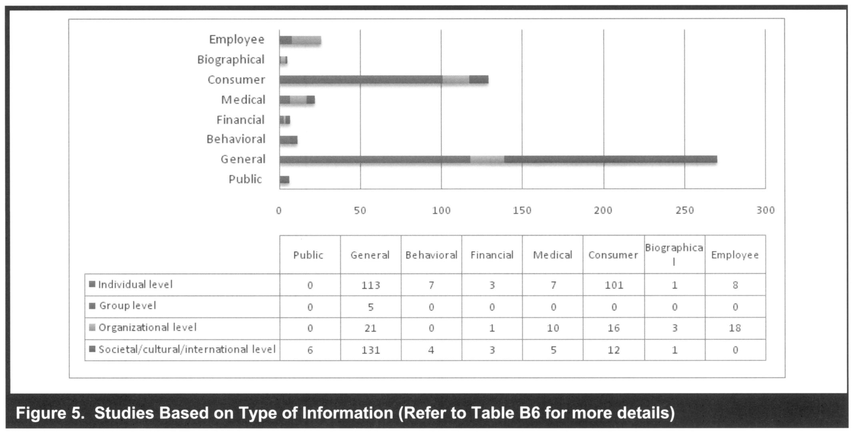

In our analysis of the privacy research, we found that the most often cited contexts for privacy and privacy-related beliefs are (1) the type of information collected from individuals (e.g., behavioral, financial, medical, biometrie, consumer, biographical); (2) the use of information by sector (e.g., healthcare, marketing, and finance); (3) political context (e.g. law enforcement, constitutional rights of self, government, pubic data and media); and (4) technological applications.
The first context, the types of information collected, is sometimes referred to as contextual sensitivity or information sensitivity (Malhotra et al. 2004): consumers' beliefs and behavioral responses to privacy threats depend on the type of information requested (Dinev and Hart 2007; Milne and Gordon 1993; Phelps et al. 2000; Sheehan and Hoy 2000). In general, information about lifestyle characteristics and shopping habits and preferences are considered less sensitive than medical and financial information (Nowak and Phelps 1992; Phelps et al. 2000; Sheehan and Hoy 2000). Malhotra et al. (2004) found a statistically significant direct effect of information sensitivity on trusting beliefs, risk beliefs, and behavioral intention. Xu et al. (2008) confirmed that privacyrelated relationships do vary across types of web sites (ecommerce, social networking, financial, and healthcare), reflecting the information sensitivity context. Figure 5 and Table B6 summarize the studies based on the type of
information collected, sorted by different levels of analysis. (Studies that do not consider a specific type of information often simply refer to phrases such as "information that most individuals would categorize as private." These studies are noted in the "general" category in Figure 5 and Table B6.)
The second context, industry sector, is considered in Table B7. For example, there are many IS studies that explore privacy in e-commerce, marketing, and healthcare. The third context, the political context of general privacy, is especially evident in the U.S. and European legal framework and constitutions. Many legal and social scholars view general privacy as a value that must be balanced against other values that individuals see as important, including the rights of self, freedom of the press, law and order, and national security (Etzioni 1999; Regan 1995). Most of the literature that examines general privacy issues in these political contexts is normative and sometimes emotionally charged, usually reflecting the authors' strong beliefs in their causes (see Table В 8).
The fourth context, technological applications, complicates privacy research due to the potential duality of its relationships. On the one hand, it is often covertly assumed that new technological applications will lead to new concerns and outcomes; at the same time, privacy protections could be implemented through privacy-enhancing technological applications. Although some of the studies have overlapped with some of the studies discussed in Question #2, the majority of these investigations have proceeded on largely parallel lines that assume a new stream of research is warranted for each new technological domain. As shown in Table 2, various studies have been conducted to examine how technological applications influence privacy concerns for individuals, groups, organizations and societies.
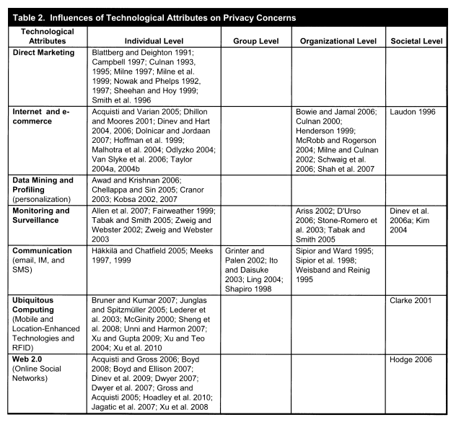

Looking Across Contexts

Although researchers have explored privacy-related research questions in different contexts, it remains unclear that the context-specific nuances actually merit parallel research streams. In our view, the answer to Question #3 ("To what extent does context matter in the relationships between privacy and other constructs?") is "much less than a first order consideration of the research stream would lead one to believe."
One can understand why individual researchers (especially in the IS domain) have embraced this path. Most of the new contexts are technologically driven, and thus the IT artifact and the impact of the new technological application on privacy is evident, making the research relevant for publication in IS journals.

Moreover, the historical precedent of the Internet as a technology that completely changed the landscape of the privacy conversation has given scholars reason to suspect that another type of technology may once again turn around our understanding of privacy. Indeed, a similar approach is taken by legal scholars who are regularly engaged in research on how a specific new legal framework
or law passed by the U.S. Congress (or another nation's legislative body) would impact privacy.

Yet we note that while these types of studies provide high relevance and illustrate the IT artifact' s salience, the cumulative impact of such context-driven studies may produce an overall contribution to knowledge that is suboptimal unless researchers are constantly aware of an over-arching model.
Although it is certainly necessary to ascertain the extent to which data from different contexts converge and diverge before such data are pooled, far more could eventually be learned from a macro perspective. As we will discuss in the next section, "Future Research and Conclusion," some minor parameterization of an APCO framework (as in our Figure 3) should accommodate the majority of the studies that are now context- specific. This would lead to a more robust framework that would move the frontier of knowledge forward far more quickly.

Future Research and Conclusion

We draw the following overarching conclusions from the literature review:

• A large body of normative studies of privacy has accumulated. Many of these offerings are politically engaging or emotionally charged with strong beliefs about the ethics and norms that underlie democratic societies. While these studies have contributed to
privacy research in their own merit, they also serve as excellent inspiration and motivation for research advancement, bringing to light hot and disputed issues, conflicts, and contradictions. There are many rich and valid theoretical developments and models in the body of purely descriptive studies on general privacy in philosophy, sociology, and law that have not been addressed in empirical research on privacy. However, rigorous empirically descriptive studies that either trace processes associated with, or test implied assertions from, these value-laden arguments could add great value.
• Most of the empirically descriptive studies that have addressed linkages between antecedents and privacy concerns have focused on individual perceptions. For the most pan, the studies that have associated privacy con-cents with outcomes have been concerned with organiza-tional and societal dynamics. Largely missing from the entire research stream are studies associated with group-level privacy. Future empirical studies—both positivist and interpretive—could profitably be targeted to these under-researched levels of analysis.

Positivist empirical studies will add the greatest value if they focus on antecedents to privacy concerns and on actual outcomes. As could be seen in our discussion of Question #2, only limited attention has been paid to factors that serve as antecedents to privacy concerns. At the same time, often due to a reliance on the TRA, researchers frequently assume that stated intentions will equate to actual behaviors, an especially tenuous assumption in light of the privacy paradox.
Once the extent to which data from different contexts converge and diverge has been ascertained, attempts to forge a context-neutrat overarching empirical framework should be encouraged. We now discuss each of these conclusions.

Normative to Empirical

Previous research has provided a plethora of nonnative argu-ments that address conundrums ranging from the theoretical orientation of privacy (e.g., debates about the extent to which privacy is a human right and ought to be protected as such) to the regulatory approach that best serves society (e.g., debates about whether there should be a federal bureau of privacy). In between, one can find normative arguments associated with specific matters of privacy interpretation (e.g., debates about whether an IP address associated with one's home computer constitutes "individually identifiable personal data" that should be protected).
There are "rules" for what constitutes a rigorous normative argument—often grounded in principles of moral argumenta-tion. Such arguments may include references to empirical data, but such references are not required since normative arguments can be made logically without reference to data.
The overall stream of privacy research has benefited from somc of the nonnative argumentation that has been published. Further, some of the normative argumentation has yielded real-world significance in domains such as privacy regulation; for example, normative arguments undergirded the competing drivers for institutional structures that can be observed in the United States and the European Union. But, in our view, a general extension of the stream of normative privacy argu mentation is unlikely to produce many new insights in the IS domain that will augur for significant changes in policy or behavior at any of the units of analysis discussed previously: individual, group, organization, or society.
However, to the extent that the normative conclusions are viewed as enlightening and motivating events for empirical studies that trace processes associated with the implementation of these normative conclusions or that test the impact on different outcomes , their value rises enormously. For example, an emotionally charged assertion such as "there is war on privacy" (e.g., Sobel 1976) or "the system is broken" (Turow 2003), or a lengthy normative debate regarding whether privacy should be viewed as a right or as a commodity will yield little additional insight. The normative debates themselves are unlikely to inform us further in terms of privacy protection, but an examination of the positivist nomological models that link the normative conclusions to different outcomes, or the processes through which that linkage occurs, could prove quite instructive.

A natural difficulty that arises regarding tests of positivist models from normative studies is the fact that only a subset of the normative arguments lends itself to such study, since the normative conclusions are seldom stated in a format that is suitable for positivist testing. Unlike many theories in the social sciences that posit relationships such as "higher levels of A will be associated with higher levels of B," normative, value-laden arguments seldom concern themselves with whether or not they are testable.

Consequently, one might observe a normative conclusion such as "societies ought to acknowledge a right to privacy in purchase transactions" without any clear linkage to outcomes that would, or would not, follow from such a right. In other words, the
normative theory prescribes that higher levels of "A" should be provided. It then becomes a task for the positivist researcher to define which constructs might constitute "B" and to develop a testable linkage back to "A."

As they traverse this path, researchers should be quite explicit in identifying the assumptions on which they are relying, and they should be sure to defend those assumptions. The normative and purely descriptive studies that provide solid argumentation and reasoning can serve as bridges in constructing empirically testable models and motivating process tracing studies. As an example, many researchers rely on the set of fair information practices (FIPs) that were codified in a 1973 study by the U.S. Department of Health, Education, and Welfare, and some researchers rotate their positivist models around these FIPs. But the FIPs do not have the standing of U.S. law in any omnibus context, and careful listeners will conclude that some members of U.S. industry groups do not
even embrace certain principles of the FIPs. It is, therefore incumbent upon researchers who assume the validity of the FIPs to note this clearly in their papers and to defend why the assumption should hold for the purposes of the positivist research.

Levels of Analysis

The majority of empirical studies to date have viewed the individual as the salient unit of analysis. This is to some degree understandable, since such studies lend themselves to data collection through written and online surveys, and they are therefore easier to implement. Further, great insight can be gained from consideration of individuals' perceptions of various privacy-related activities.
However, much of this focus on individual-level privacy perceptions and relationships has been at the expense of our understanding at other levels of analysis. The challenge, of course, is that studies at the organizational and societal levels are necessarily more complex and less conducive to "quick" data collection techniques such as written and online surveys.
Indeed, most rigorous studies of organizational privacy policies and practices would likely include a set of exhaustive interviews with an organization's members and stakeholders, and some amount of deep process tracing would also likely be involved. Such studies are the best approach to uncovering the somewhat subtle organizational dynamics that drive privacy policies and practices. Cross-national and cross-cultural studies are also likely to be challenging, although one can often simplify the measurement of certain independent variables in positivist studies by considering previously established metrics. For example, many countries' privacy regulatory structures have already been documented by previous researchers. Similarly, national public opinion surveys regarding privacy concerns are available for a number of industrialized countries. While researchers may still have to struggle with some challenges when using such external data (e.g., manual adjustment of degrees of freedom for statistical inference), the structure of the studies may not be overly complex. On the other hand, interpretive studies at the cross-national and cross-cultural levels may be overwhelming in their complexity. For example, many languages, including those in European countries (e.g., Russian, French, Italian), do not have a word for privacy and have adopted the English word.9 One's ability to collect interpretive (and, particularly, process-oriented) data across national and societal boundaries will ordinarily be limited, perhaps even artificially, due to historical factors. Even so, as the majority of the literature to date has focused on the United States, the relatively lesser focus and complexity of the literature in other countries may be due to the varying legal environs. Presumably, the United States has a more complex legal environment than Europe, and this may be partly the reason for the emphasis of the research on the United States. In any case, a richer focus on international dimensions of privacy research is needed.
Of particular note is that there have been very few studies that considered privacy at the small group level. Of course, it is at the small group level that many supra-organizational policies and practices come to rest, so the paucity of studies at this level strikes us as a significant weakness in the privacy literature stream. Further, within small groups (whether nestled in larger organizations or not), norms regarding protection of individuals' privacy may vary, and the process through which these norms develop could serve as an interesting area for future research. It is also likely that small groups differ in norms regarding protection of the group's own information,10 and these differences (and the processes through which they evolve) also merit future research consideration. In a related vein, a single individual likely belongs to more than one group, so (s)he may adhere to different norms regarding privacy as (s)he travels between groups. How an individual navigates such different normative expectations would also be a fruitful domain for additional research.

In fact, social networking websites such as Facebook and Twitter offer dynamic examples in which information boundaries are created in groups of various sizes and relationship levels. One can easily imagine a set of studies that considers the factors associated with different boundaries regarding disclosure within and across online groups. Questions such as "do limited-access groups differ from open access groups in their information norms and processes?" and "to what extent does an online group's administrator's own information concerns dictate the privacy norms and processes in the group?" could be of great interest in this domain.
Additionally, as a precursor to this work, the very definition of a group merits consideration in light of developments in online social networking. To the extent that sociological and communications research on small groups has been undertaken in the past, it has usually been associated with physical groups in which membership is somewhat static (or, at least, easily clarified) and non-anonymous. However, online groups are often associated with fluid entry and exit, with the option of identification through screen names or anonymous avatars. In addition, what constitutes a "small" group in terms of sociology and communication (for which traditional theories were developed) may well be subject to dynamic forces. Although a physical group's characteristics may shift substantially as it grows in size, this may not be as true of an online group. Clear distinctions (and, likely, reconsiderations of nomenclature) are warranted.
Yet it is also obvious that, as with organizational studies, it will not be easy to conduct these inquiries into the privacy relationships and practices of small groups. Although some possibilities for surveys do exist, the most helpful studies will likely be grounded in direct observation of the group members and their interactions. This suggests a long-term research agenda that will rely heavily on access to group settings in a variety of domains. It will be almost impossible to examine these processes without direct observation or participation (i.e., through action research).

Antecedents and Outcomes

As suggested above, the most helpful positivist studies will b those that examine differences in outcomes as a function of privacy-related independent variables. Outcomes should be interpreted as actual changes of state or behavior; this is distinct from an examination of attitudes, beliefs, and intentions.
Indeed, it is rare for privacy research to consider actual outcomes in tests of models. Although some exceptions are emerging (see Cranor et al. 2007; Hui et al. 2007), the general approach has been to ascertain what subjects report that they would intend to do in a certain situation - for example, subjects might report their likelihood of writing to an elected official to complain about a perceived privacy violation (Smith et al. 1996).

Particularly because of the privacy paradox, it will behoove privacy researchers to consider their nomological models as exhaustive only when they map to actual outcomes at one or more levels of analysis. Among others, outcomes such as documented violations of privacy, successful prosecutions of privacy violations, and cross-national data flow stoppages would all serve as salient outcomes in testable models. At the organizational level, an interesting contribution would be to reveal specific organizational outcomes and consequential decisions made after breaches of personal information considered private. In contrast, much less insight would be gained through tests of models that culminate with dependent variables that are perceptual in nature - for example, a survey of subjects' differing levels of stated privacy concern as associated with different uses of personal data. To the extent that a privacy paradox exists, it is obvious that such perceptual measures are quite distinct from measures that will
provide insight to decision-makers.

Overarching APCO Macro Model

Finally, we argue that positivist privacy researchers should keep their eye on an optimized APCO macro model that eventually includes an expanded set of antecedents as well as an exhaustive set of outcomes. The ultimate objective should be a macro model that will prove useful across disciplines and contexts.

It is well beyond the scope of the present endeavor to propose this full APCO macro model. As a nod to the attributes of emerging technological applications and other contextual factors, the macro model may require some amount of parameterization if contextual differences are demonstrated to be clearly salient. For example, one can envision a macro model that includes a set of antecedents that would apply to all types of personal information, such as financial and medical. Through parameterization, some of the antecedents could be hypothesized to hold with greater weight for some of the information types than for others based on findings from studies that target these contextual differences. Yet, all
researchers should be aware of the exhaustive set of antecedents, as there is little need for each discipline or sector to investigate its own set of antecedents. Similarly, context parameterization could be used to highlight outcomes that would be more or less salient for different contexts.

The development of this macro model would be arduous and contentious, but the ultimate payoff for the gestalt of privacy research would be immense. With the macro model in place, individual researchers could then contribute studies that addressed a clear subset of the antecedents and outcomes, with possible parameterization, always confident that their findings would contribute a clearly annotated brick in the wall of privacy knowledge.

Conclusion

The stream of modern privacy research had its genesis in the 1970s. In the subsequent four decades, a number of useful studies have been conducted and published, but the overall research stream has been suboptimized because of its disjointed nature.
We believe that our recommendations for future research in privacy should lead to a more cohesive stream of literature that yields actionable steps for individuals, managers, and regulators.

