Abstract
Information privacy has been called one of the most important ethical issues of the information age. Public opinion polls show rising levels of concern about privacy among Americans.
Against this backdrop, research into issues associated with information privacy is increasing. Based on a number of preliminary studies, it has become apparent that organizational practices, individuals' perceptions of these practices, and societal responses are inextricably linkedi n many ways. Theories regarding these relationships are slowly emerging. Unfortunately, researchers attempting to examine such relationships through confirmatory empirical approaches may be impeded by the lack of validated instruments for measuring individuals' concerns about organizational information privacy practices.
To enable future studies in the information privacy research stream, we developed and validated an instrument that identifies and measures the primary dimensions of individuals' concerns about organizational information privacy practices. The development process included examinations of privacy literature; experience surveys and focus groups; and the use of expert judges. The result was a parsimonious 15-item instrument with four subscales tappin ginto dimensions of individuals' concerns about organizational information privacy practices. The instrument was rigorously tested and validated across several heterogenous populations,providing a high degree of confidence in the scales' validity,reliability, and generalizability.
Keywords: Privacy, LISREL, ethical issues, measures, reliability, validity

It is inevitable that personal privacy will be one of the most significant pressure points...for most of the 1990s. Advancing technology, depersonalization of the workplace and other social environments, a growing population...all can be expected to create a greater personal need for a sense of space and dignity (Erwin Chemerinsky, as quoted in Smith, 1994).
Information privacy—"the ability of the individual to personally control information about one's self" (Stone, et al., 1983)—has been called one of the most important "ethical issues of the information age" (Mason, 1986; Public Smith, 1994). Public opinion polls show increasing levels of concern about privacy among Americans (Equifax, 1990; 1991; 1992; 1993; Katz and Tassone, 1990). For example, one survey indicates that 79 percent of Americans are concerned about threats to personal privacy, and 55 prcent feel that "protec-tion of information about consumers will get worse by the year 2000" (Equifax, 1992). In addition, a number of corporations have faced legal problems and received negative media attention because of privacy issues (Cespedes and Smith, 1993; Culnan, 1993; Smith, 1994). In the United States, pressure for additional laws to guard against information privacy exposures is coming from both domestic and international quarters (Cespedes and Smith, 1993; Culnan, 1993). As organizations find their data management activities receiving more scrutiny from a privacy perspective, infor-mation systems managers should be aware of exposures and be accountable to their organi-zations (Straub and Collins, 1990).
Against this backdrop, research into issues associated with information privacy is increasing. Some privacy research dates back to the 1960s and 1970s (e.g., HEW, 1973; PPSC, 1977; Westin, 1967; Westin and Baker, 1972). Most of the scholarly work, however, has emerged during the 1980s and early 1990s. Consequently, it could be argued that the research stream is still in its infancy and that much work lies ahead as researchers examine the complex web of relationships in the infor-mation privacy domain. Based on a number of preliminary studies (Culnan, 1993; Milberg, et al., 1995; Smith, 1994; and Stone, et al., 1983), it has become apparent that organizational practices, individuals' perceptions of these practices, and societal responses are inextricably linked in many ways. Theories regarding these relationships are slowly emerging: for example, Stone and Stone (1990) developed a model for information flows and physical/social structures in work environments based on expectancy theory, Culnan (1993) tested an exploratory model that explains consumer attitudes toward some direct marketing practices, and Smith (1994) developed a model that explains corporate approaches to information privacy policymak-ing. Overall, however, the theoretical base is still quite fragmented, and few empirical tests of these relationships have been conducted.
Unfortunately, researchers attempting to exam-ine such relationships through confirmatory empirical approaches may be impeded by the lack of validated instruments for measuring individuals' concerns about organizational infor-mation privacy practices. As in many other areas of information systems (IS) research (Jarvenpaa, et al., 1985; Straub, 1989), instru-mentation issues have generally been ignored in the information privacy domain. This can lead to two potential problems over time: First, it will be difficult to assess the significance of any particular study because the "lack of vali-dated measures in confirmatory research rais-es the specter that no single finding...can be trusted" (Straub, 1989, p. 148). Second, devel-opment of a research stream will become par-ticularly problematic because it will be difficult to "compare and accumulate findings and thereby develop syntheses for what is known" (Churchill, 1979, p. 67). Thus, the frontiers of knowledge in privacy research can be extend-ed by efforts to enhance the tools at researchers' disposal and to ensure that scientific rigor can be maintained in future studies.2 Specifically, a rigorously validated instrument that measures individuals' concerns about organizational information privacy practices is needed because without such an instrument, researchers cannot credibly test explanatory theories regarding causal links between prac-tices, individuals' perceptions, and societal responses. In addition, such an instrument will promote cooperative research efforts by "allow-ing other researchers in the stream to use this tested instrument across heterogenous settings and times" as well as by bringing "greater clari-ty to the formulation and interpretation of research questions" (Straub, 1989, p. 148).
To that end, this paper reports the results of a study that developed and validated a measure-ment instrument that can be used in future information privacy research. Table 1 shows the final product of our work: a 15-item instru-ment with four subscales (Collection, Errors, Unauthorized Secondary Use, and Improper Access; see definitions below) that measures individuals' concerns about organizational information privacy practices.
The following sections first consider the previ-ous literature regarding individuals' concerns about organizational information privacy prac-tices. They then detail the development and validation of the instrument and conclude with a discussion of implications for both researchers and managers.
Literature Review
A prerequisite step in the creation of a validat-ed measurement instrument is a consideration of the dimensionality of the relevant construct (in this case, individuals' concerns about orga-nizational information privacy practices). As one of several steps in this process, a thor-ough review of the existing literature was con-ducted3 (Bearden, et al., 1993; Churchill, 1979).
It is common for information privacy to be approached as though it were a unidimension-al construct. For example, while available opin-ion surveys (Equifax, 1990; 1991; 1992; 1993) report an increasing level of concern about information privacy, these surveys do not fully explore the nature (dimensionality) of those concerns.4 Furthermore, while other studies have examined various dimensions underlying information privacy concerns, the specific dimensions differ from study to study,5 and a common unifying framework relating these dimensions has not yet emerged. Thus, we attempted to ascertain the underlying dimen-sions—both central and tangential—that have been identified in either scholarly literature, in federal law, or in privacy advocates' writings.6 Of course, this was a somewhat iterative process in that the understanding of the con-struct was refined in later steps (see "Methods" section below).
This exercise revealed several central dimen-sions of individuals' concerns about organiza-tional information privacy practices: collection of personal information; internal unauthorized secondary use of personal information; exter-nal unauthorized secondary use of personal information; errors in personal information; and improper access to personal information. Two additional, tangential dimensions, which were mentioned with less frequency in the scholarly literature, were also noted: concerns regarding reduced judgment in decision makingand combining data from several sources. Each is discussed briefly below(see synopsis inTable2).
Table 1. Final Instrument
Here are some statements about personal information. From the stand point of personal privacy,
please indicate the extent to which you, as an individual, agree or disagree with each statement by
circling the appropriatenumber.*
A. It usually bothers me when companies ask me for personal information.
B. All the personal information in computer databases should be double-checked for accuracy-no
Matter how much this costs.
C. Companies should not use personal information for any purpose unless it has been authorized
By the individuals who provided the information.
D. Companies should devote more time and effort to preventing unauthorized access to personal
information.
E. When companies ask me for personal information, I sometimes think twice before providing it.
F. Companies should take more steps to make sure that the personal information in their files is
accurate.
G. When people give personal information to a company for some reason,the company should
never use the information for any other reason.
H. Companies should have better procedures to correct errors in personal information.
I. Computer databases that contain personal information shoul dbe protected from unauthorized
access-no matter how much it costs.
J. It bothers me to give personal information to so many companies.
K. Companies should never sell the personal information in their computer databases to other
companies.
L. Companies should devote more time and effort to verifying the accuracy of the personal information in their databases.
M. Companies should never share personal information with other companies unless ithas been
Authorized by the individuals who provided the information.
N. Companies should take more steps to make sure that unauthorized people cannot access personal information in theircomputers.
O. I'm concerned that companies are collecting too much personal information about me.
Items A, E, J, and 0 comprise the "Collection" subscale; items B, F, H, and L comprise the "Errors"
subscale; items C, G, K, and M comprise the "Unauthorized Secondary Use"subscale; and items D,
I,and N comprise the "Improper Access"subscale. Subscale scores are calculated by averaging the
responses to the items for each subscale; an overall score is then calculated by averaging the subscale scores. * Each of the items is followed by a seven-point Likert scale anchored by "Strongly disagree"(1) and "Strongely agree"(7).

Collection
The Association for Computing Machinery (ACM), a major association of information pro-cessing professionals, has a phrase in its Code of Professional Conduct that dictates members shall "always consider the principle of the individual's privacy and seek . . . to minimize the data collected. . ." (ACM, 1980). This area of concern reflects the perception, 'There's too much damn data collection going on in this society" (Miller, 1982). Individuals often perceive that great quantities of data regarding their personalities, background, and actions are being accumulated, and they often resent this. The growing collection of personal information has been a theme in privacy litera-ture since the 1970s. Although Westin and Baker (1972) did not find that information col-lection had increased appreciably, they argued that it was an inevitable byproduct of the grow-ing computer revolution and raised concerns in that regard. Shortly thereafter, two major reports from that era (HEW, 1973; PPSC, 1977) confirmed the trend and the concern; this position was echoed by Linowes (1989). Laudon (1986) also inferred a concern regard-ing excessive collection of data when he coined the moniker "dossier society" to describe our increasing reliance on personal data. In the behavioral literature, Stone, et al. (1983) utilized "information collection" as one component in their study; Stone and Stone (1990) also discuss a number of concerns associated with information collection.
Unauthorized secondary use (internal)
Sometimes information is collected from indi-viduals for one purpose but is used for anoth-er, secondary purpose without authorization from the individuals. Even if contained internal-ly within a single organization, unauthorized use of personal information will very often elicit a negative response. This concern was raised pointedly in the Code of Fair Information Practices, which was included in a seminal study sponsored by the U.S. Department of Health, Education, and Welfare (1973). Concerns about such secondary use were raised in several industry settings in a later study (PPSC, 1977) and echoed in Linowes (1989). Stone, et al. (1983) refers to this issue under the label of "information usage"; it is reit-erated by Stone and Stone (1990) in a discus-sion of various information uses. Specific examples of such secondary, internal uses are also covered in the literature: for example, "sugging"—a practice in which data are collect-ed ostensibly for research only to be used later for marketing purposes—falls into this area of concern (Cespedes and Smith, 1993). It is common for organizations to find new uses for data: for example, some banks' marketing groups have attempted to use income data collected on loan applications to sort cus-tomers into narrow categories for targeted sales offerings—a use of income data likely unanticipated by the customers at the time they filled in the loan application.
Unauthorized secondary use (external)
Some studies (for example, Tolchinsky, et al., 1981) have found that concerns about secondary use are exacerbated when personal information is disclosed to an external party (i.e., another organization). This issue was mentioned in studies conducted in the 1970s (HEW, 1973; PPSC, 1977; Westin and Baker, 1972), but it was not stressed in great depth at that time—perhaps because the technology of the day constrained such external exchanges of data. By the 1980s, though, the concern had become a major one. Linowes (1989) discuss-es several examples of unauthorized external use of information in various industries. Culnan (1993) examines attitudes toward external sec-ondary uses in direct marketing applications. Stone, et al. (1983) consider the issue under the rubric of "information release," and Stone and Stone (1990) discuss the "subsequent dis-closures" of personal information.
The most commonly cited examples of this concern are the sale or rental of current or prospective customers' names, addresses, phone numbers, purchase histories, categorizations, etc., on mailing "lists," which are often transferred between the organizational entities as digital files. Trade publications in the direct marketing industry such as DM News ("DM" stands for "direct marketing") con-tain pages of advertisements for such lists (e.g., "individuals who responded to an adver-tisement for a weight-loss product").
Improper access
Who within an organization is allowed to access personal information in the files? This is a question not only of technological con-straints (e.g., access control software) but also of organizational policy. It is often held that individuals should have a "need to know" before access to personal information is grant-ed. However, the interpretation of which indi-viduals have, and do not have, a "need to know" is often a cause of much controversy. PPSC (1977) and Linowes (1989) provide some attention to the topic—considering, for example, the inappropriate access to employees' healthcare records that are not controlled properly—and it is sometimes considered under the rubric of "security" in database litera-ture (see, for example, Date, 1986). Of course, technological options now exist for controlling such access at file, record, or field level. But how those options are utilized and how poli-cies associated with those uses are formed represent value-laden managerial judgments.
Errors
Many individuals believe that organizations are not taking enough steps to minimize problems from errors in personal data. Although some errors might be deliberate (e.g., a disgruntled employee maliciously falsifying data), most privacy-related concerns involve instead accidental errors in personal data. Early privacy stud-ies detail some procedures for minimizing such errors (HEW, 1973; Westin and Baker, 1972; also see minor references in PPSC, 1977). Later works (Laudon, 1986; Linowes, 1989) document continuing problems in this domain.
Provisions for inspection and correction are often considered as antidotes for problems of erroneous data (HEW, 1973; PPSC, 1977; Smith, 1994). But many errors are stubborn ones, and they seem to snowball in spite of such provisions (Smith, 1994). In addition, a reluctance to delete old data—which can clear-ly become "erroneous" because of their static nature in a dynamic world—can exacerbate this problem (Miller, 1982). Also at issue are questions of responsibility in spotting errors: does a system rely on individuals to monitor their own files, or is there an overarching infra-structure in place (Bennett, 1992)? Although errors are sometimes assumed to be unavoid-able problems in data handling, whether con-trols are or are not included in a system does represent a value choice on the part of the system's designers (Kling, 1978; Mowshowitz, 1976).
Reduced judgment
As organizations grow in size and in their data processing capabilities, they tend to rely more often on formulas and rules in their decision making (Cyert and March, 1963). Their use of automated decision-making processes may lead individuals to feel that they are being treated more as "a bunch of numbers" than as an individual. As systems are increasingly designed so that these decisions are automat-ed, mechanisms for "decoupling" the decision making from the systems as appropriate—that is, reverting to human controls when the com-puter's limits as a decision maker are reached (Ladd, 1989)—should be included. When such mechanisms are not provided, concerns about this dimension of decision making increase (Kling, 1978; Ladd, 1989; Laudon, 1986; Mowshowitz, 1976). Some examples of this phenomenon border on the ridiculous:
American Express once issued a Gold Card to a man who had been dead 14 years, just because his widow filled in all the blanks on an application form. Much of the data would have appeared immediately suspicious to a human being (e.g., she entered all zeroes for his social security number and "God" as his employer), but the system apparently had been programmed to accept these entries, and the appropriate mechanisms for decoupling the decision making from the computerized information system had apparently not been included (Smith, 1994).
While advocates often couple "reduced judg-ment" with privacy in their arguments and writ-ings, it should be noted that "reduced judg-ment" can easily be considered a tangential construct or even a separate construct of its own (under the rubric of "decision making"). Indeed, it has usually been referenced in scholarly work as a related concern rather than as a dimension of privacy, per se.
Combining data
Concerns are sometimes raised with respect to combined databases that pull personal data from numerous other sources, creating what has been termed a "mosaic effect." These combinations of data were mentioned in some of the 1970s privacy studies (HEW, 1973; PPSC, 1977) and in the 1980s (see especially Laudon, 1986). Even if data items in disparate databases are seen as innocuous by them-selves, their combination into larger databases appears to some to be suggestive of a "Big Brother" environment. The Combining Data concern is usually encountered in the literature in parallel with Collection and/or Unauthorized Secondary Use (External) concerns and, in fact, may not be a separate dimension (see "Methods" below).
Methods
The ultimate objective of this research was the development and validation of an instrument to measure individuals' concerns about orga-nizational information privacy practices. While it is expected that this instrument will be used primarily in positivist studies, the process of instrument development and validation used in this study included steps that addressed not only what Lee (1991) would call a researcher's positivist understanding (e.g., a theory taking the form of independent and dependent variables), but also the subjective understanding (i.e., what the research sub-jects themselves understand their situation to be) as well as a researcher's interpretive understanding (i.e., what the researcher observes and interprets to be the subjective understanding).?
As can be seen in Stage 1 of Figure 1,8 an iterative process is used to (1) specify the domain and dimensionality of a construct, (2) generate a sample of items, and (3) assess content validity of these items (i.e., the extent to which scale items appear to be consistent with the theoretical domain/dimensionality of the construct (Churchill, 1979; Cronbach, 1971)).
Techniques9 used to accomplish these tasks include literature reviews, experience sur-veys,1° focus groups, expert judges, and pilot tests with relevant samples. During this stage, based on input from individuals, expert judges, and literature, scale items are trimmed and refined and dimensions may be added, delet-ed, or modified as understanding of the con-struct improves.
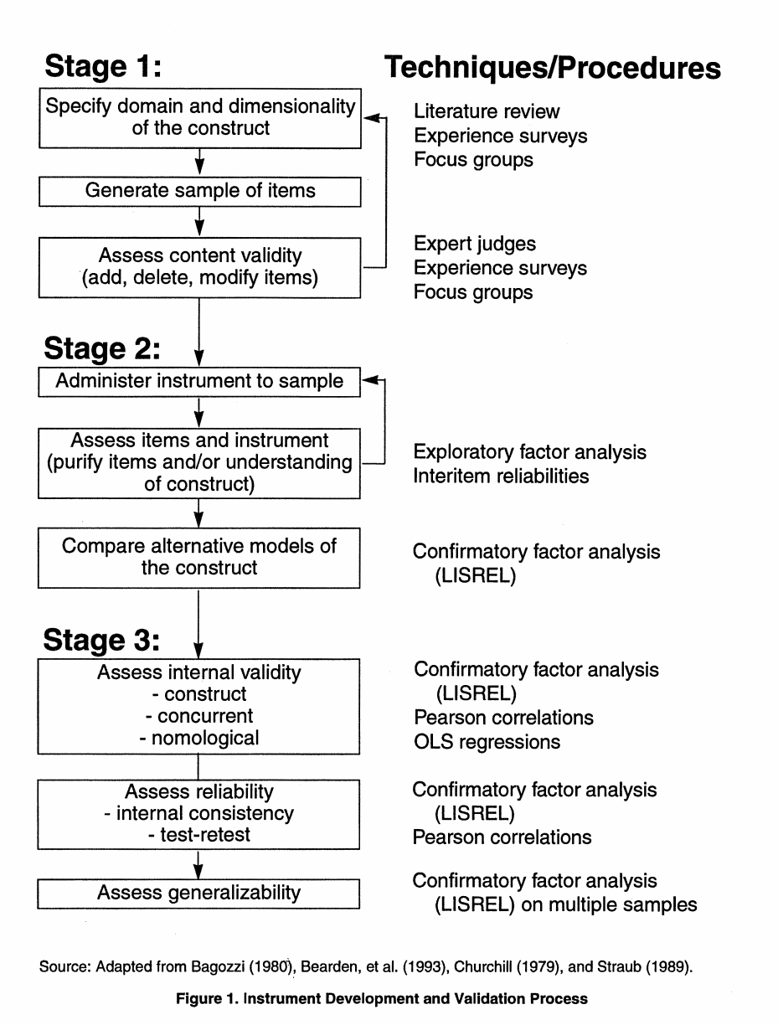
In Stage 2, the items and the conceptualization of the construct are subjected to "field tests » A preliminary version of the instrument is administered to various samples, and exploratory factor analysis is utilized to assess the items. The instrument is "purified" (Churchill, 1979) as researchers find that cer-tain items should again be added, deleted, or modified. Indeed, the researchers may even find that they must modify their understanding of the construct's dimensionality. Stage 2 con-tinues until the loading of the items in the exploratory factor analysis is consistent with the understanding of the construct's dimen-sions, and the inter-item reliabilities (Cronbach's alpha) are at satisfactory levels for all dimensions. In addition, Stage 2 includes a comparison of alternative models of the construct through confirmatory factor analysis (CFA). (See the Appendix for a dis-cussion of the merits of CFA.) .
In Stage 3, the internal validity of the instru-ment is assessed. This includes evaluations of the instrument's construct, concurrent, and nomological validity. Stage 3 also includes an assessment of the instrument's reliability, specifically internal consistency and test-retest reliability. Finally, Stage 3 includes an assessment of the instrument's generalizabili-ty (i.e., its usefulness for different popula-tions). In all tests, the instrument must per-form at statistically adequate levels. These levels have been documented, based on gen-erally accepted criteria, by numerous writers (see Bagozzi and Yi, 1988; 1991; Bearden, et al., 1993; Bentler and Bonett, 1980; Fornell and Larcker, 1981) .
The following sections provide further detail regarding our instrument development process.
Instrument validation results—stage 1
To specify the domain/dimensionality of the "individuals' concerns about organizational information privacy practices" construct and to establish content validity of the generated scale items, the extensive literature review, detailed in a previous section, was used as a starting point in determining the central and tangential dimensions of the construct. Concomitant with this effort, semistructured interviews were conducted with 83 executives, managers, and employees of banks, insurance companies, and a credit card issuer.11 Further, 18 consumers were interviewed either individ-ually or in focus groups. (See Table 3a for a description of the samples; see Table 3b for a summry of the procedures and results in this study.)
By discussing the construct both with people who were employed in organizations handling much personal data and with people who were not in any way associated with such organiza-tions, we were better able to interpret the sub-jective understanding (i.e., what the individuals themselves understood "concerns about infor-mation privacy" to mean). To achieve our own interpretive understanding, rather than rely exclusively on how other researchers and some advocates have already interpreted what individuals themselves understand information privacy to mean (see previous discussion under "Literature Review"), we interviewed 12 consumer/privacy advocates either in person or over the phone.
Commonly cited themes regarding information privacy concerns from the research articles, from privacy advocates' writings and U. S. laws, and from the interviews/focus groups were sorted in an iterative and interpretive process by the researchers, and the cate-gories were combined and modified in an intu-itive manner to suggest underlying dimen-sions. Based on the dimensions identified, we generated a preliminary set of 72 survey items for measuring individuals' concerns about organizational information privacy practices.
To establish content validity of the scale items (i.e., whether the items truly sampled the uni-verse of situations we were attempting to mea sure (Cronbach, 1971; Straub, 1989)), we asked three judges, familiar with the privacy area, to screen the 72 items for those that did not appear consistent with the construct and the identified dimensions (i.e., did not appear to actually measure individuals' concerns about organizational information privacy prac-tices).12 This resulted in a reduced set of 39 items. Then, 15 doctoral students and faculty members at a large Eastern university judged this reduced set of items. Specifically, the dimensions were explained to eight of the doc-toral students/faculty members, who were asked to evaluate the items for their applicabil-ity to the respective dimensions. The other seven doctoral students/faculty members were presented with the items but were not given an explanation of the dimensions. They indicated, for each item, what they perceived that item would measure. Items that were either incon-sistently classified or were misclassified were eliminated or reworded. After this analysis, 32 items remained.
Following this step, follow-up interviews were conducted with 15 corporate employees. In addition, at this point, the items were present-ed to 25 people employed by banks and insur-ance organizations. Using a focus group for-mat, participants filled in the survey and then discussed their reaction to, and thoughts about, each item. Based on this test, further modifications and reductions resulted in a 20-item scale.
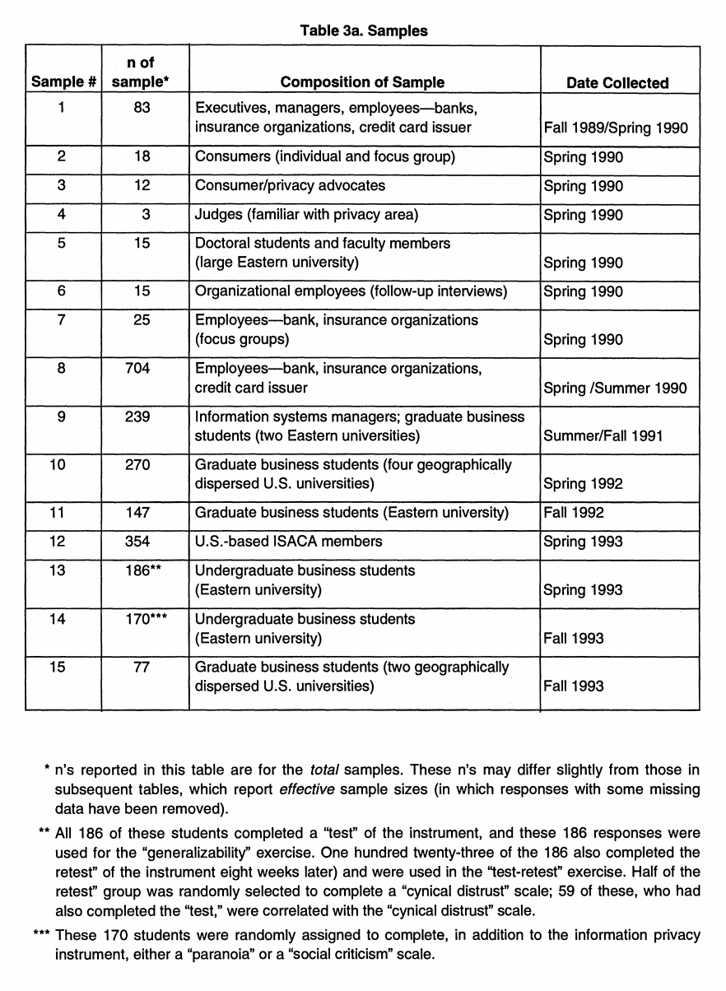
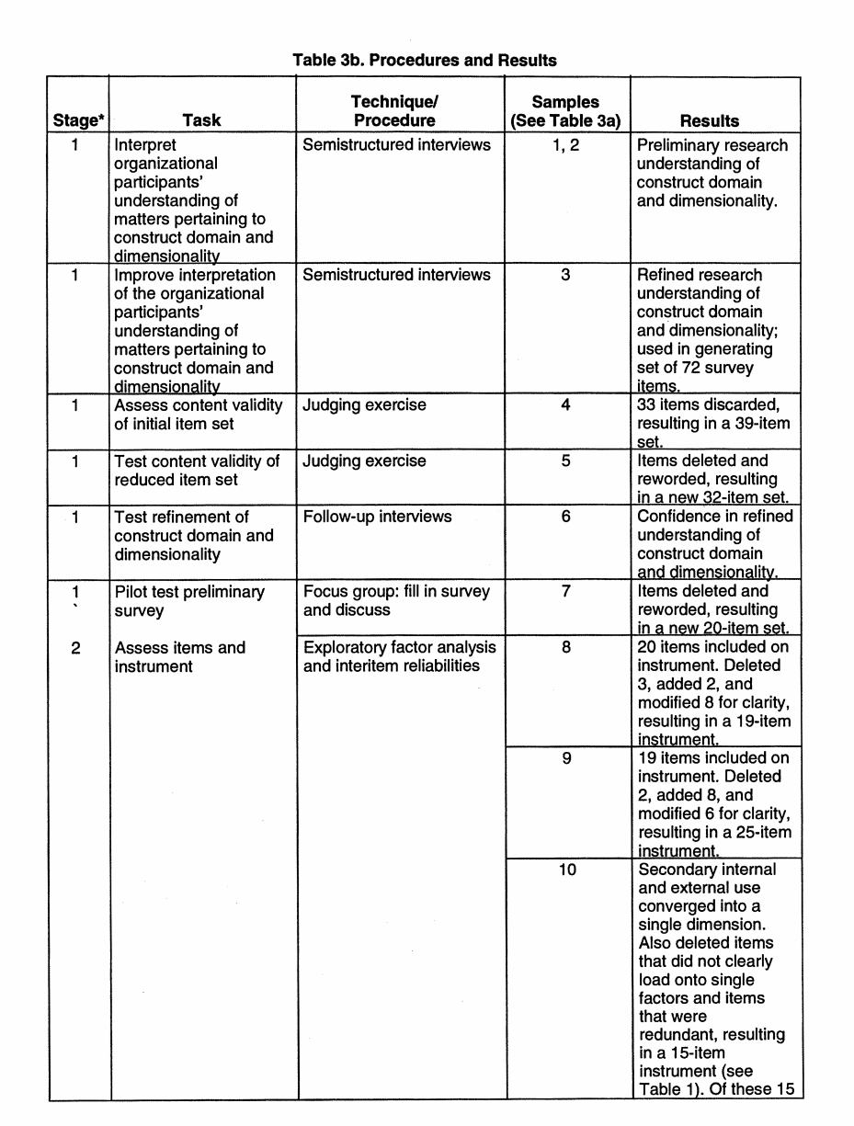
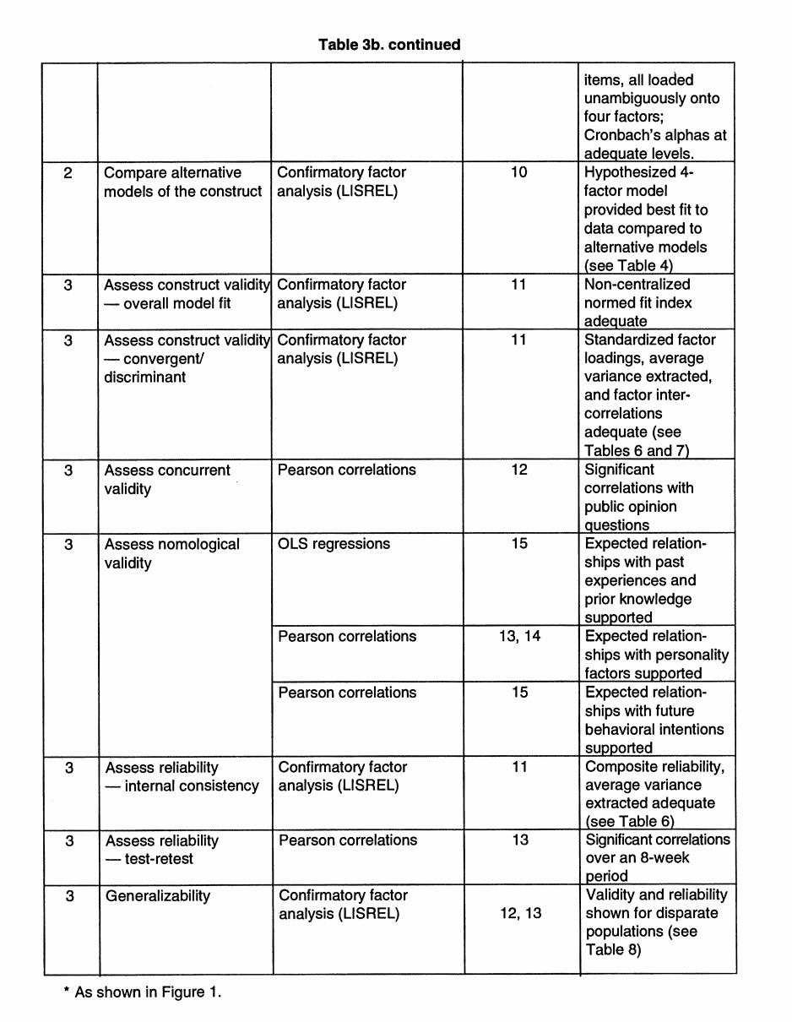
During this iterative process, as defined in Stage 1, the domain and the dimensionality of the "individuals' concerns about organizational information privacy practices" construct were repetitively assessed and modified. It became apparent that the Combining Data dimension was actually subsumed by two other dimen-sions: Collection and Unauthorized Secondary Use (External). Further probing with both advocates and consumers revealed that Combining Data concerns are actually viewed as an outcome of Collection and Unauthorized Secondary Use (External). When we tested some items that purported to measure con-cerns about Combining Data, our judges con-sistently held that it was almost impossible to separate the items' content from the Collection and Unauthorized Secondary Use (External) dimensions. Also during this process, Reduced Judgment was found by our judges and by some consumers to be tangential to the major construct of concern about information privacy and was dropped from further consideration. Few scholarly works hold Reduced Judgment to be a dimension of privacy. Furthermore, pri-vacy advocates, when pressed, were inclined to concede that Reduced Judgment was actu-ally outside the sphere of privacy concerns, per se.
Instrument validation results—stage 2
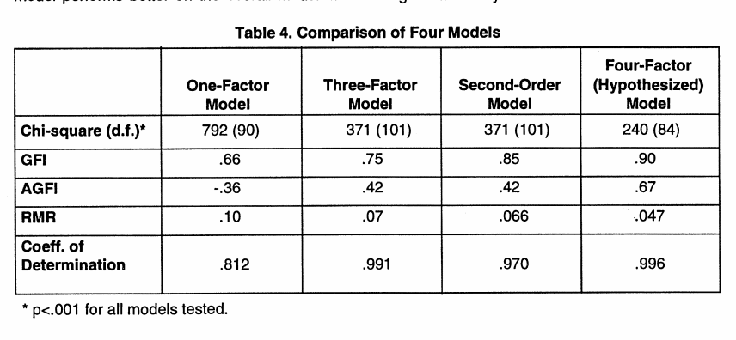
Stage 2 includes a preliminary assessment and refinement of the instrument through exploratory methods. In particular, in our study, the 20-item scale was administered to a sample of 704 bank, insurance organization, and credit card issuer employees.13 Exploratory factor analysis and interitem reliability (Cronbach's alphas) provided tentative support for the various dimensions. Unfortunately, however, several items did not load as expected. An additional iterative process was initiated in which three versions of revised instruments were administered to varied populations, such as information systems man-agers and graduate business students.
Based on additional exploratory factor analy-sis, items were deleted, added, or revised. This process eventually resulted in a 15-item instrument. Four factors emerged representing the subscales: Collection. (4 items), Errors (4 items), Unauthorized Secondary Use (4 items), and Improper Access (3 items). Examination of the exploratory factor analysis revealed that the unauthorized internal secondary use and the external secondary use dimensions had converged onto a single factor, the salient fea-ture being that the secondary use of the infor-mation had not been authorized by the individ-uals involved. Chosen items all had factor loadings greater than .60 on the same factor in all factor analyses performed. (The final instru-ment is shown in Table 1.)
Stage 2 included one final step: to determine whether the hypothesized model of a four-dimension construct provided the best fit to the data as compared to alternative plausible mod-els. To accomplish this, the overall fits of four theoretically plausible alternative models (a unidimensional model, a three-dimensional model, a model with two main factors and three sub-factors, and the hypothesized four-factor model) were compared using the CFA program LISREL (Joreskog and Sorbom, 1984). Four statistics provided in the LISREL program that are commonly used to compare model fits are the non-adjusted and adjusted goodness-of-fit indices (GFI and AGFI, respec-tively), root mean square residuals (RMR), and chi-square statistics (Bagozzi and Yi, 1988).
Comparison of these statistics (see Table 4) suggests that the hypothesized four-factor model performs better on the overall model fit measures than competing models. The chi-square statistics for all models estimated were significant, but—given the large samples used in the study—the significant chi-squares were likely artifacts of sample size (Bentler and Bonett, 1980) . Thus, a comparison of the GFI, AGFI and RMR measures—which are indepen-dent of sample size (Bagozzi and Yi, 1988)—was performed to assess the model's fit. As shown in Table 4, both the GFI and the AGFI of the four-factor model are higher than those for the three competing models. Further, RMRs are also considerably higher in the competing models (more residual variance remains) than in the hypothesized model. Finally, the coeffi-cient of determination, a criterion for evaluating the global fit of a model by assessing explained variance (i.e., how well the items serve as joint measures of the latent variable), was exam-ined. As shown in Table 4, the coefficient of determination is as high or higher in the four-factor model as in the other three models. Thus, of the four models compared, the hypoth-esized four-factor model provided the best fit to the data and was ultimately accepted.
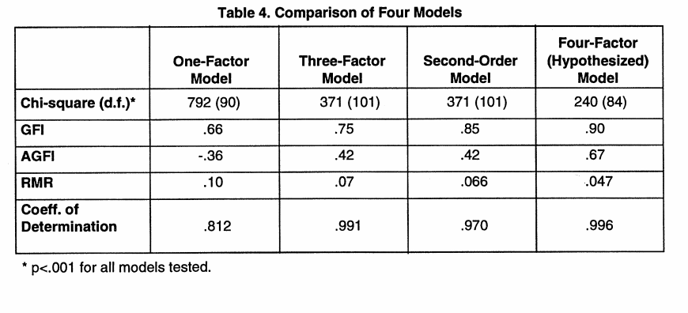
Instrument validation results—stage 3
Stage 3 included assessments of the instru-ment's internal validity, its reliability, and its generalizability.
Internal Validity
Construct Validity
Construct validity is defined as the extent to which the operationalization of a construct measures what it is supposed to measure (Cook and Campbell, 1979). To establish con-struct validity, we considered (1) the adequacy of the model's fit and (2) convergent and dis-criminant validity for the model. To this end, the instrument was administered to a new sample of graduate business students (n=147).14
Adequacy of Model's Fit: In Stage 2, it was shown that the four-factor model provided the best fit to the data, suggesting its superiority over the other models in defining the "individu-als' concerns about organizational information privacy practices" construct. However, the accepted model will achieve an adequate or satisfactory fit to the data only when a signifi-cant degree of correspondence exists between concepts and their respective measures and when measurement error is random (Bagozzi and Phillips, 1982). If significant measurement or method errors (or other external confound-ing factors) are present, overall model fit will be poor, suggesting model misspecification. In other words, subject responses must fit a fairly well-defined pattern for the hypothesized model to be sustained and construct validity supported.
On that basis, the first step in assessing con-struct validity using the CFA technique is to assess overall model fit. While the chi-square statistic provided in LISREL is often used to assess the adequacy of the model's fit, it may be a misleading artifact of sample size (Bentler and Bonett, 1980). Given the large sample size in this study, the overall fit of the model was examined using the non-centralized normed fit index (NCNFI). The NCNFI, which is independent of sample size (Bentler, 1990; McDonald and Marsh, 1990), assesses the proportion of additional variance explained in the hypothesized model as compared to a null model that hypothesizes that all variables are mutually independent.15 This analysis is com-monly performed to assess model fit when the CFA does not fulfill the acceptance criterion of a non-significant chi-square statistic, even though other measures of model fit fall within acceptable ranges (Bagozzi, 1993; Bentler, 1990; McDonald and Marsh, 1990), as was found in this case.
The NCNFI for this model is .91, which is greater than the .90 rule of thumb recommend-ed as a minimum satisfactory level (Bentler and Bonett, 1980), suggesting adequate model fit from a practical standpoint. In other words, the remaining incremental fit that could be achieved by additional model modifications is small. Further, the coefficient of determination (which shows how well the hypothesized rela-tions account for the factors) is very high at .996. Finally, the RMR is also very low, at .065 (Bagozzi and Yi, 1988). These findings support the overall adequacy of the model fit and pro-vide support for the theoretical structure of the construct (Bagozzi and Yi, 1988).
Convergent and Discriminant Validity: Convergent validity refers to the extent to which multiple measures of a construct agree with one another (Campbell and Fiske, 1959). Discriminant validity refers to the extent to which measures of different constructs are dis-tinct (Campbell and Fiske, 1959). A traditional method for assessing construct validity has been the multitrait-multimethod (MTMM) matrix. However, CFA affords certain advan-tages in validity assessment over MTMM matrix analysis (Bagozzi and Phillips, 1982). CFA explicitly represents random measure-ment error and allows for estimation of method variation. In addition, it provides explicit tests of the entire model, estimates of parameters, and a variety of fit measures, not available with the MTMM procedure (Bagozzi, 1993).
There are several approaches to assessment of convergent validity through CFA. First, con vergence implies that all within-construct cor-relations are both high and of approximately the same magnitude (Fornell and Larcker, 1981). To assess this aspect of convergent validity, the fit of the internal structure of the model (as discussed above), factor loading size, and significance were assessed. Bagozzi and Yi (1991) suggest weak evidence of con-vergent validity results when the factor loading on an item of interest is significant. Strong evi-dence is achieved when the squared factor loading is greater than .5 (more than half of the total variation in the measures is due to the trait). As shown in Table 6, standardized factor loadings (SFL) for all measures are greater than .6; all are statistically significant at p<.05. In addition, 12 of the 15 items have squared factor loadings greater than .5.
Second, convergent validity can be assessed in terms of the degree to which the four sub-scales (which might be considered four differ-ent measures of concern) are correlated (Bagozzi, 1980; Barki and Hartwick, 1994).
Thus,to further assess convergent validity,the correlations between the subscales were examined. As shown in Table 7, the correlations between the dimensions are all significantly different from zero (p<.05). This suggests that the four dimensions are all measuring some aspect of the same construct (are not orthogonal).
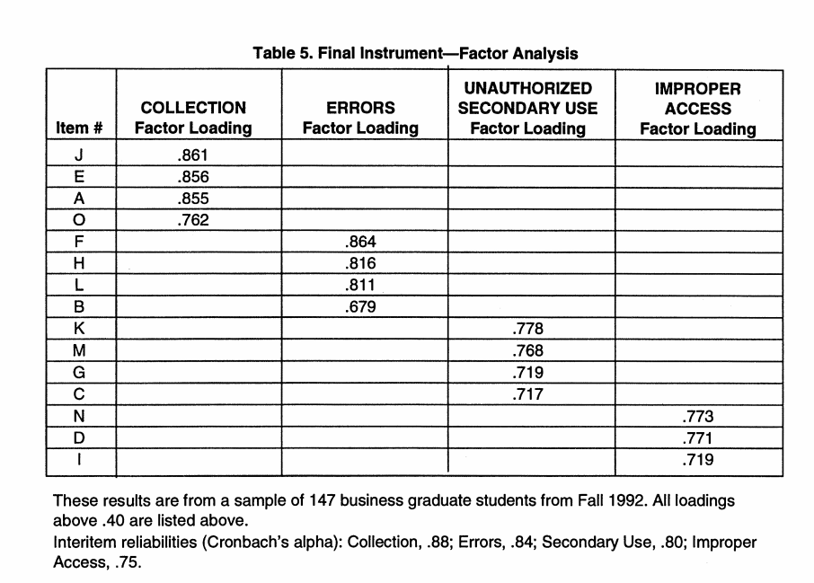
To assess discriminant validity, subscales must be examined to insure they are not perfectly correlated(correlationsequal to 1). As shown in Table7, all subscale correlations are significantly different from one (p<.05).This suggests that while the subscales are measuringaspects of the same construct, they are measuring unique dimensionsof that construct. Further, more rigorous evidence of discriminant validity is also observedby lookingat the averagevariance extracted(AVE)by each factor relative to that factors shared variance with other factors in the model (see Fornell and Larcker,1981). (AVE measures the amount of variance that is captured by the construct in relation to the amount of variancedue to measurementerror.) In everycase, the AVEassociated witha factor (see Table 6) is greaterthan the shared variance (squared correlation) between that and everyother factor(see Table7).
ConcurrentValidity
Concurrent validity is considered when one test is proposed as a substitutefor an other or if the test is shownto correlate with some useful criterion(e.g., anothertest) administered at the same time (Cronbachand Meehl, 1955; Bagozzi, 1981). To assess concurrent validity of this instrument, the correlation between responses to the current instrument and responses to previously utilized public opinion survey questions was assessed. These public opinion surveys (see Cambridge Reports, 1989; Equifax,1990; 1991; 1992; 1993; Katz and Tassone, 1990) typically used questions that have been subjected to limited validation procedures,and the questions address general, unidimensional privacy concerns.

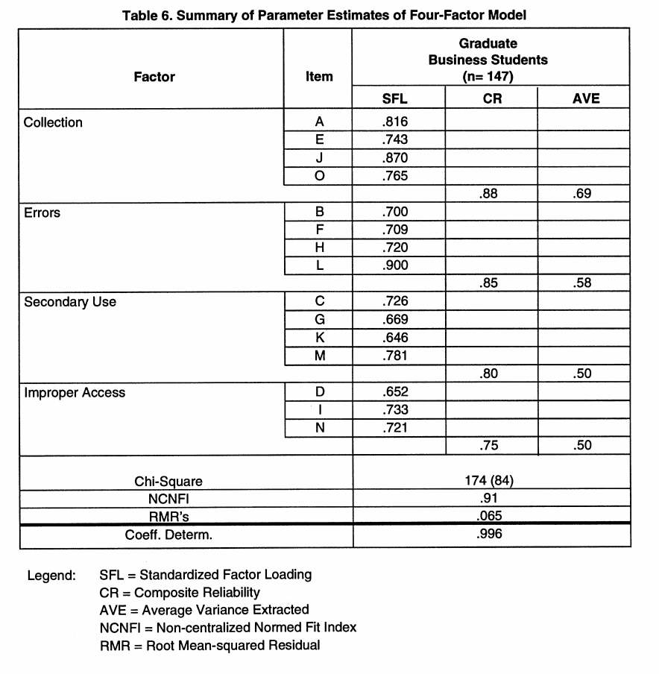

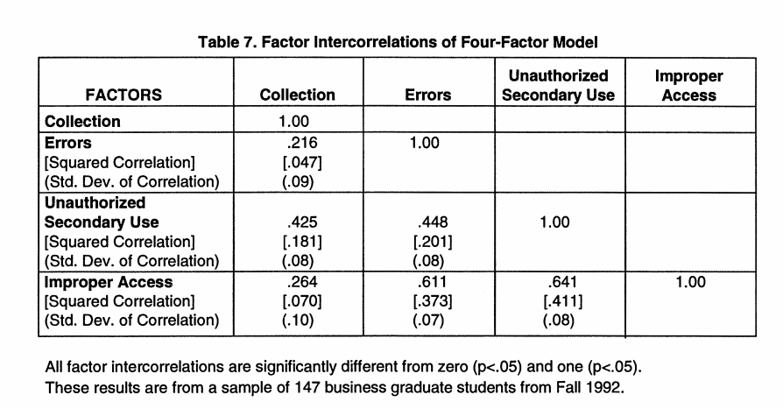

Nevertheless, it is expected that a strong relationship should exist between a subject's responses to those questions and the scale developed in this research. To check this, three questions that had been used on previous publicopinion surveys were included with our instrument, and this combined survey was administered to a sample of 354 U.S.-based members of the Information Systems Audit and ControlAssociation (ISACA).16 The three questionswere:
1. "Compared with other subjects on your mind, how importantis personal privacy?" (CambridgeReports,1989).
2. "How concerned are you about threats to your personal privacy today?" (Equifax, 1990; 1991; 1992; 1993).
3. "As computer usage increases in business and the general society, more and more information on individual consumers is being acquired and stored in various computers. How serious a threat to personalprivacy is this development?" (Cambridge Reports,1989).
Correlations between each subject's response to these questions and their overall score on our instrumentwere .35, .36, and .46 for items (1), (2), and (3), respectively (p < .001 for all three). The expected relationship between public opinion survey questions and the current instrument was observed.
Nomological Validity
Nomological validity refers to the extent to which predictions based on the construct being measured are confirmed within a wider theoretical context or network of constructs (Bagozzi, 1981; Cronbach, 1971; Cronbach and Meehl, 1955). Not often tested in IS research (see, however, Straub,et al., 1995),
Nomological validity examines the robustness of the constructs as they interrelate with one another. To assess nomological validity, we considered(1) some possible antecedents that might affect levels of information privacy concern, (2) individual factors that might have theoretical relationshipsto levels of concern, and (3) some future behavioral intentions that should be associated with levels of concern.
Antecedents: Two theoretically plausible "causal"variables were assessed. It has been suggested that (a) previous personal experiences may impact one's concerns aboutinformation privacy (Culnan, 1993; Stone and Stone, 1990), and (b) media coverage may increase the level of concern about information privacy (Westin,1990). These assertions lead to a reasonable set of propositions. It was proposed that individualswho had been exposed to, or been the victimof, personal information misuses should have stronger concerns regarding information privacy.To that end, 77 business graduate students from two geographically dispersed U.S. universities were asked to complete our instrumentand were also asked to answer the following questions (on seven-point Likertscales) (1) "How often have you personally been the victim of what you felt was an improper invasion of privacy?"
and
(2) "How much have you heard or read duringt he last year about the use and potential misuse of computerized information about consumers?"17 The first question examines, to some degree, the respondent's perception of his or her own experiences with respect to information handling. The latter question examines the respondent'sl evel of knowledge regarding collection and use of personal information. Results of regression analyses, with overall concern as the dependent variable and experience and knowledge as independent variables, strongly support these research propositions, with beta coefficients of .16 and .22, respectively (p < .01 forboth). Individual Personality Factors: Prior research has suggested that information privacy concerns may also be associated withvarious personalityfactors (e.g., Berscheid, 1977; Cozby, 1973; Kelvin,1973; Lauferand Wolfe, 1977; Levin and Askin, 1977; Stone, 1986; Warrenand Laslett, 1977). Some factors that one might expect to be correlated with information privacy concerns include:(1) trust/distrust (2) paranoia, and (3) social criticism.
Therefore, the instrument was administered in conjunction with scales measuring the suggested related personality factors to separate samples of undergraduate business students as follows:
It is argued that cynical distrust may be positively correlated with concern for information privacy in that individuals with high levels of distrust may also be more concerned about the use and dissemination of their personal information. Examination of the responses to the "cynical distrust"and the "overall level of concern"scales supports this contention(n =59,18 correlation = .30,19 p< .05). Paranoiais a second personality trait argued to be positively correlated with concern for information privacy. It is plausible that individuals who are paranoid are also likely to be more concerned about the privacy of their personal information. When both the paranoia scale (Fenigstein and Vanable, 1992) and the information privacy concern scale were administered to undergraduates, a significantcorrelation was observed (n = 87, correlation= .37, p< .001).
The social criticism scale measures "the degree of acceptance or rejection of the values, norms, and practices of...society"(Jessor and Jessor, 1977). It is proposed that consumers who reject society's values, norms, and practices would also be highly concerned about information privacy. Correlational analysis of responses to the information privacy concern instrument and the social criticism scale showed support for this proposition (n = 83, correlation = .37,20 p< .001).
Future Behavioral Intentions:
Previous research (e.g., Stone, et al., 1983) suggests that individuals with higher levels of concern about information privacy practices may be more likely in the future to refuse to participate in activities that require the provision of per-sonal information. They may also be more like-ly to contact official agencies or companies regarding information practices. To provide a preliminary test of such assertions, the 77 business graduate students from two geo-graphically dispersed U.S. universities (see "Antecedents" section above) were given, in addition to the information privacy instrument, a set of six items that investigated such future behavioral intentions with respect to informa-tion privacy.21 The six items exhibited a high level of interitem reliability (Cronbach's alpha = .87). A mean score for the six items was corre-lated with the overall scale score for our instru-ment. The research proposition suggesting that higher levels of information privacy con-cern will be associated with stronger intentions to take privacy-related actions was strongly supported (correlation = .33, p<.01).
Reliability
The reliability of the instrument was assessed by evaluating (1) internal consistency and (2) test-retest reliability.
Internal Consistency
Internal consistency examines the degree to which the "items used to assess a construct reflect a true, common score for the construct" (Bagozzi, 1980; Barki and Hartwick, 1994). To assess internal consistency in this research, two measures were calculated in addition to factor loadings: (1) composite reliability (CR) of the dimension measures and (2) AVE from the dimension measures. CR considers the ratio of non-random variation associated with all measures of a subscale to total variation in all these measures. As shown in Table 6, CRs for the dimension measures are all quite high and well above a .6 rule of thumb of accept-ability (Bagozzi and Yi, 1988).
AVE, as described earlier, measures the amount of variance captured by the construct in relation to the amount of variance attribued to measurement error. If AVE is less than .5, the variance associated with measurement error is larger than the variance captured by the construct, and the construct reliability is questionable. As shown in Table 6, AVEs are all at or above .5, which is a rule of thumb for adequacy of this measure (Bagozzi and Yi, 1988). Thus, the measures of internal reliability and structure fit all surpass the minimum stan-dards of adequacy.
Test-Retest Reliability
Test-retest reliability examines an instrument's ability to achieve stable responses from a sin-gle sample over time (Churchill, 1979). To assess the test-retest reliability of our instrument, it was administered on two separate occasions to a single sample of undergradu-ate business students. Specifically, 123 stu-dents (of 186 total) responded to both the "test" and "retest" of the instrument, which were separated by a period of eight weeks. Correlations for these repetitions for the four subscales ranged from .63 to .74, and the cor-relation for the overall scale was .78 (p<.001 for all), which is in line with acceptable levels reported in prior, similar scale development research (Bearden, et al., 1993). Test-retest correlations for individual items ranged from .39 to .66 (p< .001 for all).
Generalizability
To achieve its full usefulness, an instrument should be applicable to "other subjects, other groups, and other conditions" (Kerlinger, 1986, p. 299). Such a concern is included under the rubric of "external validity," which is defined as "persons, settings, and times to which findings can be generalized" (Straub 1989). While our instrument was initially based upon input from numerous sources (as described in Stage 1), it must also be validated with different popula-tions. To achieve generalizability of the instru-ment, it was administered to, and validated with, two diverse sample populations in addi-tion to the sample of graduate business stu-dents: undergraduate business students (n= 186) and U.S.-based members of the ISACA (n= 354).22 As can be seen in Table 8, the results of CFA analyses on data from these samples supports the validity and reliability of the instrument across these populations as well. Specifically, the validation of the instru-ment across two groups as dissimilar as undergraduate students (who have, arguably, a low level of understanding regarding actual industry practices) and IS auditors (who, arguably, should represent a population with high on-the-job knowledge) stands as strong evidence of the instrument's generalizability (Gordon, et al., 1986).
Additional Findings The relationships between the subscales and individuals' response patterns seem to provide additional insights into the underlying nature of the information privacy concern construct. As can be seen in Table 9, there may be a hierar chy of concern regarding the various dimen-sions. It was observed that the highest levels of concern were associated with Improper Access and Unauthorized Secondary Use. Lower levels of concern were associated with Collection and Errors. Within these categories, however, there seem to be some distinctions between samples (see Table 9). For example, ISACA members ranked Unauthorized Secondary Use as their top concern, while the other respondents indicated more concern about Improper Access.
Discussion
This study provides two major contributions to the privacy literature: (1) a framework describ-ing the primary dimensions of individuals' con-cerns about organizational information privacy practices and (2) a validated instrument for measuring those concerns. The development process included examinations of privacy liter-ature and U.S. laws; experience surveys and focus groups; and the use of expert judges. The result was a parsimonious 15-item instru-ment with four subscales tapping into dimen-sions of individuals' concerns about organiza-tional information privacy practices. The instru-ment was rigorously tested and validated across several heterogenous populations, pro-viding a high degree of confidence in the scales' validity, reliability, and generalizability.
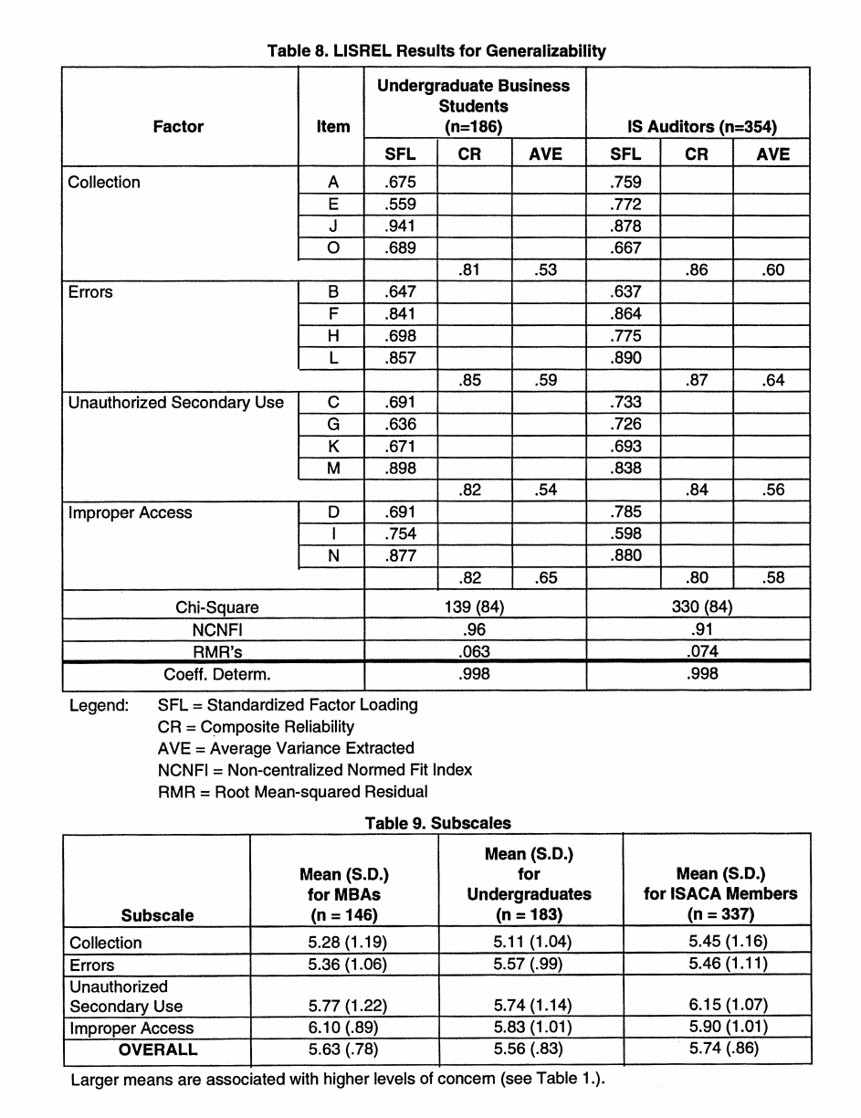
Before considering implications for researchers and managers, two limitations of this study should be noted. First, all scale development processes require a number of "judgment calls" by researchers based on their analysis of the literature; on input from experi-ence surveys, focus groups, and expert judges; and on levels of acceptability for vari-ous statistical measures. In particular, based on input from various sources, we concluded that one of the dimensions, Combining Data, was actually represented by two of the other dimensions, Unauthorized Secondary Use (External) and Collection. We also concluded that Reduced Judgment was not a part of the major "individuals' concerns about organizational information privacy practices"construct.
Both of these assessments appear to be consistent with the majority views of scholars, consumers, and advocates, and the four-dimension model of the construct seems to reflect current thinking. We acknowledge, however, that this dimensionality is neitherabsolute nor static, since perceptions of advocates, consumers, and scholars could shift over time.
Thus, the instrument should be viewed as measuring the most centraldimensions of the construct at this time. Future research endeavors might consider any changes in these dimensions that may occur. Second, while we made a concerted effort to validate the instrument in a nomological model of antecedents, individual personality variables, privacy concerns, and future behavioral intentions (Stage 3), it should be noted that this nomological model is not purported to be an exhaustive one, nor did we test it in an experimental, causal context. Indeed, theories regarding the interrelationships between privacy concerns and other constructsare not fully developed in the literature at present, and the creation of a full model is a task appropriate for a subsequent study. Furthermore, because of the constraints of time and length associated with administration of written surveys, we were unable to test all the antecedents, personality variables,and behavioral intentions witha single sample. Despite these limitations, this work has significant implications for both researchers and managers. We examine each inthe following sections.
Implications for researchers
Like many other areas within the IS domain, little attention has been paid to instrumentation issues in privacy research. Now, with a validated instrument for measuring individuals'concerns about organizational information privacy practices, researchers can undertake studies to carefully examine the linksbetween relevant privacy-related variables, privacy concerns, and outcomes of those concerns.
Theoretical models (see Stone and Stone, 1990) often posit theoretical relationships that include privacy concern as one of the model's constructs. With respect to factors that may impact levels of concern,it has been suggested that concerns may be context-sensitive based on either the type of information being managed (Culnan, 1993; Stone and Stone, 1990) orthe type of organization collecting and storing the data (Stone, et al., 1983). Concerns may also be associated with numerous personality factors and demographic data (see review in Stone and Stone, 1990). Further, some public opinion survey findings (Equifax, 1990) suggest that levels of concern on some subscales may be lower for professionals with day-to-day exposure to information processing activities.
There may also be factors that are impacted by levels of concern. It has been asserted that Individuals may take a variety of different actions based on their levels of concern, such as "optingout"of various activities (Culnan, 1993; Stone and Stone, 1990). Furthermore, perceptions of organizational privacy policies and practices may be related to levels of employee concern (Smith, et al., 1995), and levels of concern may also be associated with different culturalvalues and regulatory structures in various countries (Milberg, et al., 1995). It is clear that a significant research stream could emerge from empirical tests of the relationships between the antecedents, associated factors, levels of concern, and outcomes. As suggested by the discussion in the previous paragraph, most of this instrument's usefulness will come from its application in positivis tresearch-in particular, the development and testing of theories that take the form of independent and dependent variables (Lee, 1991). But the instrument may also assist a researcher in conducting interpretive research on what the meaning of information privacy is for the individuals themselves in an organization, apart from or prior to whatever a positivist theory would define it to be (Lee, 1991). Full understanding of a phenomenon is best achieved not through any singularity in approach, but rather, through iterative cycles of positivist and interpretive research (Lee, 1991).23 To the extent that researchers con-firm some of the theoretical linkages in posi-tivist approaches (e.g., by showing that indi-viduals exhibit higher levels of concern when stimulus materials prompt them to think about medical data rather than financial data), these findings may then feed back to interpretive studies (e.g., field studies that examine differ-ent approaches to managing medical data and managers' perceptions of differing responsibil-ity levels).
As privacy increases in importance, it behooves the IS research community to care-fully consider the complexity of individuals' concerns, the factors that may cause increased levels of concern, and the outcomes of those concerns. The instrument developed in this study should enable future work in this important area.
Implications for managers
This study, which identified the most central dimensions of individuals' concerns about organizational information privacy practices, can serve as the first step on a path of proac-tive management. By carefully considering their own organizations' approaches to the four major dimensions of concern—Collection, Errors, Unauthorized Secondary Use, and Improper Access—mariagers can identify underlying problems and take corrective actions as appropriate. Table 10 contains a set of possible recommendations that might be embraced for each of the dimensions.
As an example, IS professionals can address secondary use issues by identifying the sec-ondary uses of data within their organizations and ensuring that the appropriate technological approaches are being adopted for tracking purposes. It is acknowledged that IS managers and executives will seldom be in a position to unilaterally correct all the organizational problems in these domains since they are likely to involve some degree of existing organizational policy. Changing existing policy will demand attention from general managers at a senior level. However, IS professionals can be aggressive in challengingorganizationalpolicies for sharing personal data with outside organizations, and they may insist on tighter interpretations of the "need to know" when organizational policies regarding access are constructed. By taking a proactive stance in managing these dimensions of concern, IS managers and executives may reduce the probability that onerous regulatory options will be pursued (see Milberg, et al., 1995; Smith, 1994).
Research has shown that increased concerns about information privacyare associated with increased levels of governmental involvement in organizational privacy management (Milberg, et al., 1995), but so far, managers have been primarily reactive in addressing Information privacy concerns (Smith, 1994). Managers should be alert to the value-laden choices that are made by systems designers and implementers (Kling,1978; Mowshowitz, 1976), because these choices can ultimately impact the privacy domain and reactions there to. This study, along with future research addressing the antecedents and consequences of various concerns, may allow managers to evaluate specific situational contexts and manage responses to information management practices, thus avoiding costly consumer and/or regulatory backlashes.

